Adams – Van der Waeren 1994: White to play & win (2-4 moves):

341 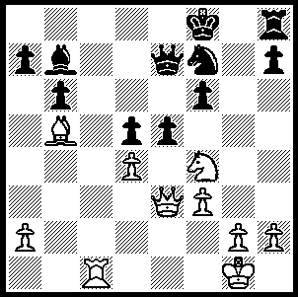

In recent columns mention was made of World Number 1 Magnus Carlsen loss of 3 games at the Olympiad and his loss against Georgia was printed. Here is another of his losses, against England’s Michael Adams who was for some years one of the top ten GMs. Carlsen tries an off beat defence, a cross between the Modern and Alekhines Defence, but is crushed on the kingside:

MICHAEL ADAMS - MAGNUS CARLSEN
2010 Olympiad: Irregular Defence

1.e4 g6 2.d4 Nf6
3.e5 Nh5 4.Be2 d6(a)
5.Nf3 Nc6 6.exd6 exd6
7.d5 Ne7 8.c4 Bg7
9.Nc3 0-0 10.0-0 Bg4
11.Re1 Re8 12.h3 Bxf3
13.Bxf3 Nf6 14.Bf4 Nd7
15.Rc1 Ne5 16.b3 a6(b)
17.g3 Nf5 18.Bg2 g5
19.Bxe5 Bxe5 20.Ne4 Ng7
21.Qd2 h6(c) 22.f4! gxf4
23.gxf4 Bf6 24.Kh2 Nh5
25.Rg1 Kh7 26.Rcf1 Rg8(d)
27.Qe2 Ng7 28.Qd3 Kh8
29.Bf3!(e) b5 30.Bd1 bxc4
31.bxc4 Bh4 32.Bc2 f5
33.Rg6! Kh7 34.Rfg1 Qe7
35.Ng3 Bxg3+(f) 36.Qxg3 Qf7(g)
37.Bd1 Rae8 38.Rxh6+! resigns (h)

a) This counter gambit rather than 4…Ng7 gives Black some positional compensation after 5.Bxh5 gxh5 6.Qxh5: eg 6…Rg8 or 6...dxe5 7.dxe5 Qd5.
b) After 16...Nxf3+ 17.Qxf3 Nf5 White’s space advantage leaves him with the advantage.
c) Black’s planned 22…f5 would give him a good game but White gets in first.
d) If 26...Bg7 27.Bf3 Nf6 28.Ng3 / Nf5.
e) Heading for c2.
f) 35…Kxg6 36.Nxf5+ Kf7 37.Nxe7 wins the queen and maintains the attack but not 37.Nxh6+? Kf8 38.Qh7 Qe2+ 39.Rg2 Bg3+! 40.Kxg3 Nf5+ 41.Kh2 Qxg2#.
g) 36...Nh5 loses to 37.Qf3! Rxg6 38.Bxf5.
h) 38…Kxh6 39.Qg5+ Kh7 40.Qh4+ Nh5 41.Bxh5 Qe7 42.Bg6+ Kg7 43.Bxe8+ wins.

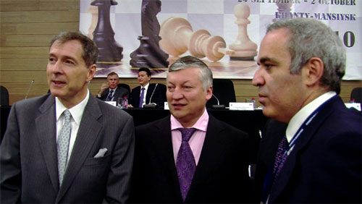
KIRSAN ILLYUMZHINOV was re-elected
president of FIDE at the Olympiad by 95 votes
to 55 after facing a challenge from former world
champion Anatoly Karpov. Karpov was strongly
supported by Gary Kasparov who complained
vehemently against the president’s reliance on
proxy votes. To have lost the FIDE presidency
would have been a second serious blow to
Illyuzhinov’s prestige after being forced earlier
this year to resign as the president of Kalymkia, Kapov (centre) & Kasparov (right) at
a position he had held since 1993, as part of FIDE elections
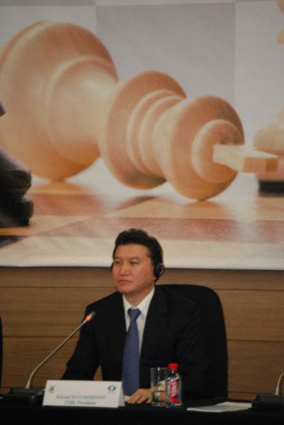
Russian President Dmitri Medvedev’s push to
remove all long serving leaders of the Russian
republics.

THE WILLETTON OPEN (WA & Australian GP event)
was won by Stephanus Kurniawan with a picket fence score
of 6/6. Runner up was relatively lowly rated Ned Tomic
with 4.5/6 despite a very strong field which included the
WA champion Tim Hare.

SOLUTION: 1.Rc7! resigns (if 1…Qxc7 or …Qd8 2.Ne6+:
if 1…Qd6 2.Rxb7: if 1…Qb4 2.Ne6+ Kg8 3.Be8 wins:
if 1…exf4 2.Qxe7#).

Re-elected FIDE President
Kirsan Illyumzhinov

