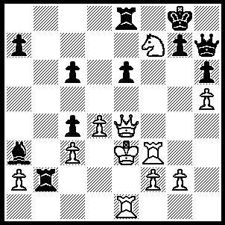

Corrales (Cuba) – Stellwagen (Netherlands)
2010 Olympiad:
Black to play and win
(4 moves):

342

342

Today we look at the Australian team at the recent Chess Olympiad at Khanty-Mansiyak, Siberia.
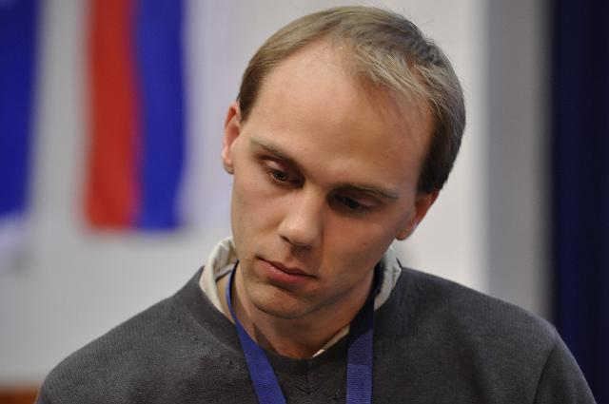
Australia scored +5, =2, -4 to come 55th/149. All members of the team finished with a plus score: Zhao Zong-Yuan +4, =2, -3, David Smerdon +4, =2 -2 (+ 1 default), George Xie +4, =2, -3, Daryl Johansen +4,=3, -2, Stephen Solomon +4,=1,-3. Readers may well imagine that the two week event entails nothing more than going through one’s opening preparation followed by playing a game, leaving plenty of time to relax and enjoy oneself. David Smerdon’s blog reveals that nothing could be further from the truth: “For us the mental match begins at 11 pm the night before when the country pairings come out. We rush to check our possible opponents, do a database sweep
of their opening repertoires and cross reference with our own. We usually head for bed at 1pm or so….. We get up for breakfast and then the serious preparation at about 9 am …. We go
through the hundreds of our now-determined opponents’ previous games at lightning speed, analyse their style (and) evaluate their strengths and weaknesses…. Then we work out what systems we plan to play against every one of our opponents main defences (or attacks presumably). We learn, memorise and re- David Smerdon memorise these systems until 2 pm with perhaps 15 mins for lunch. Then we head for the play venue and play our match from 3 to 8 pm. Then afterwards we analyse the game with our opponents, come home for a late dinner and then re-analyse withour team mates until 11 pm when we start all over again.” The team also submitted their analysed games for a regular email bulletin to Australian supporters and on top of all this the whole team was struck down by Siberian Flu!

Here is an exciting game from our top board, Zhao Zong-Yuan against Puerto Rico (I am indebted to Yuan for his detailed notes, most of which are included below):

ZHAO ZONG-YUAN - RIVERA MARK MACHIN
39th Chess Olympiad, Rd 3
Kings Indian Defence: Saemisch Variation
1.d4 g6 2.c4 Bg7
3.e4 d6 4.Nc3 Nf6
5.f3 0-0 6.Nge2(a) c5
7.d5 e6 8.Ng3 exd
9.cxd Re8 10.Be2 a6
11.a4 Nbd7 12.0-0 h5
13.Bg5 Qb6?!(b) 14.Qd2(c) Nh7
15.a5 Qc7 16.Be3 h4
17.Nh1 f5 18.Nf2 b5
19.axb Qxb6 20.Rfb1 Rb8
21.b4(d) Qd8!(e) 22.bxc(f) Rxb1+
23.Rxb1 Nxc5 24.Bd4(g) Ng5
25.Bxg7 Kxg7 26.Nd3?!(h) fxe(i)
27.Nxc5 dxc5?!(j) 28.f4 Nf7(k)
29.Na4 c4(l) 30.Rb6! Kh7
31.Qd4 Nd6 32.Nc3(m) e3
33.Qc5 Ne4(n) 34.Nxe4 Rxe4
35.Rb8!(o)

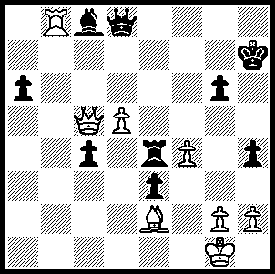 343

Position after 35.Rb8. Black’s choice is defence with 35…Re8 or counter-attack with 35…Qf6. He chooses 35…Qf6. Is he correct?

35…. Qf6?(p) 36.Qxc8 Qa1+(q)
37.Bf1 e2 38.Rb7+ Kh6
39.Qf8+ Kh5 40.Rh7+ Kg4
41.Rxh4+! Kxh4 42.Qh6+ resigns

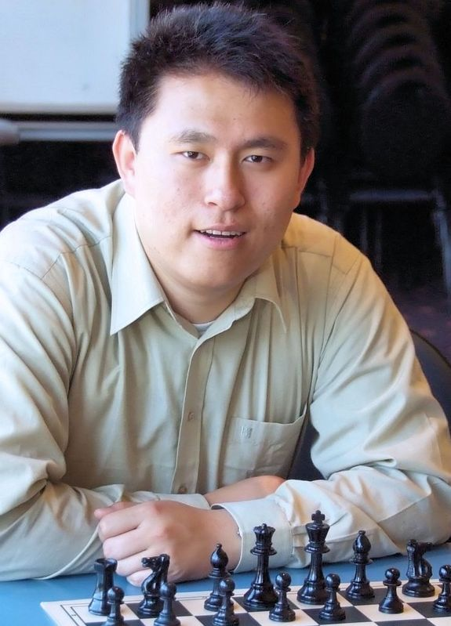
a) The idea of this system is to delay the commitment
of the dark squared bishop for a little while as it’s not
yet known whether it’s better on e3 or g5.
b) An inaccuracy as the queen is not well placed here.
c)14.a5!? Qxb2 15.Bd2 Bh6! 16.Ra2 Qb4 17.Bxh6 Qxc3
18.Nh1 is interesting and rather unclear.
d) 21.Nd3 Bxc3 22.Qxc3 fxe 23.fxe Rxe4 24.Nf2 Re8
25.Ng4 Ne5 26.Nxe5 Rxe5 27.b4 is better for White.
e) The only move to stay afloat.
f) Possible are 22.Nd3! Bxc3 23.Qxc3 fxe 24.Nxc5 dxc5
25.bxc5 Rxb1+ 26.Rxb1 exf3 27.Bc4 Ne5 28.d6+ and
22.b5 Qf6 (22…axb 23.Bxb5 Qf6 24.Ra3 Nhf8 25.Rab3)
23.Ra3.
g) Alternatives 24.Nd3 or 24.Bxc5 dxc5 25.Bd3 Ng5
(or 25…Bd4).
h) Now Black is fine again. 26.Qd4+ Qf6 27.Qxf6+ Kxf6
28.Rb6 Ke5 is equal while 26.Rb8!? Qf6! (26…fxe
27.Rxc8 Qxc8 28.Qxg5 is good for White) 27.exf gxf
28.f4 Nf7 29.Nfd1 Bd7 30.Rxe8 Bxe8 31.Ne3 a5 32.Nc4 Australian top board Zhao Zong-Yuan
is also more or less even.
i) An unwise decision when both players have little time left although if followed up correctly it’s objectively also a good move. 26…Nxd3 is more practical – 27.Qxd3 fxe 28.fxe (28.Nxe4 Nxe4 29.fxe4 Qf6 also looks unimpressive for White) 28…h3 and Black has a nice position.
j) 27…exf3!! is a very difficult move to see, let alone in time pressure. Now best play seems to lead to some advantage for Black although the road is difficult for both players – 28.Nb7 Qe7 29.Bxa6 fxg 30. Kxg2 Bf5 and Black is better although White may be able to hold (30…Qe5 31.Nxd6 h3+ 32.Kh1 Qxd6 33.Bxc8 Rxc8=).
k) 28…Ne6 centralising the knight is much better.
l) In time pressure Black is going astray – 29…e3 30.Qc3+ Qf6 31.Qxf6+ Kxf6 32.Nxc5 Rd8 and Black should hold.
m) 32.Qc5! immediately was better. In time pressure I instinctively wanted to block the c pawn before taking action but this gives Black chances – 32…Nf5 (32…Nb7 33.Qxc4) 33.Nc3 e3 34.Bxc4 with advantage to White.
n) 33…Nb5 is much better – 34.Nxb5 axb5 35.Qxb5 Re4 and Black still has a chance to defend.
o) Here I went into a long think with only about 2 mins left. I didn’t quite see the mate which finishes the game until after I played my next move. Luckily my intuition pointed in the right direction.
p) Decisive blunder which allows a mating finish. Gritty defence still offers chances for Black – 35….Re8 36.h3! creating a luft for the king seems good: 36.g4 is also interesting – 36…hxg (36…Rxf4 37.Qg8+ Kh6 Qh8??+ wins) 37.hxg Qd7 38.g4.
q) Now I saw the forcing conclusion to the game. What a relief!
SOLUTION: 1…Re2+!! - a decisive deflection sacrifice - resigns (2.Rxe2 Bc1+ 3.Rd2 Bxd2+ 4.Kxd2 Qxe4.

