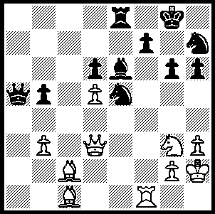
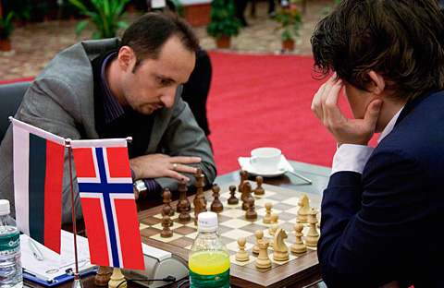

344

Carlsen – Topalov (Nanjing 2010):
White to play and win (5 moves). Carlsen – Topalov in Nanjing

‘When you’re onto a good thing, stick to it,’ might sum up world champion Vishwanathan Anand’s choice of defence when playing Black against Veselin Topalov in the Pearl Spring tournament in Nanjing, China. With his world title on the line in the final game of his match against Topalov in Sofia earlier this year Anand chose Lasker’s Defence to the Queens Gambit and in Nanjing he once more opted for this rarely played defence to 1.d4, again with success. The Nanjing International tournament, with the world’s top three players competing, continues until October 30th. It is played as a ten-round double round-robin event, in which each player faces every other player twice, once with White and once with Black. Time control is 40 moves in two hours, then 20 moves in one hour followed by the rest of the game in 15 minutes with a 30 second increment from move 61. Competitors are Carlsen (Norway, world ranking 1), Topalov (Bulgaria, world ranking 2), Anand (India 3), Wang Yue (China 18), Vugar Gashimov (Azerbaijan 26) and Etienne Bacrot (France 28). Scores after 5 rounds: Carlsen 4, Bacrot 3.5, Anand 2.5, Gashimov 2, Topalov 1.5, Wang Yue 1.5.

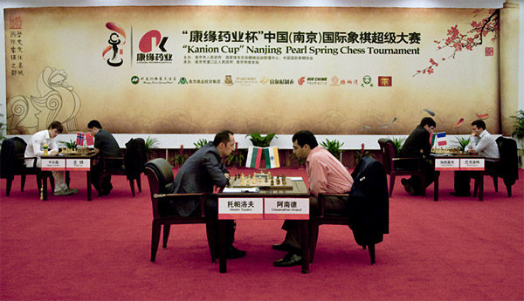
.
Veselin Topalov - Viswanathan Anand
Pearl Spring Chess Tournament, Rd 3
Queens Gambit, Laskers Defence
1.d4 Nf6 2.c4 e6
3.Nf3 d5 4.Nc3 Be7
5.Bg5 h6 6.Bh4 0-0
7.e3 Ne4 8.Bxe7 Qxe7
9.cxd5(a) Nxc3 10.bxc3 exd5
11.Qb3 Rd8 12.c4 Be6!
13.c5(b) b6 14.Rc1 bxc5!
15.Qa3!?(c) Nd7 16.Bb5(d) Bg4!
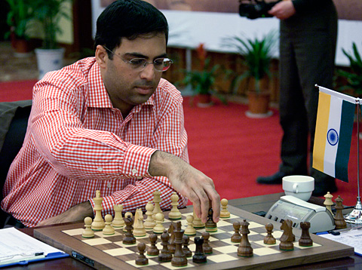
17.Bxd7 Rxd7 18.Qxc5(e) Qe4
19.Rg1 Re8! 20.Qb5(f) Rdd8!(g)
21.Qe2 Rb8 22.h3 Bxf3
23.gxf3 Qf5 24.f4 Rb1
25.Rxb1 Qxb1+ 26.Qd1 Rb8
27.Ke2 Qf5 28.Rh1 Rb2+
29.Kf3 h5! 30.a4 Qe4+
31.Kg3 h4+! 32.Kxh4 Rxf2
33.Qg4 Rg2 34 resigns(h)
a) The main move 9.Rc1 didn't bring any success to Topalov last time against Anand.
b) If 13.Qxb7 13...dxc4! (14.Qxa8? Qa3 threatening 15…Qc3+ & 15…Bd5)
c) Appears strong but obviously Anand was ready for it. After 15.Rxc5 Nd7 16.Rxc7 Black, with a pronounced lead in development will have excellent compensation for the pawn.
d) 16.dxc5 seems safer
e) 18.Ne5 looks winning but Black has 18...cxd4! 19.Qxe7 Rxe7 20.Nxg4 h5!: 18.Rxc5 also leads to a difficult position - 18...Qe4 19.Ke2 Rd6! threatening …Rf6 and if 20.h3 Bc8! switching to a6.
f) 20.Ne5 is met by 20...Rxe5! 21.dxe5 d4! with a strong attack.
g) Planning to switch the inactive rook to the b-file.
h) A case of déjà vu with same opponent, same defence and same result.

I recently came across an article by UK columnist Malcolm Pein which stated that 21 year old university student Will Taylor with a FIDE rating of 1866 had laid a ₤200 bet at 25-1 with William Hill (a leading UK bookmaker) that he would become a Grand Master. Pein considers the odds very miserly, believing 250-1 ‘would be more like it.’ Besides studying for a BSc Taylor plays the guitar as well as the Japanese game Go and has a regular girlfriend. Good luck to him!

SOLUTION: 1.dxe6! resigns (1…Nxd3 2.exf+ Kf8 3.Bxh6+ Ke7 4.fxe=Q+ Kxe8 5.Bxd3 with a considerable material advantage (and the knight will also be lost – eg 5…Qc7 6.Bxg6+ Kd8 7.Rf7).

