Steven Zierk – Nils Grandelius
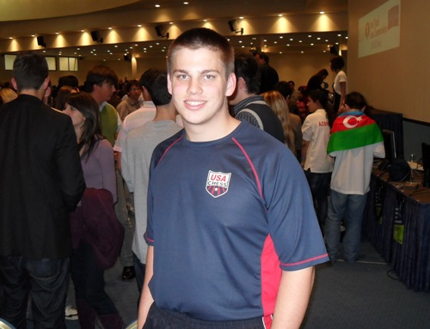
(World Youth 2010, Rd 3): White
mates in 3 moves (the first move is
clever and the second sensational):

346 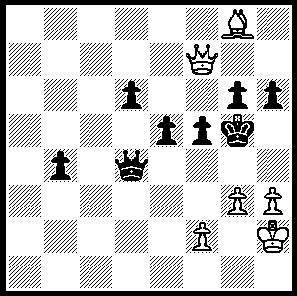 World Youth Under 18 winner, Steven Zierk
Bobby Fischer’s first experience with a chess master occurred as an eight year old during a simultaneous given by Max Pavey. Bobby lost his queen and the game in 15 minutes and burst into tears when he lost. Imagine then the potential for problems for the organisers of the World Youth Championships held in the 5 star resort of Porto Caras in northern Greece in which nearly 1400 budding Bobby Fischers were competing in Under 8, U 10, U 12, U 14, U 16 & U 18 events in both Open & Girls’ sections. Not to be confused with the World Junior Championships, the World Youth Championships have evolved from tournaments which began in 1974. Winner of the Under 18 Open was US player Steven Zierk who played consistent and enterprising chess throughout, finishing with 8.5/11. Although in a field including a number of GMs, Steven won his first 4 games, drew the next three and finished strongly, winning the last four rounds. Here is one of his games, extremely double-edged with both players fighting throughout for victory:

Steven Zierk - Upadhyaya Anwesh
2010 World Youth Championships, Rd 9
Scotch Game, Mieses Variation
1.e4 e5 2.Nf3 Nc6
3.d4 exd 4.Nxd4 Nf6
5.Nxc6 bxc6 6.e5 Qe7
7.Qe2 Nd5 8.c4(a) Ba6
9.b3 Qh4 10.a3 Bc5
11.g3(b) Bxf2+!?(c) 12.Qxf2(d) Qe4+
13.Kd2 Qxh1 14.Bg2 Qxh2
15.cxd5 0-0 16.dxc Qh5
17.Nc3 dxc 18.Kc2 Rfd8
19.Bf4 Qf5+ 20.Kb2 Rab8
21.Qxa7 g5!(e) 22.Qxa6 gxf4
23.Qe2 fxg3 24.Be4 Qg5(f)
25.Kc2 Re8 26.Rg1 h5
27.Bd3(g) Rxe5 28.Ne4 Rxe4(h)
29.Qxe4 Qc5+ 30.Bc4!(i) Qxg1
31.Qg6+ Kh8 32.Qh6+ Kg8
33.Qg6+ Kh8 34.Qxh5+ Kg7
35.Qxf7+ Kh8?(j) 36.Qh5+ Kg7
37.Qg5+ resigns(k)

a) A line brought to prominence in the 1990 Kasparov-Karpov World Championship. In Game 14 Karpov played 8…Ba6 (9.b3 0-0-0) and drew. In Game 16 he played 8.Nb6 and lost in 102 moves.
b) 11.Ra2 is a safer alternative.
c) The symbol !? means interesting or speculative move. Black gives up two pieces for a rook, exposes White’s king and picks up a few pawns.
d) If 12.Kxf2 Qd4+ wins the queen’s rook.
e) Although exposing the Black king somewhat this secures potential united passed pawns on the g & h files.
f) Not 24…Qxe5?? 25.Bxh7+ winning the queen.
g) Play could continue 27.Qf3 h4 28.Rf1 Re7 29.Qf4 Qxf4 30.Rxf4 Rxe5 31.Rxh4 f5 32.Bxc6 Kg7 33.Bg2 Kg6 34.b4 Rd8 35.Rc4 where Black is holding his own.
h) An attractive combination.
i) If 30.Kb2 Qxg1 31.Qh7+ Kf8 32.Qh8+ Ke7 33.Qxb8 Qf2+ 34.Bc2 g2 looks fine for Black.
j) The fatal error – 35….Kh6 would enable Black to draw.
k) 37…Kf8 38.Qf6+ Ke8 39.Bf7+ Kd7 40.Qe6+ Kd8 41.Qe8#.

SOLUTION: 1.f4+!! (an obstruction sacrifice to deprive Black of the queen’s protection of h4) 1…Kh5 (if 1…exf 2.Qe7+ Kh5 3.Qh4#) 1…Kh5 2.Qxf5+!! resigns (2…gxf5 3.Bf7#).

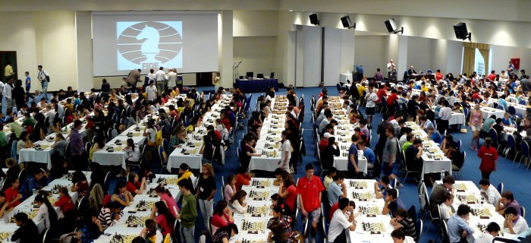

Play under way in the 2010 World Youth Championships

