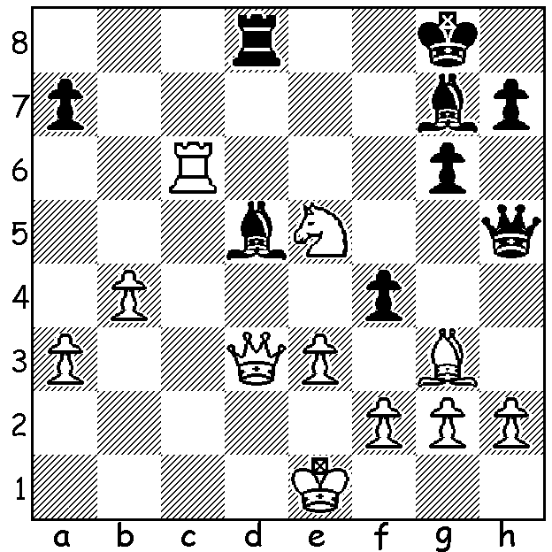

Ribli-Chandler 1982: White has three
pieces en prise but his next move brings
an immediate resignation from Black
(need a hint? go to asterisk below).

347

For a few weeks I intend to create columns linking chess and music by highlighting individuals who have excelled in both fields. We start with Francois-Andre Philidor (1726 – 1795) described in Golembek’s Encyclopedia of Chess as ‘the greatest chess player among musicians and the greatest composer among chess players’. His name appears in The Oxford Companion of Music as the most important member of the Philidor family who ‘resemble the Purcells, the Couperins and the Bachs in the family possession of musical gifts.’ A musician at the French court, Philidor had a composition performed at the court of Louis XV at the age of 11 and later in life became a most prolific and successful opera composer (Tom Jones was one of his operas). Chess, a favourite activity of the court musicians, was taken up by Philidor whose talent came to the notice of France’s leading player Legal who gave him coaching. Philidor developed into the best player in the world, not only proving superior to the leading players in England but also his mentor Legal and he astounded the chess world by taking on three opponents simultaneously while blindfold. In 1749 Philidor published his famous book Analyse du jeu des Echecs which went into about 70 editions in less than 100 years including translations into English, German, Russian and Italian. He was the first to give detailed annotations on how to play the middle game, including such concepts as blockade, prophylaxis, positional sacrifice and mobility of the pawn formation and also showed how to draw rook v rook and pawn endgames. He has the defence 1.e4 e5 2.Nf3 d6 named after him (his idea being not to block the future advance of the c pawn by 2…Nc6) and also the well-known smothered mate by a knight, Philidors Legacy * (although it had been seen earlier in, for example, the games of Greco). His stress of the importance of pawns –‘the pawns are the life of chess’ – was at odds with the more romantic leanings which concentrated so much on free piece movement and gambits. He became stranded and died in England after being put on the banned list by the Revolutionary Government because of his social connections. It was not the custom to record games so we have few examples of Philidor’s prowess. This game certainly shows Philidor’s understanding of the use of pawns to dominate the centre and open lines for attack:

SMITH - PHILIDOR
London 1790
Bishops Opening
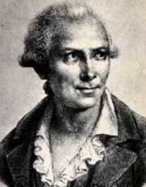
1.e4 e5 2.Bc4 Nf6
3.d3 c6 4.Bg5 h6
5.Bxf6 Qxf6 6.Nc3 b5
7.Bb3 a5 8.a3 Bc5
9.Nf3 d6 10.Qd2 Be6
11.Bxe6 fxe6 12.0-0 g5!
13.h3 Nd7 14.Nh2 h5
15.g3 Ke7 16.Kg2 d5
17.f3 Nf8 18.Ne2 Ng6
19.c3 Rag8 20.d4 Bb6
21.dxe Qxe5 22.Nd4 Kd7
23.Rae1 h4 24.Qf2 Bc7
25.Ne2 hxg 26.Qxg3 Qxg3+
27.Nxg3 Nf4+ 28.Kh1 Rxh3
29.Rg1 Rxh2+! 30.Kxh2 Rh8+
31.Nh5 Rxh5+ 32.Kg3 Nh3+
33.Kg4 Rh4#

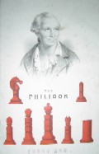
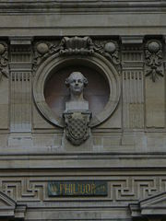

Philidor the musician Philidor the chess player
Bust on Paris Opera house

CHRISTMAS OPEN (last Australian & WA Grand Prix event of 2010) Moresby St. Centre, Kensington, Sat 27 & Sun 28 November. Further details cawa.org.au and entries to Haydn Barber 9398 4242

SOLUTION: 1.Rc8! resigns (1…Rxc8 – everything else loses material – 2.Qxd5+ Kh8 3.Nf7+ Kg8 4.Nh6+ Kh8 5.Qg8+! Rxg8 6.Nf7# - an example of the smothered mate, Philidors Legacy).

