Levon Aronian (Armenia) was the recent winner of the World Blitz Championship. Here is an example of his superb play with a time limit of 3 minutes for the whole game with 2 second increments added after each move. Aronian (Black) is a pawn down against Mamedyarov with his own pawns seemingly little danger while White’s h pawn is on the way to queening. However Black (to move) finds a winning plan (10 moves): try to consider an alternative White move to the obvious:

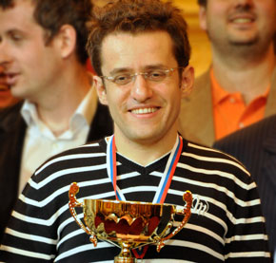
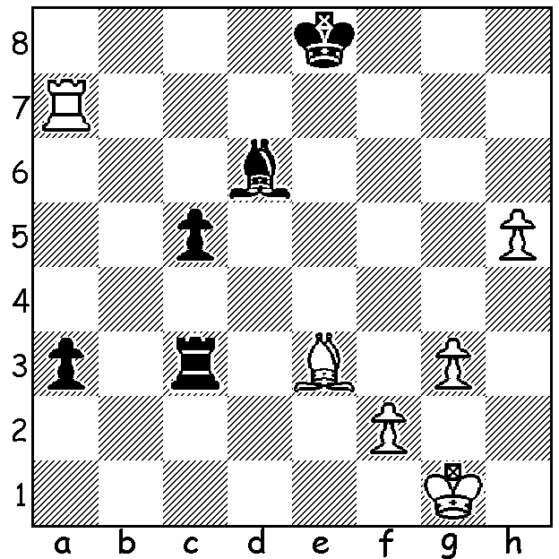
A happy Aronian with the World Blitz trophy.

The World Blitz was played over three days immediately after the Tal Memorial tournament and featured 20 of the world’s top players in a double round robin. Aronian scored 24.5/38 closely followed by Teimour Radjabov (Azerbaijan) 24 and last year’s winner Magnus Carlsen (Norway) 23.5. Boris Gelfand (Israel) and Hikaru Nakamura (USA) 21.5 shared 4th place and Vladimir Kramnik (Russia) and Sergey Karjakin (Russia) 20.5 equal 6th. Here is a fine sacrificial game from the event in which the Russian Alexander Grischuk puts a dent in Nakamura’s chances:

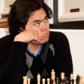
Hikaru Nakamura – Alexander Grischuk
World Blitz 2010
Nimzo Indian, Rubinstein Variation
1.d4 Nf6 2.c4 e6
3.Nc3 Bb4 4.e3 0-0
5.Ne2 d5 6.cxd exd
7.a3 Bd6 8.g3 c6
9.Bg2 a5 10.0-0 Na6
11.f3 c5 12.g4 h6
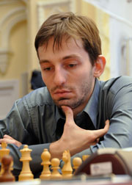
13.h3 Re8 14.f4 Nc7
15.a4 b6 16.Ng3 Ba6
17.Rf2 Qd7 18.Bd2 Rad8
19.Qf3 Bd3 20.g5 hxg
21.dxc(a) Bxc5 22.fxg Ne4
23.Ngxe4 Bxe4 24.Nxe4 dxe4
25.Qh5 g6 26.Qh4 Qxd2!(b)
27.Rxd2 Rxd2 28.Kh1(c) Nd5
29.Qe1 Rxg2! 30.Kxg2 Nxe3+
31.Kg3 Nc2 and Black wins (d)

a) This leaves the weak e pawn even weaker.
b) An excellent positional queen sacrifice.
c) White falters however if 28.Bxe4 Bxe3+ 29.Kh1 Ne6 maintains the pressure on White’s loose position (not 29…Rd4 30.Qg3 Rdxe5 31.Qxc7).
d) Conclusion 32.Qe2 (32.Qd1 Nxa1 33.Qxa1 e3 wins) 32…Nxa1 33.h4 Nb3 34.h5 (34.Qb5 Re7 35.Qxb3 e3 wins) 34…Nd4 35.Qc4 Nf5+ 36.Kh3 Kg7 37.h6+ Kg8 38.Qc3 e3 White resigns.
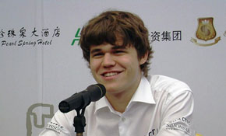

In a serious blow to FIDE world number
1 for most of 2010, Magnus Carlsen has
withdrawn from the world championship
cycle to find a challenger to Vishy Anand.
Carlsen had qualified for the final stage,
the eight player Candidates knock-out
tournament. His place will be taken by
Alexander Grischuk

Magnus Carlsen announces his withdrawal
from the World Championship cycle.

CHRISTMAS OPEN (last Australian & WA Grand Prix event of 2010) Moresby St. Centre, Kensington, tomorrow (12.30 start) & Sunday (10.30 start). Further details cawa.org.au and entries to Haydn Barber 9398 4242. Enter before tomorrow to obtain discount.

SOLUTION: 1...Rxe3 (1…Bxe3? 2.h6!) with the game concluding 2.h6 (if 2.fxe3 c4 & Black will
queen) 2…Re6 3.h7 Rh6 4.Kg2 (if 4.Ra6 c3 5.Rxd6! Rxh7! 6.Rd1 c2 7.Rc1 a2 8.Kf1 Rd7 or Ra7 and again one Black pawn will queen) 4…c3 5.Ra8+ (or 5.a8=Q first) 5…Kd7 6.h8=Q Rxh8
7.Rxh8 c2 8.Rh1 a2 9.Kf3 Ba3 resigns.

