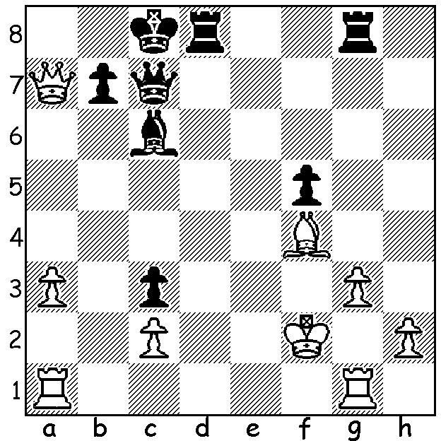

349

Black looks in trouble in
Maurice Delarge – Serge Prokofiev.
However it’s Black who brings the
game to a speedy conclusion (5 moves):

- CHESS & MUSIC (Part II) Sergei Prokofiev

Readers may recognise the name Sergei Prokofiev (1891-1953), the famous 20th century Russian composer. He is most well known for such works as ‘Peter and the Wolf’, ‘The Classical Symphony’, the opera ‘War and Peace’, the ballet ‘Romeo and Juliet’ and for his film music. He was born and died in Russia although he fled the country after the Russian Revolution before being lured back in 1932. In the period between his return and death (the same day and hour as Stalin) he had many problems with the soviet authorities which included denunciation on the grounds his music did not extol the virtues of the Stalinist regime.
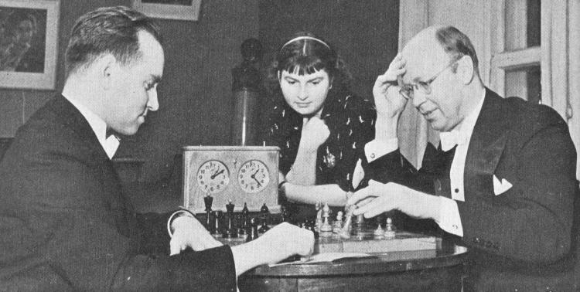
At an early age he learnt piano from his mother and chess from his father and it was these two interests which would dominate his life. He had composed an opera at the age of nine and entered the St Petersburg Conservatory at the age of thirteen. He became a member of a very strong conservatory chess team and his interest in the game, both playing and watching, continued throughout his life (he even named his two dogs
Lasker and Tarrasch). His opponents in recorded
games include the English composer Frederick
Delius, the French composers Maurice Ravel
(see game below) and Maurice Delage (see
position above) and the famous Russian violinist
and conductor David Oistrakh who was
considered an even better player than Prokofiev.
Prokofiev was on friendly terms with many of the
leading Grandmasters of his day including
Capablanca, Botvinnik and Tartakover. He Sergei Prokofiev (white) v David Oistrakh
defeated Capablanca at a simultaneous display
by the great Cuban (he had previously lost to Emanuel Lasker in another simul), and also beat Tartakover in a friendly game which Tartakover generously published. Botvinnik wrote of him, “Sergei Prokoviev was passionately fond of chess. … I played him several times. He played a vigorous, forthright game. His usual method was to launch an attack which he conducted cleverly and ingeniously.” How true this description of Prokofiev’s play can be seen from the following sparkling game:
Sergei Prokofiev - Maurice Ravel
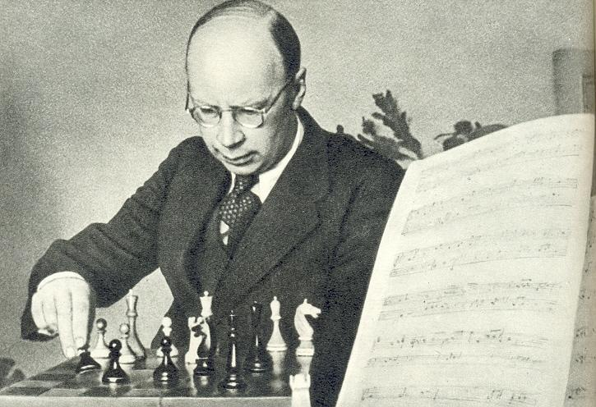
Mont La Joli 1924
Nimzo-Indian Defence, Leningrad Variation
1.d4 Nf6 2.c4 e6
3.Nc3 Bb4 4.Bg5 Nc6
5.e3 0-0 6.Bd3 d5
7.Ne2 a5 8.Qc2 h6
9.h4!? hxg5 10.hxg5 Re8
11.gxf6 Qxf6 12.0-0-0 dxc
13.Bh7+ Kf8 14.Ne4 Qe7
15.Nf4 b5 16.Rh5 e5
17.Ng6+! fxg6 18.Bxg6 Be6
19.Rdh1 Rad8 20.Rf5+! Kg8
21.Qe2 Bxf5 22.Rh8+! Kxh8
23.Qh5+ Kg8 24.Qh7+ Kf8 Sergei Prokofiev, composer & chess player
24.Qh8#

- The 2010 Australian Schools Team Championships take place tomorrow and Sunday at Perth Modern, Roberts Rd., Subiaco, starting 9.30 am each day. Perth Modern (secondary) and Swan Christian School (primary) will be representing WA. Spectators are welcome.

- SOLUTION: 1…Qxf4+!! 2.gxf4 Rd2+ 3.Kf1 (3.Ke3 Re8#) 3…Bb5+ 4.Ke1 Re8+ 5.Qe3 Rxe3#.

