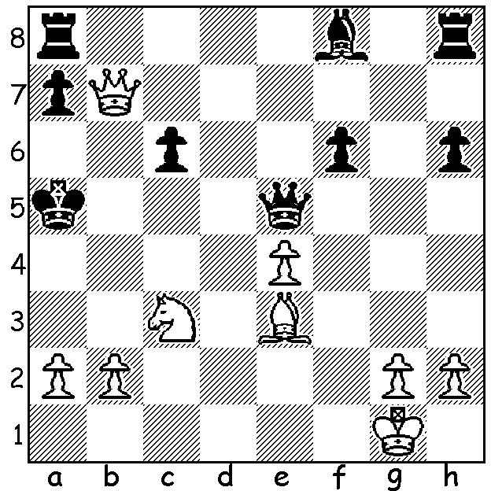

Plaskett-Tarsh 1984:
how does White bring a king
hunt to a successful conclusion
with mate in 3?

350

The final WA Grand Prix event of 2010, the Christmas Open, was played last weekend with 25 competitors. First place was shared by Stephanus Kurniawan and WA’s top rated player Tristan Boyd with 5/6. Four players, Yita Choong, David Ellis, Ned Tomic and Marc Vliestra, shared 3rd place with 4/6. Ned Tomic also won the Under 1700 prize while the Under 1500, Under 1300 were won by Berouz Ghorbanian and Tamas Szabo respectively. The WA Grand Prix events form part of the Australian Chess Federation’s Yulgibar-Think Big Australian Grand Prix which awards a state prize to WA’s most successful player. The WA Grand Prix saw Stephanus Kurniawan winning the Premier for the second time with three times winner David Ellis runner-up. Ned Tomic won the Major section for the third time, well ahead of other participants, while Gary Donaldson retained the Minor section, just ahead of Girma Orssengo, and George Carolin-Uncovich won the Junior section. Awards for the Grand Prix will made after the WA Teams Championship (approx 4pm) on Sunday at Moresby Hall, Kensington.
Today’s game comes from the final Grand Prix event and features Premier winner Ned Tomic who has been one of the most regular supporters of the Grand Prix over the years:

NEDELJKO TOMIC - TOM DONALDSON
2010 Christmas Open, Rd 6
Queens Pawn Opening
1.d4 d5 2.Nf3 c6
3.g3 Bg4 4.Bg2 Nd7
5.Nc3 f5(a) 6.h3 Bxf3
7.Bxf3 e6 8.g4(b) Bd6
9.gxf exf 10.h4 Ngf6
11.Bg5 Qb6 12.Qd3 Ne4(c)
13.Bxe4 fxe4 14.Nxe4!? dxe4
15.Qxe4 Be5?(d) 16.0-0-0(e) Qa5
17.dxe5 Qxa2 18.Rh3(f) Nb6
19.Qb4 Qe6 20.Rd6!!(g) Qxh3
21.Rd8+! Kf7 22.Qe7+ Kg6
23.Rd6+ Kh5 24.b3?(h) g6(i)
25.f3 Nd5?(j) 26.Qg7 Qf1+
27.Kb2 Qxe2 28.Qh6#(k)

a) As White’s last move prevented c4 Black stops the other central thrust e4 by setting up a stonewall formation. His queen’s bishop, traditionally an inactive piece in the stonewall, is able to be exchanged off.
b) An energetic move leaving to a lively game.
c) This allows White the opportunity of a promising sacrifice: safer was 12…0-0 and if 13.Qxf5 Qxb2 14.0-0 Qxc3 15.Qe6+ Rf7 16.Qxd6 Qxd5 with advantage.
d) Black should hold onto the extra piece with 15…Kf7 although after 16.Qf5+ Nf6 17.Bxf6 White has strong attacking chances.
e) Not 16.dxe5? Qxb2 17.Rd1 Qxe5.
f) 18.Qb4 Qe6 19.Qxb7 leaves White well on top.
g) A brilliant rook sacrifice which exposes Black’s king.
h) White misses the winning sacrifice of the second rook – 24.Rh6+!! gxh6 25.Qf7+ Kg4 26.Qe6+ Kh5 27.Qxh6+ Kg4 28.Qe6+ Kh5 29.Qxh3 with a winning position.
i) This breaks White’s attack as does 24…Rag8 or 24…Qf1+ 25.Kb2 Qxf2 26.Qxg7 Qf8.
j) 25…h6! would win – 26.Rxg6! Rag8! (not 26…Kxg6? 27.Qf6+ Kh5 28.Qf7#).
k) White’s enterprising play is rewarded.

SOLUTION: 1.b4+! (a clever obstruction sacrifice depriving Black’s king of a vital escape square)1…Bxb4 2.Bb6+! (a combined obstruction & deflection sacrifice) 2…axb6 3.Qxa8#.

