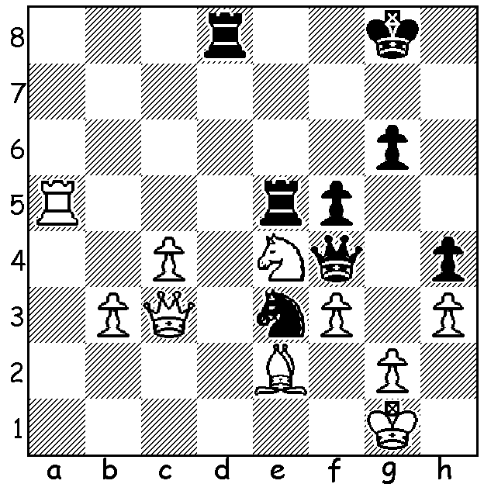

Vladimir Liberzon – Mark Taimanov 1967:
Black to play & win (5 moves):

351`

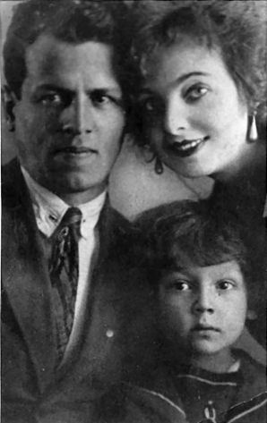
CHESS & MUSIC:
MARK TAIMANOV (Part I)

Mark Taimanov was one of those outstanding
individuals who was simultaneously able to
effectively combine two careers with great distinction.
Born in 1926 in the Ukraine the young Taimanov
learnt music from an early age from his parents
who were both talented musicians as well as chess
from his father who was a passionate player. He
gained surprising fame at the age of eleven when
he was selected to take the part of a young violinist
in the Russian film ‘Beethoven’. He studied music
A young Mark Taimanov at the Leningrad Conservatory and became an
with his parents accomplished concert pianist. He married fellow
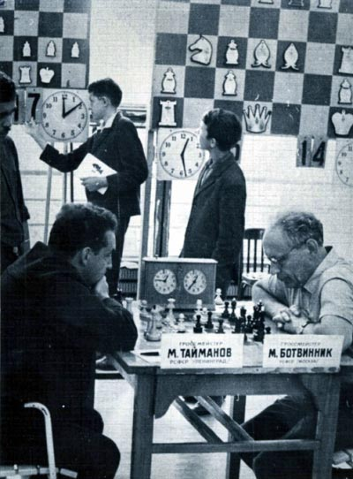
pianist Lyubov Bruk at the age of 19 and together
they made frequent tours together as dual pianists.
In chess he became a Grandmaster in 1952 and
developed into one of the top ten chess players in
the world. His greatest success was in 1956 when
he won the USSR championship after a play-off
with Boris Spassky and Yuri Averbakh. He saw
chess, like music, as an art and his play was
influenced by a desire to create beauty. Here
is a wonderful win against a leading Russian
grandmaster:

Taimanov in play against his
mentor Mikhail Botvinnik

Mark Taimanov - Lev Polugaevsky
Leningrad 1960
Queens Gambit Accepted

1.d4 d5 2.c4 dxc
3.Nf3 Nf6 4.Qa4+ Nbd7
5.Nc3 e6 6.e4 c5
7.d5 exd 8.e5 d4(a)
9.Bxc4 dxc3 10.exf6 Qxf6
11.Bg5 Qc6 12.0-0-0!! cxb2+
13.Kxb2 Be7(b) 14.Rhe1! f6
15.Bb5 Qb6 16.Kc1! fxg5
17.Bxd7+ Kf8 18.Rxe7! Kxe7
19.Qe4+ Kd8 20.Bf5+ Kc7
21.Qe5+ Kc6 22.Rd6+ Kb5
23.Qb2+ resigns (c)

a) Better 8…b5 (9.Qxb5 Rb8 10.Qa4 d4 11.exf6 dxc3 12.Bxc4 Rb4 13.Qc2 Nxf6) Miles v Karpov v 1990.
b) If 13…Qxa4 14.Rhe1+ Be7 15.Rxe7+ Kf8 16.Rxf7+ Kg8 17.Rfxd7+! Qxc4 18.Rd8+ Kf7 19.Ne5+ Ke6 20.Nxc4 winning.
c) 23…Ka4 24.Bc2+ Ka5 25.Qa5# or 23…Kc4 24.Ne2#.

SOLUTION: 1…Rxe4!! (a deflection sacrifice opening the f file) 2.fxe4 Rd1+! (now deflecting the bishop) White resigns – 3.Bxe1 Qf1+ 4.Kh2 Qxg2#.

(for report on Teams Lighning & CAWA 2010 wind-up see supplement)

