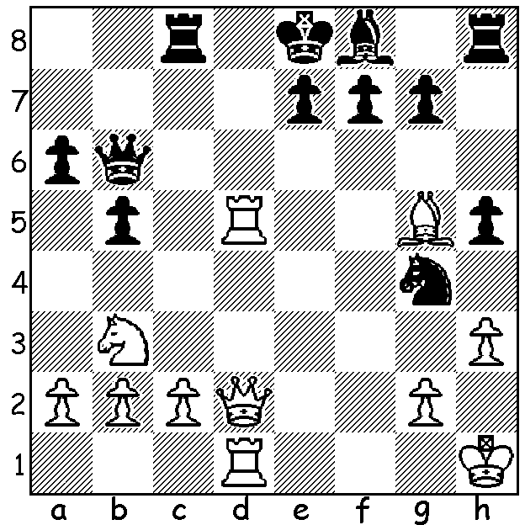

Carlsen-Kjartannson 2006:
White to play wins very quickly:

353

LONDON CLASSIC 2010

The second London Classic played during the
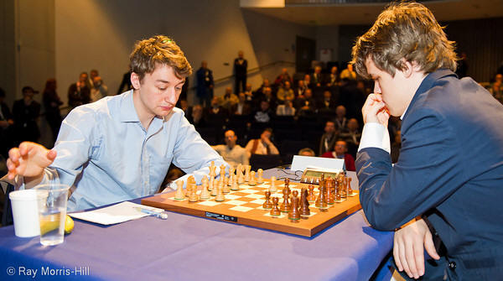
first half of December again brought together
four of the world’s top GMs and four leading
British GMs in a format which gives three points
for a win and one for a draw. The first round
created a sensation with the 26 year old Brit Luke
McShane outplaying world number 2, 20 year old
Norwegian Magnus Carlsen. After losing to world
champion Vishy Anand in Rd 3 Carlsen was left
trailing the leaders badly. However he was able to
win 3 of his remaining 4 games to clinch first prize
of 50,000 euros. Scores: 1st Carlsen 13/21 (+4 =1
-2), =2nd Vishy Anaand & Luke McShane 11 (+2
=5), =4th US champion Hikaru Nakamura & ex-
world champion Russian Vladimir Kramnik, 6th
MichaelAdams 10, 7th David Howell 4, 8th Nigel
Short 2. Here is McShane’s win from round 1, a McShane & Carlsen at the start of their game
brilliant example of a queenside attack backed up
by the fianchettoed king’s bishop:

LUKE MCSHANE - MAGNUS CARLSEN
London Classic 2010, Rd 1
Symmetrical English

1.c4 c5 2. g3 g6
3.Bg2 Bg7 4.Nc3 Nc6
5.Nf3 d6 6.0-0 Nh6
7.d4! cxd 8.Bxh6 Bxh6
9.Nxd4 Ne5(a) 10.Qb3 0-0
11.Rfd1 Nd7 12.Qa3! a5
13.b4 Ra6(b) 14.b5 Ra8
15.e3 a4 16.Rab1 Bg7
17.Ne4! Qb6 18.Nc6! Re8(c)
19.Nb4! f5 20.Nc3 Qc5(d)
21.Nxa4! Qa7 22.Na6! bxa6
23.b6 Nxb6 24.Rxb6 Rb8
25.c5! Be6 26.Rdb1 dxc
27.Rb7 Rxb7 28.Rxb7 Qa8
29.Nxc5 Qc8(e) 30.Qxa6 Bf7
31.Bc6 Rd8 32.Nd7!(f) Rxd7
33.Bxd7 Qc1 34.Qf1 Qxf1+
35.Kxf1 Bc4+ 36.Kg1 Bxa2
37.Ba4 e5 38.f3 Bh6
39.Bb3+ resigns(g)

a) 9…Nxd4 or 9…Bd7 are the more accepted moves.
b) 13…Black might have tried the complicated 13…Nb6 (14.c5 Nc4 15.Qb3 Nd2).
c) If 18…bxc6 19.bxc6 Qa5 (19…Qxc6? 20.Nf6+) 20.cxd7 Bxd7 with a strong initiative for White.
d) 19..e6 was better.
e) If 29..Bf7 30.Rxe7!
f) Not 32.Nxe7? Bf8. Now with White planning Qb6 & Rb8 Black makes a desperate exchange sacrifice to go into an ending with only kingside pawns remaining.
g) A fine win for McShane, a world Under 10 champion at the age of eight. He became the youngest British GM at the age of 16 (a record subsequently beaten by David Howell). He read philosophy and mathematics at university and after further studies become a share trader in 2007 before returning to a full-time chess career.

SOLUTION: 1.Rc5! Black resigns after this clearance sacrifice: if 1..Rxc5 2.Qd7+: if 1…Qb7 to defend d7 2.Na5 wins.

Quote from Christmas Joke book I read in the waiting room prior to a wisdom tooth extraction: ‘According to research British homes will be adding to Santa’s fat belly this year by leaving him 18 million mince pies, nine million glasses of sherry and at least a million chocolate biscuits, giving him two million times as many calories as he needs and five million times the recommended number of units of alcohol.’ You might ask what has this to do with chess. Probably nothing but it was written by William Hartson who might or might not be the William Hartson who twice won the British championship in the 1970s.

