2010 WOMENS WORLD CHAMPIONSHIP
The Womens World Championship was played last month in Turkey as a 64 player Knock-Out. Each round consisted of a two game match (90 mins for 40 moves, then 30 mins to finish with 30 sec increments from move 1) with 2 tie break games if necessary at 25 mins + 10 sec. European Womens Champion Pia Cramling (Sweden) lost in the first round to 23 year old Ruan Lufei (China) who was ranked only 57th in the event. On her way to the final Ruan Lufei went on to defeat defending champion Alexandra Kosteniuk (Russia) as well as enduring tie breaks in every round. Top ranked player Humpy Koneru (India) was beaten in the semi-final by 16 year old Hou Yifan (China) who was losing finalist in 2008. Hou Yifan then went on to win the final played over four games (2-2) with four tie break games (3-1) to become the youngest ever world champion. Here are two positions from the semi-final:

354 355
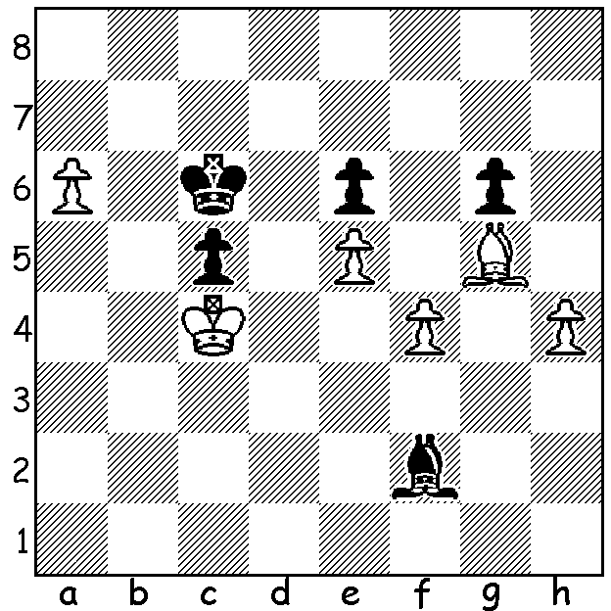
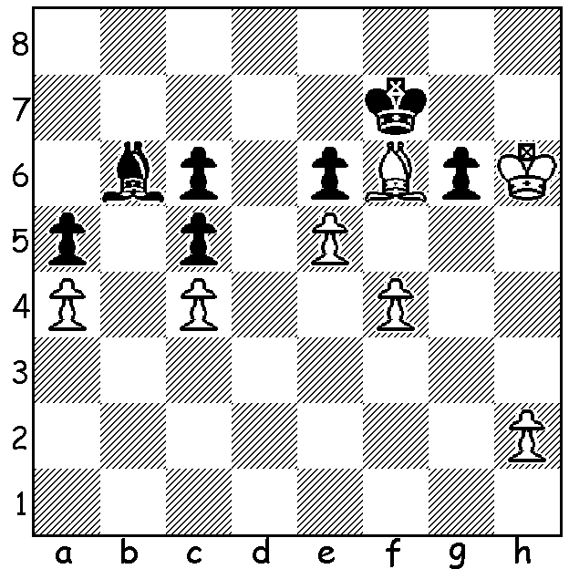

i) Hou Yifan – Koneru: White makes ii) Hou Yifan – Koneru: how does
a surprise move to break through. White promote a pawn?

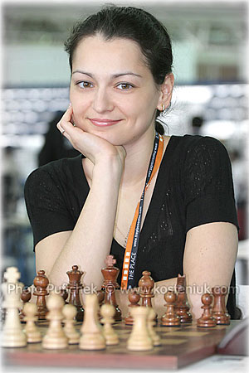
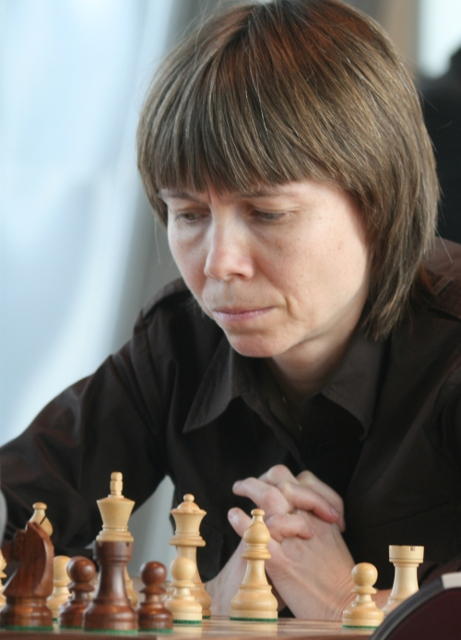
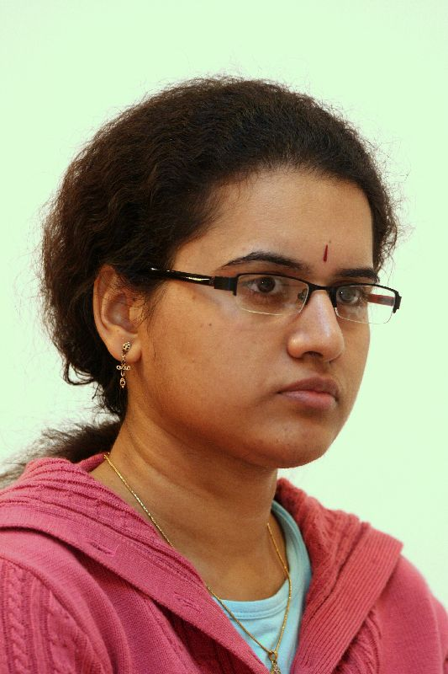

Pia Craming Alexandra Kosteniuk Humpy Koneru

And now a game from the event with the new world champion off to a sparkling start:

HOU YIFAN - HERIDIA SERRANO
Womens World Championship 2010, Rd 1
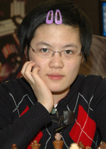
Caro-Kann Defence, Main Line
1.e4 c6 2.d4 d5
3.Nc3 dxe 4.Nxe4 Bf5
5.Ng3 Bg6 6.h4 h6
7.Nf3 Nd7 8.h5 Bh7
9.Bd3 Bxd3 10.Qxd3 e6
11.Bd2 Ngf6 12.0-0-0 Be7
13.Ne4 Nxe4 14.Qxe4 Nf6
15.Qd3 b5 16.Ne5 Qd5
17.Kb1 0-0 18.g4 Nd7
19.Nf3 c5 20.g5 hxg
21.Rdg1 c4 22.Qe3 b4
23.Bxb4! Bxb4 24.Rxg5 f5
25.h6 Rf7 26.hxg Rxg7
27.Rhg1 Bf8 28.Rxg7+ Bxg7
29.Qh6 Kf8 30.Rxg7 Ke8
31.Qh4 Qd6 32.Ng5 Qb4 New Womens World Champion
33.Qh5+ Kd8 34.Nxe6+ Kc8 HOU YIFAN
35.Qe8+ resigns

SOLUTION: i) 1.Be7!! putting Black in zugzwang. If 1..Ke7 2.Kxg6 Bd8 3.h4 Kf8 4.h5 Kg8 5.h6 Bh4 6.h7+ Kh8 7.Kf7 Kxh7 8.Kxe5 Kg8 9.Kd7 Kf7 10.f5 Be7 11.Kxc6 & wins. Black declined the piece offer and gave up a pawn, reaching the second diagram.
ii) 1.h5! gxh 2.f5! exf 3.e6 Bg3 4.e7 Kd7 5.a7 resigns.

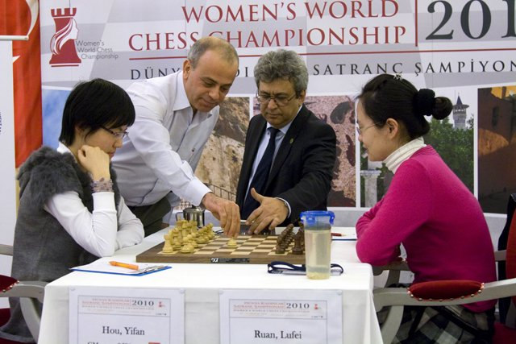

The final with Hou Yufin white against Ruan Lufei.

