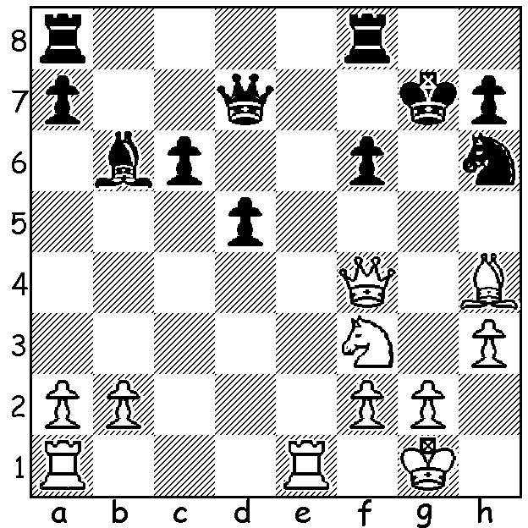
The most recent chess ratings have seen
Magnus Carlsen regain top spot, relegating
world champion Vishy Anand to second.
One of the big movers was former World
Junior Champion, Frenchman Maxine
Vachier-Lagrave who gained 12 points
and rose from 36th to 31st. Here is a very
recent win of his: Vachier-Lagrave – Peter
Nguyen (White to play & win, 4 moves):

366

HASTINGS INTERNATIONAL CHESS CONGRESS 2010-1011

The UK chess public was hoping for a home victory
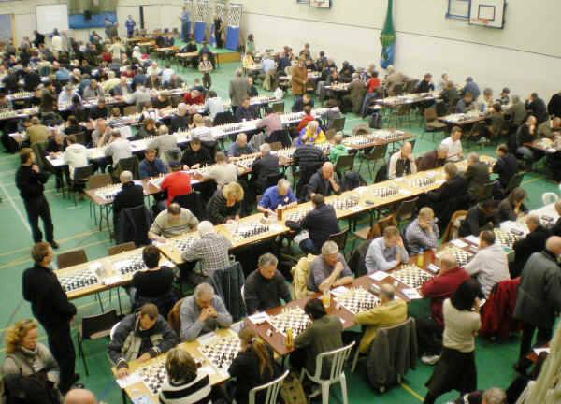
in the 87th Hastings Congress especially after the
brilliant start by 20 year old David Howell who reeled
off wins in his first five games. However he lost in
Round 6 to Edouard Romain (France) and then slipped
from top spot with 3 successive draws. Romain failed
to hold onto the lead, losing in the final round to Deep
Sengupta who took first place with fellow Indian
Arghyadip Das, both 7/9. Howell finished =3rd on
6.5. Australia’s Aleks Wohl had an excellent result
finishing =9th position with 6. The congress, played
from 28 Dec to 5 Jan with 10 GMs and 15 IMs among
the 103 competitors, is the longest running event in the
world and has over time attracted many of the leading
figures in world chess.
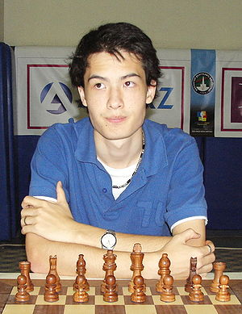
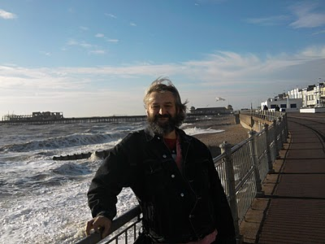

Aleks Wohl enjoying the sea air at Hastings David Howell

Here is a fascinating game from the event:
(Pictures below – joint winners Deep Sengupta (top) & Arghyadip Das)
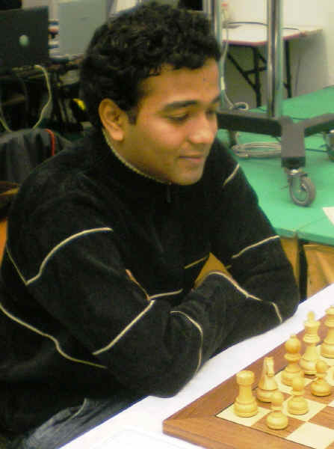
THOMAS RENDLE - DAVID HOWELL
87th Hastings 2010-2011
Caro-Kann, Exchange Variation
1.e4 c6 2.d4 d5
3.exd cxd 4.Bd3 Nc6
5.c3 Nf6 6.Bf4 Bg4
7.Qb3(a) Qc8 8.Nd2 e6
9.Ngf3 Be7 10.0-0 0-0
11.Ne5 Nxe5 12.dxe5 Nd7
13.Qc2 g6 14.h3 Bf5
15.Bxf5 gxf5(b) 16.Nf3 Kh8
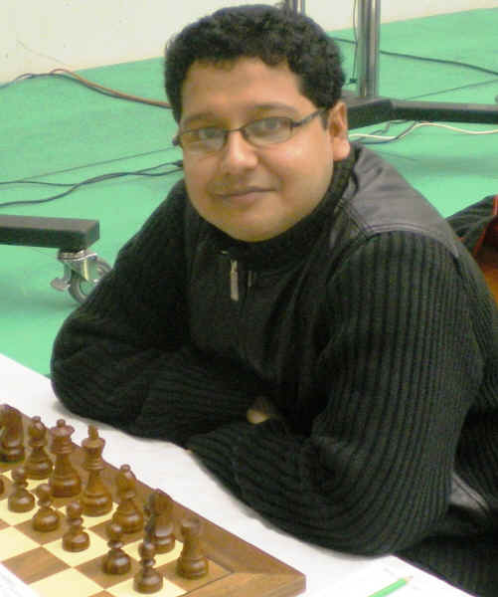
17.Ng5 Qc4 18.Qd2 Nc5
19.Rad1 Rac8 20.b3 Qa6
21.c4(c) dxc 22.Qe2 Bxg5
23.Bxg5 Ne4 24.Qh5 Rg8
25.Bh4 Rg6 26.f3 Qxa2
27.g4 Nc3 28.Rf2 Qxb3
29.Rd7 Rf8 30.Be7 Qb5
31.Rfd2 fxg! 32.Bxf8 gxf3+(d)
33.Kh2 Qb6 34.R7d4(e) Ne2
35.Qxf3 Nxd5 36.Qe3 Nf3+!
White resigns

a) This quiet exchange variation, as distinct from 4.c4 (Botvinnik-Panov Attack), was played successfully by Bobby Fischer against Tigran Petrosian (Rest of World v USSR 1970). Petrosian here played the inferior 7…Na5.
b) Black’s pawn position around his king is weakened but he hopes to use the half-open g file to attack.
c) A pawn sacrifice to enable White’s queen to get to h5 via e2.
d) 32.Qb6+ 33.Kh2 Ne2! is winning (34.Rxe2 gxf3).
e) In serious time trouble White misses the resource 34.Bg7+!!. If 34..Kxg7 35.Rxf7+! Kxf7 36.Qxh7+ with perpetual while 34…Rxg7? loses to 35.Rd8+ Rg8 36.Rxg8+ Kxg8 37.Qg5+. Howell despite his own serious time trouble planned 34…Kg8 and if 35.Qxg6+! hxg6 36.Bf6 g5 but again White has a perpetual in 37.Rd8+ Kh7 38.Rh8+ Kg6 39.Rg8+ Kf5 40.Rxg5+ Kf4 41.Rg4+ Kf5 (not 41.Ke3? Bg5#).

SOLUTION: 1.Bxf6+! Rxf6 2.Qg5+ Rg6 3.Re7+ Kf8 (3…Nf7 4.Qxg6+! hxg6 5.Rxd7) 4.Rxd7 resigns (after 4…Rxg5 5.Nxg5 with a winning material advantage).

