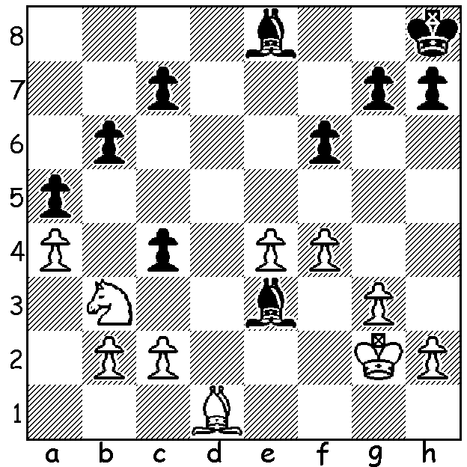
De la Villa – Illescas 2000 - under pressure
White hopes to obtain a draw by 1.Kf3 Bg1
(not 1…Bh4+ 2.g4) 2.Kg2 (not 2.Nd2 c3!).
However Black has foreseen a continuation
that now wins a piece or queens a pawn
(and can you guess the opening).

367

Diagram 366

Gordon Dunlop as Player Readers will recall that last December I began a
and Administrator series on Chess and Music. What provided the
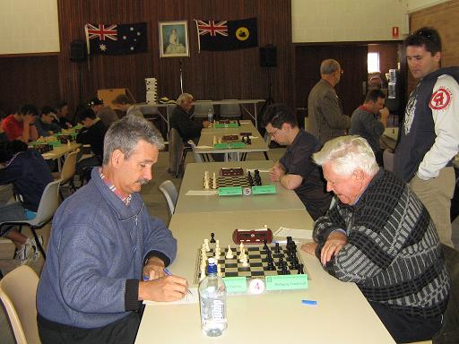
idea was a get-together late last year at the home
of Gordon and Chris Dunlop of members of the
WA chess community with an interest in music.
Present, besides Gordon and Chris, were ex-WA
champions Wolfgang Leonhardt, Richard Lilly
and myself, Norbert Muller, Wallace Sheridan
and Kelvin Taylor, together with wives/partners.
Music was performed during the afternoon by
Gordon, Wolfgang and myself. Whilst Gordon
was able to perform a Beethoven piano sonata
and items by Chopin and others composers without
music and Wolfgang played a very varied and
Gordon v Wolfgang Leonhardt extensive selection on the piano accordion, also
at 2006 WA Championship without music, my own contribution which included
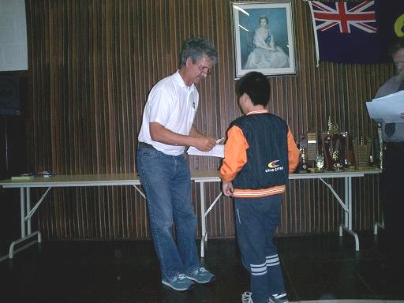
Ravel and Schubert needed the scores.
Gordon Dunlop has over the years been a very
regular competitor in WA events. Of note is his
participation in every WA state championship since
1983 (28 and hopefully still going), wining the WA
Reserves title on a number of occasions. He has also
organised and acted as DOP at many events including
Grand Prix, Harris Shield (inter-club competition) and
WA individual and teams Lightning Championships.
On the music side he studied Music at UWA (as well
as Applied Maths) and holds an Associate of Music
(AMusA). He is also an enthusiastic bridge player Gordon making presentation to Ryan and was a talented athlete, having recorded a time of
Sam at 2007 Christmas wind-up. 2.52 for the Bunbury Marathon in 1983.

Besides over the board chess Gordon plays correspondence chess (via the net) and sent me the following recently completed correspondence game:

WALTER BAUMANN - GORDON DUNLOP
Reti Opening: Advance Variation
1.Nf3 d5 2.c4 d4
3.c5(a) Nf6 4.e3 e5
5.Qa4+ Bd7 6.Qb3 Nc6
7.Bc4 Bxc5(b) 8.Bxf7+ Kf8
9.Ng5 Na5 10.Qc2 Qe7
11.a3 d3!(c) 12.Qc3 h6
13.Nf3 Nc6 14.Bb3(d) Bd6
15.0-0 g5 16.Bd1 e4
17.Nd4 Nxd4 18.exd4 Kg7
19.b4 h5 20.Qc4 b5
21.Qb3 Bxh2+! 22.Kxh2 Ng4+
23.Kg1(e) Qd6 24.g3 h4
25.d5 hxg3 26.Qc3+ Kg6
White resigns

a) This strange looking move opens the a2-g8 diagonal for use by White.
b) Relying on his superior development, Black is prepared for the displacement of his king.
c) This paralyses White’s queenside as 12.Qxd3 loses a piece to 12…h6.
d) 14.Ba2 is more natural, allowing the advance b4. Perhaps White was already thinking of a retreat to d1 to bolster the defence of the king.
e) If 23.Bxg4 hxg4+ and White is soon mated.

SOLUTION: (1.Kf3 Bg1 2.Kg1) 2…cxb3 3.Kxg1 Bh5! – a deflection sacrifice, queening after 4.Bxh5 bxc. The position has the pawn configuration of a Ruy Lopez Exchange (1.e4 e5 2.Nf3 Nc6 3.Bb5 a6 4.Bxc6 dxc6).

