The annual Wijk aan Zee (Netherlands) tournaments, now sponsored by Tata Steel, has three GM tournaments as well as a number of amateur events running simultaneously. The top event, a 14 player round robin, has the world’s four top players, Magnus Carlsen, world champion
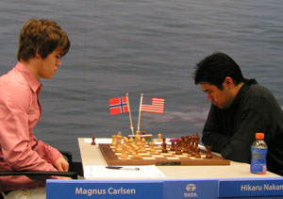
Vishy Anand, Levon Aronian
and ex-world champion Vladimir
Kramnik, as well as seven players
ranked 7th to 31st competing with three
top players from the Netherlands. In
Round 8 Carlsen threw the event wide
open beating US champion Hikaru
Nakamura to leave a bottleneck at
the top with Nakamura and Anand
on 5.5 and Carlsen, Levon Aronian
and Maxine Vachier-Lagrave on 5
with 5 rounds to be played.

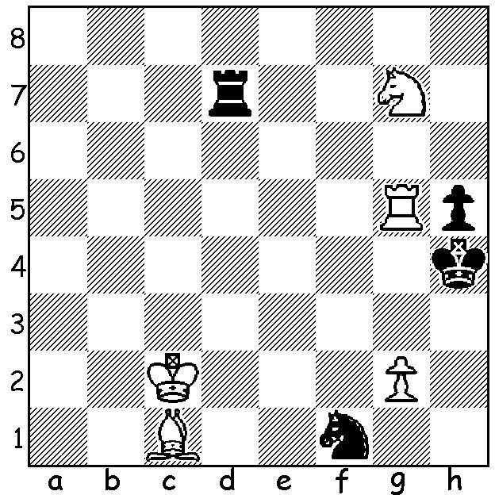

Here is a position from Carlsen (White)
against the Netherlands player L’Ami.
It looks like an easy win but Black has
a sensational tactical idea that enabled
him to obtain a drawn position. Can you
find it? (need a clue? – look at note a)

Diagram 368




Erwin L’Ami Anish Giri

The sensation of the event was the loss by Carlsen against 16 year old Anish Giri. It might be compared to Bernard Tomic beating Nadal at the Australian Tennis Open although Anish is ranked 52nd in the world while Tomic was 199th. Born in St Petersburg of a Nepalese father and a Russian
mother, Anish became the youngest ever GM at the age of 14. His family moved to Netherlands in 2008 and he qualified for this tournament by winning the B group last year.

Magnus Carlsen - Anish Giri
2011 Wijk aan Zee
Semi-Gruenfeld Defence
1.d4 Nf6 2.c4 g6
3.g3 Bg7 4.Bg2 d5
5.cxd5 Nxd5 6.Nf3(a) Nb6
7.Nc3 Nc6 8.e3 0-0
9.0-0 Re8 10.Re1 a5
11.Qd2(b) e5 12.d5 Nb4
13.e4 c6 14.a3 cxd5!
15.axb4 axb4 16.Rxa8 bxc3
17.bxc3 Nxa8 18.exd5 Nb6
19.Rd1? e4 20.Ng5??(c) e3
21.Qb2 Qxg5 22.Bxe3(d) Qg4
White resigns(e)

a) 6.e4 is more aggressive (Clue to problem: Black’s king has no move).
b) Very unusual: more normal are 11.Qe2, Qc2 or b3.
c) This is a blunder but if 20.Ne1 Na4 is good for Black.
d) 22.Qxb6 would enable Black to finish brilliantly with 22…e2 23.Re1 Qxc1! 24.Rxc1 e1Q+ 25.Rxe1 Rxe1+ 26.Bf1 Bh3.
e) If 23.f3 Qa4 attacking the rook again and Black remains a piece ahead.

SOLUTION: 1…Ne3+!! (Black attempts to sacrifice his two pieces for stalemate) 2.Bxe3 Rd2+!
3.Kc1+ Rd1+ 4.Kb2 Rd2+ 5.Kc3 Rd3+ 6.Kc4 Rxe3 (if 6…Rc3+ White’s king would escape the perpetual: now play hinges on Black’s attempt to win White’s last pawn) 7.Rxh5 Kg4 8.Rh2? (White would win with 8.Rh4+! Kg5 – if 8…Kxh4 9.Nf5+ - 9.Rh8 Kg6 – if 9…Rg3 10.Rg8 wins – 10.Ne8 Re2 11.Kd4 Kf7 12.g3! Rg2 – 12…Rxe8 loses - 13.Nd6+ Ke6 14.Ne4) 8…Re7 9.Nh5 Re5 10.Nf6+ Kg3 11.Rh7 Kxg2 with a drawn position. However L’Ami later blundered and lost in the R v R & N ending (WKe5, WRg1, WNf5, BKg4, BRa2: Black played 1…Kf3?? & resigned – 2.Nh4+ Kf2/e2 3.Rg2+)

