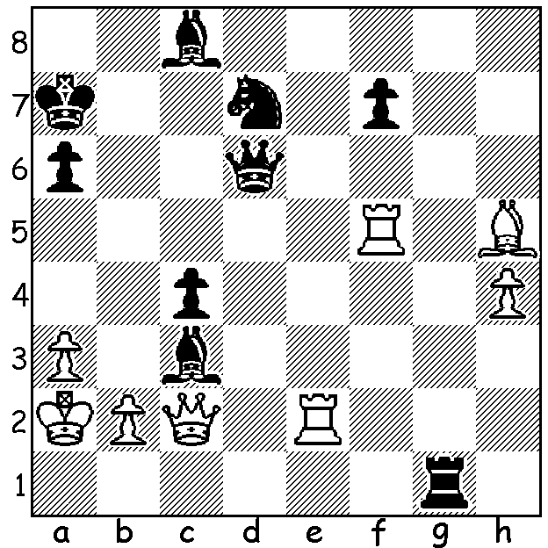

Sagalchik – Nakamura 2003:
a spectacular & speedy win
for Black:

Diagram 369

NAKAMURA WINS AT WIJK AAN ZEE
US champion Hikaru Nakamura won his first Super-GM tournament at the Tata Steel event (Wyjk aa Zee, Netherlands) with 9/13 (+6 =6 -1), just ahead of world champion Vishy Anand 8.5 (+4 =9) with Magnus Carlsen (+5 =6 -2) and Levon Aronian (+3 =10) sharing third place with 8 pts. 16 year old Anish Giri was the highest placed Netherlands player with a 50% score. The second of the three GM tournaments was won jointly by Luke McShane (Eng) and David Navara (Czech) with 8.5. Both will be invited to take part in the main event next year. One of the best games from the event was Carlsen’s win against Nakamura, a powerful kingside attack culminating in a piece sacrifice:

Magnus Carlsen - Hikaru Nakamura
Tata Steel (Wijk aan Zee) 2011, Rd 8
Sicilian, Najdorf Variation
1.e4 c5 2.Nf3 d6

3.d4 cxd 4.Nxd4 Nf6
5.Nc3 a6 6.Be2 e5
7.Nb3 Be7 8.Be3 0-0
9.g4 Be6 10.g5 Nfd7
11.h4 Nb6 12.Qd2 N8d7(a)
13.f4 exf 14.Bxf4 Ne5
15.0-0-0 Rc8 16.Kb1 Qc7
17.h5 Rfe8 18.Ka1(b) Bf8
19.Nd4 Qc5(c) 20.g6 Nec4
21.Bxc4 Nxc4 22.Qd3 fxg6
23.hxg6 h6 24.Qg3 Qb6
25.Bc1 Qa5 26.Rdf1 Ne5
27.Nd5 Bxd5 28.exd5 Qxd5
29.Bxh6! gxh6(d) 30.g7 Be7
31.Rxh6 Nf7 32.Qg6! Nxh6
33.Qxh6 Bf6 34.Qh8+ Kf7 Happy Hikaru, winner of Tata Steel
35.g8=Q+ Rxg8 36.Qxf6+ Ke8
37.Re1+ resigns (e)

a) 12…a5 (Nunn’s Chess Openings)
b) Carlsen was pleased with this prophylactic move which avoids a possible …`Qxc2+.
c) 19…g6 has been suggested as an improvement but Black’s game is clearly inferior.
d) If 29…Qxd4 30.Be3 Qg4 31.Rh8+! Kxh8 32.Qh2+ mates.
e) 37…Qe5 38.Rxe5+ dxe5 39.Qe6+ wins.

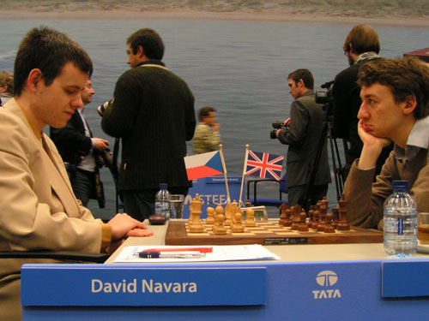

David Navara & Like McShane, joint winners of Tata Steel B
pair off in the last round: the game was drawn.

HUMOUR IN CHESS: I’ve recently come across a list of films with chess themes. It includes a number with chess player names such as ‘Capablanca’, ‘The Fischer King’, ‘Korchnoi’s Complaint’ ‘Kasparov the Friendly Ghost’ and ‘Svidler on the Roof’. A few came to my mind: ‘North to Lasker’, ‘The Bird’s’ (1.f4) and its sequel ‘From – Here to Eternity’ (1.f4 e5)

SOLUTION: 1…Qxa3+!! 2.Kxa3 or bxa3 Ra1#.

