CHESS & MUSIC: Wolfgang Leonhardt (1)
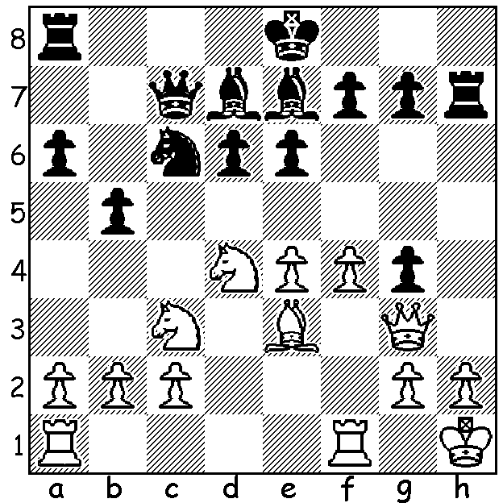
In 1965 in the first round of the Australian Chess Championship in Hobart defending champion John Purdy was beaten by WA’s Wolfgang Leonhardt. Here is the crucial position after 1.Qg3? How does Black take advantage of this error (4/5 moves)?

Diagram 370

Wolfgang Leonhardt was born in 1928 in Berlin of a Russian father and a German mother. He was taught to play chess at the age of five by his father and became Berlin Under 12 champion in 1939. After evacuation to Czechoslovakia to escape air raids and subsequent university studies in Rothenburg he began work as interpreter for the Australian Refugee Organisation in Schweinfurt. His family moved to WA in 1950. Between 1952 and 1972 Wolfgang won the WA championship eight times. In 1969 he joined Lufthansa as Manager in WA before moving to New Zealand as Lufthansa manager for NZ and the Pacific Islands. His work commitments curtailed his chess activities to some extent but he did win the biannual Lufthansa (worldwide staff of 55,000) world championship five times between 1974 & 1992 as well as regularly representing Lufthansa on Board 1 in the International Airlines championships. After his return to WA in 1999 Wolfgang continued to show his chess talent by sharing first place in the popular Yanchep/Two Rocks Allegro and then in 2001 at the age of 72 coming 2nd WA championship as well as being joint winner of the Metro Championship and winner of the Metro Respini tournament. His music talent and activity in that and other fields will be left to next week. Here is fine game against another former WA champion (now deceased):

Wolfgang Leonhardt - Jim Raudzins
City of Perth Championship 1966
Ruy Lopez: Closed Defence
1.e4 e5 2.Nf3 Nc6
3.Bb5 a6 4.Ba4 Nf6
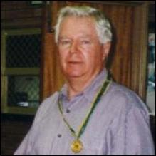
5.0-0 b5 6.Bb3 Be7
7.d4 exd 8.e5 Ne4
9.Bd5 Nc5 10.Nxd4 Bb7
11.Nf5(a) 0-0 12.f4 Kh8(b)
13.b3 Ne6 14.Nc3 f6(c)
15.Ne4 fxe 16.fxe Rb8
17.Bb2 Rf7 18.Qd2 Qf8(d)
19.Nfg3 Bh4 20.Rxf7 Qxf7
21.Rf1 Qg6 22.Nf5 Bg5(e)
23.Nxg5 Nxg5(f) 24.e6! Nxe6
25.Nxg7! Nxg7 26.Rf7 Rg8
27.Bxg7+ Rxg7 28.Rf8+ Rg8
29.Qc3+ Qg7 30.Rxg8#

a) Given as Sliva-Cuellar 1958 in MCO 10th edition as a slight advantage to White.
b) Prophylaxis – meeting the threat of 13.Qg4 g6 14.Rf3 with a strong attack.
c) This attempt to free Black’s game will be shown to be weakening by White’s forceful play. More logical would be an attempt to relieve Black’s game by seeking to exchange the white bishops.
d) Doubling but it’s White who will take control of the f file: the ugly 18…Na7 seems better.
e) Fatally allowing the opening of the a1-h8 diagonal.
f) 23…Qxg5 is no better - 24.Qxg5 Nxg5 25.e6! dxe (25…Nxe6 26.Nxg7! Nxg7 27.Rf7 Rg8 28.Bxg7+ Rxg7 29.Rf8+) 26.Bxg7+ Kg8 27.Bb2! exd4 28.Nh6#.

THE KINGSLEY OPEN (Sat 19 / Sun 20 Feb) is the first Grand Prix event of 2011. Details on web cawa.org.au or contact Haydn Barber 9398 4242.

SOLUTION: 1…Bh4! 2.Qxg4 Nxd4 3.Bxd4 e4 (attacking queen & bishop): White now tried 4.Nd5 Qb7 (not 4…Qc4? 5.Qxd7+! Kxd7 6.Nb6+ nor 4…Qxc2? 5.Qf3 exf4 6.Rfc1 / 7.Nc7+) 5.Qd1 exd4 & White soon resigned. Wolfgang also defeated many times Australian champion Garry Koshnitsky on the way to 3rd place.

