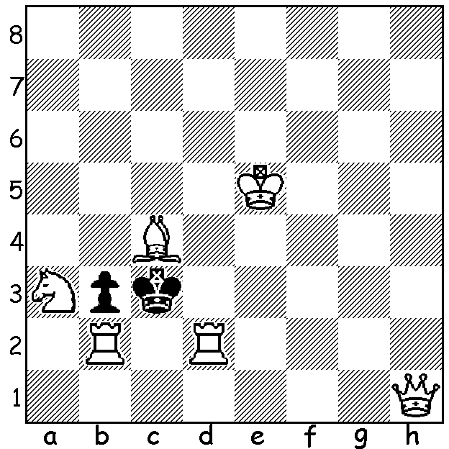
If we remember the thoughts of the famous
problem composer Sam Loyd –“My theory
of a key move is always to make it just the
reverse of what a player in 999 cases out of
a thousand would look for” – the position
below (Katz 1937) with White to play and
mate in two will be quite simple to solve:

Diagram 371

CHESS & MUSIC: Wolfgang Leonhardt (2)

Last week we looked at the chess career of eight-times WA champion Wolfgang Leonhardt. Today we look at his many achievements away from the chess board, particularly in the field of music. Wolfgang showed musical promise at the age of four, being able to sing many folk and pop songs, some after only one hearing. At five he began to play the zither, followed by the violin and then the piano, although piano lessons only lasted for nine months due to the Depression. Aged 16 Wolfgang joined a local orchestra in Rothenburg playing piano, accordion and, something new, saxophone as well as travelling to Wurzburg three times a week to study clarinet, theory, musical history and conducting. He moved to Bad Kissingen and joined the only Youth Band in Europe, The Hep Cats, on clarinet and saxophone. The band played on US air bases and various theatres and provided the background music for the film One Step Forward. His musical ‘career’ came to a halt when starting work in Schweinfurt for the Australian Military Mission screening would-be migrants. His family came to Western Australia in 1950 and was taken to a camp in Northam housing about 10,000 migrants. Here Wolfgang’s musical talents were in great demand and he remembers winning a musical marathon, playing the accordion for 24 hours without repeating one tune. After settling in Perth Wolfgang learnt the balalaika to join a balalaika orchestra and also played in the seven piece club band at the Rhein Donau Club, a club he helped to establish and served as president 1967-69. His musical ‘career’ finally finished when joining Lufthansa in a position demanding nearly all his time.

In an amazingly active life Wolfgang has pursued with great distinction a successful career, family life and two very demanding interests, chess and music. He was also for many years President of the German Association of NZ, the Auckland Goethe Society and the NZ German Student Exchange Society. He also initiated and moderated the Deutsche Stunde, a German language broadcast from 1991 until 1999. In 1955 Wolfgang was awarded the Federal Cross of Merit by the President of the German Federal Republic. He has been President of the Chess Association of WA and has taught chess at various schools around Perth (and continues to do so). For his achievements and services to chess Wolfgang has been awarded Honorary Life Memberships of the Perth Chess Club, the Chess Association of WA and the Australian Chess Federation.

The World Airlines Championships took Wolfgang all round the world including such places as Madrid, Bangkok, Honolulu, Reykjavik, Miami, Lisbon and Katmandu. Here is delightful miniature he played representing Lufthansa:

B. Muzafar - W. Leonhardt
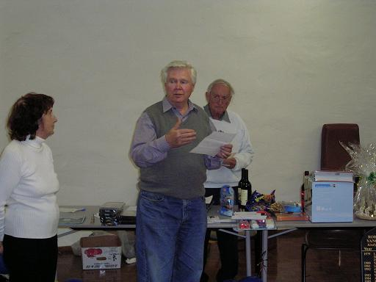
XII International Championships 1989, Las Vegas
Queens Indian Defence
1.Nf3 Nf6 2.d4 e6
3.e3 c5 4.Bd3 Nc6
5.Nbd2 b6 6.b3 cxd
7.exd Bb7 8.0-0 Nd5
9.c4 Nf4 10.Bb1 Nxd4!
11.Bb2(a) Nde2+ 12.Kh1 Qg5!!
13.Rg1 Qg4 14.h3 Qh5
15.Be4 Bxe4 16.Nxe4 Nxh3!
17.Nh2 Nxf2+! 18.Nxf2 Ng3#
Wolfgang officiating at Yanchep/Two
a) If 11.Nxd4? Qg5 12.g3 Nh3#. Rocks Prize-Giving 2006
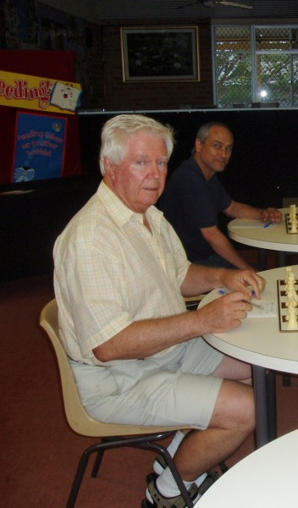
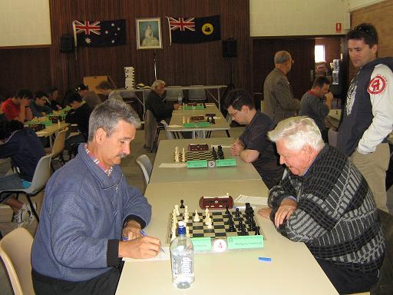

Wolfgang at Perth Club (left) and
playing fellow musician Gordon Dunlop
in WA Championship 2006 (above)

THE KINGSLEY OPEN (tomorrow and Sun 20 at Moresby St. Centre) is the first Grand Prix event of 2011 (details on cawa.org.au). Contact Haydn Barber 9398 4242 or hadix@vianet.net.au today for a $10 entry discount.

SOLUTION: 1.Nc2!! (putting all 4 pieces near Black’s king en prise but cutting off the escape square on b4): if 1…Kxb2 2.Qa1#: if 1...Kxd2 2.Qe1#: if 1…bxc2 2.Rdxc2#: if 1…Kxc4 2.Qc6#.

