For the past two weeks we have looked at the life of WA’s ‘Grand Old Man of Chess’, Wolfgang Leonhardt (I hope he is not offended by the term). Today focus is on the world’s ‘Grand Old Man of Chess’, Viktor Korchnoi. Now 79, Korchnoi continues to compete regularly in top tournaments with his last outing being at the Gibraltar Open, played last month with a field of 232 including 53 GMs.
Winner was Vassily Ivanchuk (Ukraine) with a superb score of 9/10 with Nigel Short (UK) only a half point behind on 8.5. Below is a position from the event in which Korchnoi missed a winning line against Paco Vallejo Pons (Spain) which, had it been seen, may have won the veteran the Best Game Prize (White to play: 5+ moves).

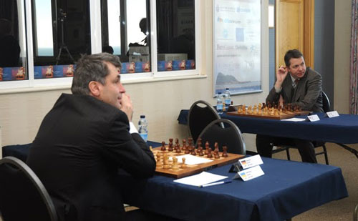
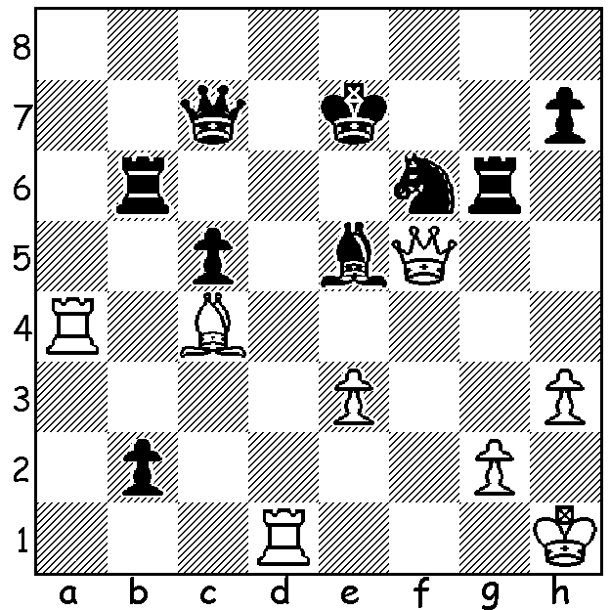
Ivanchuk (left) & Short awaiting
Diagram 372 their opponents in Gibraltar.

Here is a fine attacking win by ‘Viktor the Terrible’ from the event in which he outplays one of the top young GMs, 18 year old Fabiano Caruana (Italy), ranked 25th in the world:

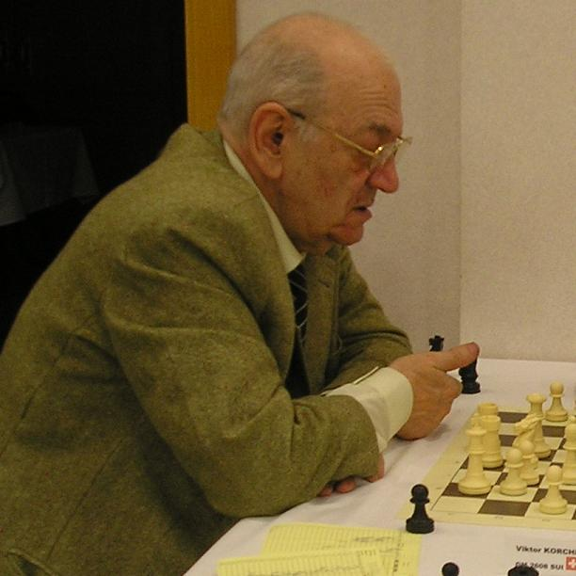
Fabiano Caruana - Viktor Korchnoi
2011 Gibraltar Open, Rd 2
Ruy Lopez
1.e4 e5 2.Nf3 Nc6
3.Bb5 a6 4.Ba4 Nf6
5.d3(a) d6 6.c3 Be7
7.0-0 0-0 8.Re1 Nd7(b)
9.Be3 Nb6 10.Bb3 Kh8
11.Nbd2 f5 12.Bxb6 cxb6
13.Bd5 g5! 14.h3 g4
15.hxg4 fxg4 16.Nh2 Bg5

a) This quiet continuation is now frequently played
to avoid the dangerous Marshall Attack - 6.0-0 Be7
6.Re1 b5 7.Bb3 0-0 8.c3 d5!?
b) A clever choice, this move was first played 100
years ago by Maroczy and was out of fashion well
before Caruana was born.
17.Nc4 b5 18.Ne3 Bxe3
19.Rxe3 Qf6 20.Qe1 Ne7
21.f3 Nxd5 22.exd5 Rg8
23.Qg3(c) gxf3 24.Qxf3 Bf5(d)
25.Rf1 Rg5 26.Kh1 Qh6!
27.Rf2 Rag8!(e) 28.Re1 Qg6
29.Re3 Bxd3! 30.Kg1(f) e4
31.Qh3 Rxd5 32.Qd7 Rg5
33.g4 Qh6 34.Rf7 R5g7(g)
35.Rxg7 Rxg7 36.Qd8+ Rg8
37.Qb6 Qf6!(h) 38.Qxb7 Rf8
39.Qa7 b4 40.Rh3(i) Qg7
41.Qe3 bxc3 42.bxc3 Qxc3
43.Rh5 d5 44.g5(j) Qa1+
45.Kg2 Bf1+ 46.Kg3 Qe5+
White resigns(k)

c) Preventing 23…g3.
d) Black doesn’t fear putting his bishop in a pin.
e) Threatening 28…Bh3 29.Qxh3 (29.gxh3 Rg1#) 29…Rh6.
f) Not 30.Rxd3 e4.
g) Stops the possible danger of Kg2/Rh3.
h) Happily giving back one pawn to increase pressure on White.
i) If 40.cxb4 Qxb2 while 40.Qd4 Qxd4 41.cxd4 would leave White with an imprisoned knight.
j) Not 44.Rxd5? Qa1+ 45.Kg2 Qxa2+ wins rook.
k) 47.Kg4 d4 48.Qc1 (48.Qd2 e3) 48…Be2+ wins.

SOLUTION: 1.Ra7! (a winning deflection sacrifice) 1…Qxa7 2.Qxe5+ Kf8 3.Rd8+ Kg7 4.Rg8+ Kh6 5.Qf4+ & soon mates.

