In Hunt – Quinn (2010) Black has a clever draw (5 moves):

Diagram 373 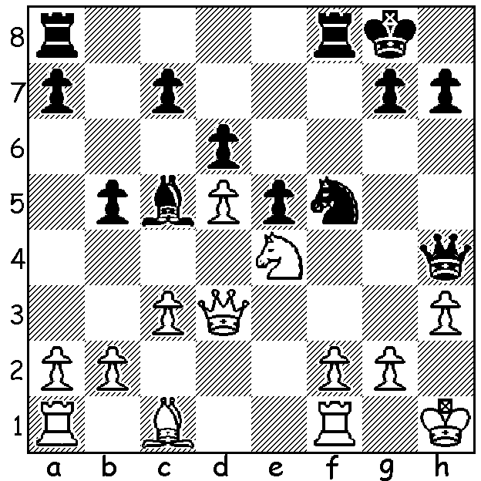

Last week I reported on the 2011 Gibraltar Open won by Vassily Ivanchuk (Ukraine) with score of 9/10 with Nigel Short (UK) second on 8.5. A game and a position from 79 year old Viktor Korchnoi at Gibraltar were featured. Today we stay with the tournament to see the game which earned the winner, Victor Makhalevski, the £1000 Best Played Game Prize. Makhalevski was born in 1972 in Belarus and emigrated with his family to Israel in 1991.

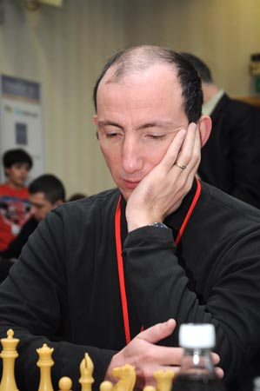
Varuzhan Akobian - Victor Mikhalevski
Queens Pawn, Benoni Defence
2011 Gibraltar Open, Rd 6
1.d4 Nf6 2.c4 g6
3.f3 c5 4.d5 Bg7
5.e4 d6 6.Nc3 0–0
7.Bg5 h6 8.Be3 e6
9.Qd2 exd5 10.cxd5 Re8
11.Nge2(a) Nbd7 12.Ng3 h5
13.Be2 a6 14.0–0 b5
15.Bh6 h4 16.Nh1(b) Nh5
17.Bxg7 Kxg7 18.a4 b4
19.Nd1 f5 20.exf5 Nb6!?
21.fxg6 Rxe2! 22.Qxe2 Nf4
23.Qe4 Qg5 24.g4(c) Nh3+
25.Kg2 Nf4+ 26.Kg1 Bd7
27.Ne3 Nh3+ 28.Kg2 Nf4+
29.Kg1 Re8 30.Nf5+ Kg8
31.Qb1 Nh3+ 32.Kg2 Nf4+
33.Kg1 Nh3+ 34.Kg2 Nxd5!
35.Nf2(d) Re2 36.Nxd6 Bxg4!
White resigns Victor Mikhalevski at Gibraltar.

a) If 11.Bxh6? Nxe4! & 12…Qh4+ regains the piece with advantage.
b) 16.Nf5 seems better - 16...gxf5 17.Qg5 Nh5 18.Qxh5 Bxh6 19.Qxh6 Qf6.
c) Meeting the dual threats of 24…Nh3# & 24…Qxg2#
d) 35.Kxh3?? Nf4#.

2011 WA OPEN CHAMPIONSHIP, a 7 round Swiss tournament, will be held March 12, 13, 19, 20. Entry at cawa.org.au or phone Haydn Barber 9398 4242. The top three players qualify for the
WA Closed Championship and the top scoring female will be WA Womens Champion.

CHESS FILM NAMES: ‘The Pawn that would be Queen’, ‘The Giuoco Piano’, ‘The Castle’, ‘All the Kings Men’, ‘Invasion of the Pawn Snatchers’, ‘Lord of the Kings’, ‘Snow White and the Seven Pawns’, ‘Deep Throat’ et alia (Pawn Movies) and a personal, ‘Ellis in Blunderland’.

SOLUTION: 1…Qxe4!! 2.Qxe4 Ng3+ 3.fxg3 Rxf1+ 4.Kh2 Bg1+ 5.Kh1 Bc5+ with a seesaw repetition.

