WOMENS GRAND PRIX

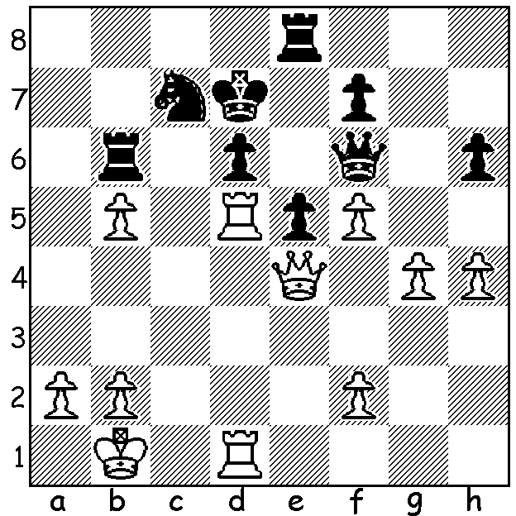

In Xu Yuhua – Pia Cramling (Qatar Womens
Grand Prix 2011) White has given up a knight
for three pawns. However Black is forking rook and pawn and hopes to establish a knight on d4 and win. White’s next move puts paid
to any Black chances (3-10 moves):

Diagram 374

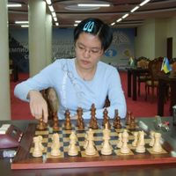
In January I reported on the Womens World
Championship, a 64 player Knock Out, won
by 16 year old Hou Yifan (China). To find a
challenger FIDE had planned a series of six
Grand Prix events over two years, each with
up to 14 of the world’s best female players.
Competitors could play in four of the events
with the best three to count with points ranging
from 160 for top place down to 10. In the final
event in Qatar it appeared as if Nana Dragnidze
(Georgia), who had scored well in three events,
might well qualify after beating her main rival World Champion Hou Yifan
Humpy Koneru (India) in Rd 1. Koneru, who
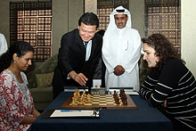
needed at least a =1st at Qatar, trailed tournament
leader Elina Danielian (Armenia) by 2 points with
four rounds to go but victory for Koneru over
Danielian in Rd 8 narrowed the gap to one point.
With 5.5 points from her last six games Koneru
succeeded in catching Danielian who lost her
penultimate game and drew the final round. The
leading Grand Prix players were: 1st Hou Yifan
410, 2nd Humpy Koneru 398.3, 3rd Nana Dragnidze
390. Elina Danielian was 5th with 358.

I had saved the following game in expectation that
I would be announcing Dragnidze as the challenger Humpy Koneru (L) v Nana Draghidze
to Hou. It was a sparkling win by Dragnidze at the in Round 1
recent Gibraltar Open where she gained the top
female prize:

Nana Dzagnidze - Francisco Vallejo Pons
Queens Pawn, King’s Indian Defence
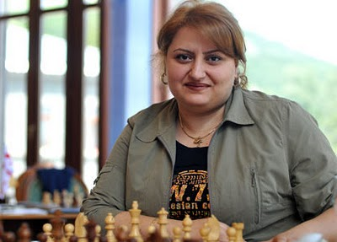
2011 Gibralatar Open, Round 6
1.d4 Nf6 2.c4 g6
3.Nc3 Bg7 4.g3 0–0
5.Bg2 d6 6.Nf3 Nc6
7.0–0 a6 8.e4 Rb8
9.h3 b5 10.e5 Ne8
11.Ng5 Na5 12.e6!? Bxe6
13.Nxe6 fxe6 14.c5 e5
15.dxe5 Bxe5 16.Bg5 Nc4
17.Nd5 Nf6 18.b3! Bxa1
19.Qxa1 Ne5 20.f4 Nd3?!(a)
21.c6 Rf7 22.Rd1 Nc5
23.Re1! Qf8 24.Rxe7! Rxe7 Elina Danielian who started with 6.5/7
25.Nxf6+ Kf7 26.Bd5+ Ne6(b) before 1.5 in her final four rounds
27.Nd7 Qh8 28.Bf6 Qg8 enabled Humpy Koneru to catch her.
29.Bxe7 Kxe7 30.Qf6+ resigns

a) 20...Ned7 (21.c6 Nb6) looks better.
b) If 26...Re6 27.Nd7 Nxd7 28.cxd7 Qh8 29.Qxh8 Rxh8 30.d8=N+ Rxd8 31.Bxd8 wins.

2011 WA OPEN CHAMPIONSHIP, a 7 round Swiss tournament, will be held March 12, 13, 19, 20 at Moresby St. Centre (start 12.30 tomorrow). Entry at cawa.org.au or phone Haydn Barber 9398 4242. Late entries accepted up to noon tomorrow. The top three players qualify for the WA Closed Championship and the top scoring female will be WA Womens Champion.

SOLUTION: 1.Rxd6+!! Qxd6 (1…Rxd6 loses quickly to 2.Qc6+) 2.Rxd6+ Rxd6 3.Qb7: while material is approximately level with Q + 4p v 2R +N Black’s pieces are not coordinated, her king is exposed and the b pawn will cost her the knight. Play continued 3…Rc8 4.b6 Rd1+ 5.Kc2 Rd5 6.Qa7! (now Black has for the moment prevented 6.bxc7 White now threatens 7.b7 / 8.b8=Q) 6…Rb5 7.Kb1 Kd6 8.bxc7 Rxc7 9.Qa6+ Kc5 10.Qxh6 and there are far too many extra White pawns.

