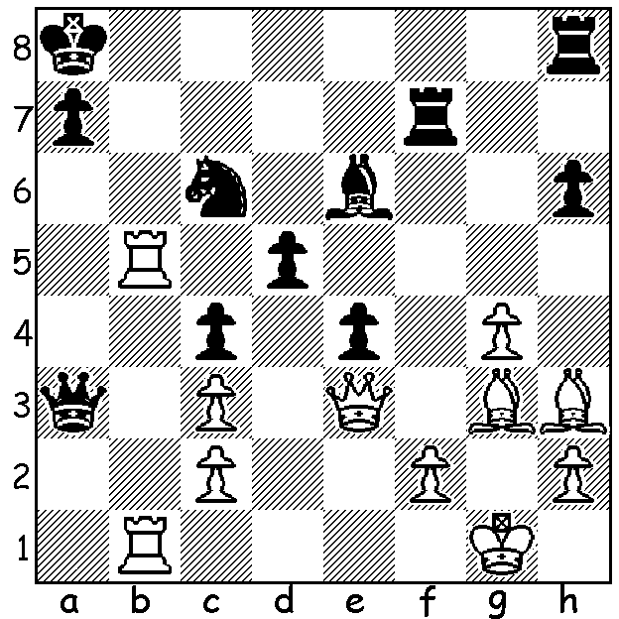
Fischer – Weinstein 1960:

after White’s next move

Black resigns.

Diagram 376

Bobby Fischer’s Estate

Last September I reported on the various claims to the $2 million estate of Bobby Fischer. Fischer had died in Iceland in January 2008 aged 64 leaving no will. In 2010 Fischer’s body was exhumed to determine whether he was the father of nine-year-old Filipino girl Jinky Young, whose mother Marilyn said she had had a relationship with Fischer. The Youngs had flown to Iceland from the Philippines to provide a blood sample, but DNA testing proved Jinky was not Fischer's child. This left Fischer’s two nephews and Miyoko Watai, who claimed to have married Fischer in Japan, as the remaining claimants. Earlier this month the Reykjavik District Court ruled that fresh documents presented by Miyoko Watai proved that her 2004 wedding with Fischer was legal and she was the rightful heir and the nephews should pay her $57,000 in legal costs. An appropriate game this week is surely a Fischer win in Iceland where Fischer wrested the world title from Boris Spassky and where he lived his last days after being granted Icelandic citizenship:


GUDMUNDSSON - FISCHER

Reykjavik 1960
Grunfeld Defence
1.d4 Nf6 2.Nf3 d5
3.e3 g6 4.c4 Bg7
5.Nc3 0-0 6.Qb3 e6
7.Be2 Nc6 8.Qc2(a) dxc
9.Bxc4 e5!? 10.dxe Ng4
11.0-0(b) Ncxe5 12.Nxe5 Nxe5

13.Be2 c6 14.f4(c) Ng4!
15.h3 Bf5! 16.e4?(d) Qd4+
17.Kh1 Nf2+ 18.Rxf2 Qxf2
19.exf5 Bxc3! 20.bxc3 Rae8
21.Bd3 Re1+ 22.Kh2 Qg1+
23.Kg3 Rfe8 24.Rb1?(e) gxf5
25.Bd2 Rxb1 26.Qxb1 Qxb1
27.Bxb1 Re2 White resigns(f)

a) Black threatened 8...Na5 9.Qc2 Nxc4 gaining the two bishops; the alternative 8.cxd leaves Black with the more promising game.
b) Better 11.e6! Bxe6 12.Bxe6 fxe6 13.0-0 (not 13.Qe4 Nce5! 14.Nxe5? Nxf2 15.Qc4 Bxe5 16.Qxe6+ Rf7 17.Qxe5 Nd3+ wins) and Black’s best might be 13…Rxf3! 14.gxf3 Qh4! 15.fxg4 Qxg4+ drawing by perpetual check.
c) 14.e4 would invite 14…Qh4 15.h3 g5! with a strong attack.
d) Appears to win material but Black has seen further; White should play 16.Qb3.
e) An incredibly complicated position: best seems 24.fxg hxg 25.Rb1 (25.Bxg6 R1e2! 26.Bxf7+ Kh8! 27.Qf5 Rxg2+ 28.Kh4 Qe1+ 29.Kh5 Kg7! 30.Bxe8 Qxe8+ 31.Kh4 Qd8+ 32.Qg5+ Rxg5 & wins) 25…R8e3+! 26.Bxe3 Rxe3+ 27.Kg4 Qh2 28.Qf2 Rxd3 29.Rb2! (29.Rxb7? Rxh3 30.Rb8+ Kh7 31.f5 Rh6 wins) 29…Rxc3 30.Rd2 with some chances.
f) A bishop is lost after 28.Bc1 Re1.

SOLUTION: 1.Qxh6! resigns (1…Rxh6 2.Rb8+ Nxb8 3.Rxb8# or 1…Re8 2.Qxe6!).

