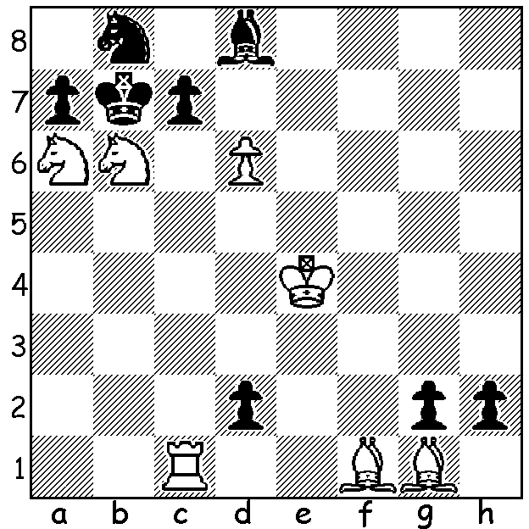

It’s not too difficult to work out the
theme of today’s problem with White
to play & mate in two (Morse 1989):

Diagram 377

The Australian March Ratings would have left most players happy with adjustments giving an average increase of 60 points. WA’s top player Tristan Boyd on 2349 is ranked 18th in Australia, Stephanus Kurniawan (2252) 40th and Yita Choong (2222) 48th (Yita is also ranked 9th Australian Under 20). In the junior ranks Aston Taminsjah (1811) is ranked 13th in the Under 14 age group and Natalie Maris (1668) is 8th among female players. In the Senior classification (60+) Haydn Barber is 3rd on 2104, David Ellis 9th on 2026 while Dave Dempster and Wolfgang Leonhardt are also in the top 20. Today’s game is a win by 18 year old Yita Choong now in his 4th year at UWA. Despite a fast time limit of 60 mins + 10 sec per move Yita invites intense complications in a search for a win against the 2009 WA Grand Prix winner Dennis Holland (annotations based on notes supplied by Yita):

YITA CHOONG - DENNIS HOLLAND
Kingsley Open, Rd 2: Feb 2011
French Defence, Rubinstein Variation
1.e4 e6 2.d4 d5
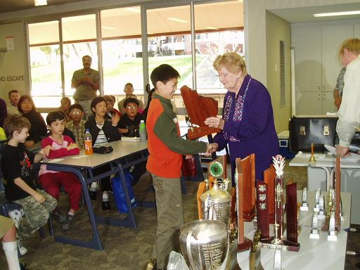
3.Nd2 dxe 4.Nxe4 Nd7
5.Nf3 Be7 6.c3 Ngf6
7.Nxf6+ Bxf6 8.Bd3 c5
9.0-0 cxd 10.cxd 0-0
11.Bf4 Qa5 12.Qc2 Qh5
13.Rfe1 Nb6 14.Ne5 Nd5
15.g4!?(a) Qh3 16.Bf1 Qh4
17.Bg3 Qh6 18.Qe4 Bh4
19.f4 Bxg3 20.hxg3 g5!(b)
21.Bd3(c) gxf4 22.Kg2 f5
23.gxf5 Ne3+ 24.Rxe3! fxe3
25.Rh1?(d) Qg7?(e) 26.f6 Rxf6
27.Rxh7 Rf2+ 28.Kg1?(f) Qxg3+
29.Kh1 Rf5 30.Rh4 Qe1+ Yita Choong, WA Junior Champion 2005
31.Kh2 Qf2+?(g) 32.Kh3 Kf8
33.Qg4 Ke7 34.Rh7+ Kd6
35.Qe4 b5(h) 36.Qc6#

a) Trying to exploit the position of Black’s queen: 15.Bd2 was safer.
b) Black prevents a White pawn steamroller.
c) A risky move: the safer 21.f5 would maintain White’s advantage.
d) Too hasty: 25.f6 would ensure the win.
e) Black misses his chance – 25…exf5! - although White remains with strong attacking chances.
f) White forgot h3 was available for the king.
g) The fatal error allowing White’s queen in via the g file: the immediate 31…Kf8 was necessary.
h) To stop 36.Nc4#.

The Kingsley Open (WA Grand Prix) was won by Yita Choong with 5/6 with Gordon Dunlop (4.5) second and Tom Donaldson and David Ellis =3rd on 4. First Under 1850 was Ned Tomic on 4 and first Under 1750 was Aston Taminsjay also
on 4.


The W A Open was won for the second year
running by David Ellis with 6/7 although the
sensation of the tournament was the performance
of 13 year old Aston Taminsjay who played six
of the top ranked players and finished unbeaten
to gain second place with 5.5. Natalie Maris (4)
played strongly to gain the WA Women’s title.

SOLUTION: The theme is clearly promotion in which White foils all three Black queen promotions with capture with promotions of his own: 1.dxc7! (threatening 2.c8=Q#, 2.cxb8=Q# and 2.cxd8=N#) meeting 1…dxc1=Q with 2.cxd8=N#, 1…gxf1=Q with 2.c8=Q# & 1…hxg1=Q with 2…cxb8=Q#: if 1…Bxc7 2.Rxc7#, 1…axb6 2.cxb8=Q#, 1…Nxa6 or 1…Nc6/d7 2.c8=Q#.

