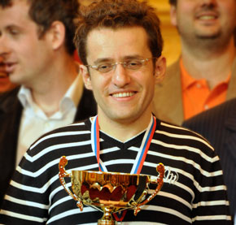
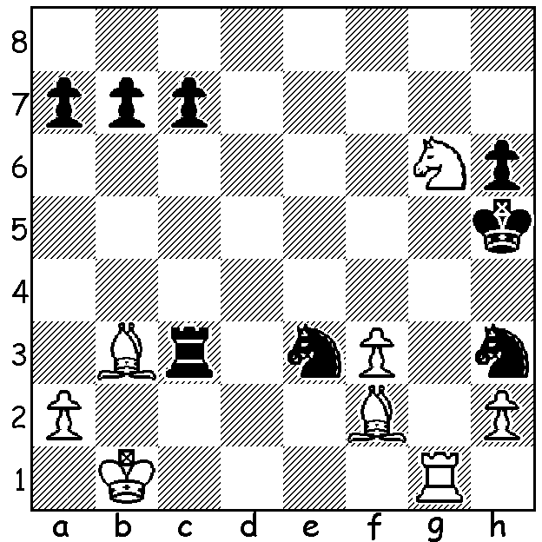

Aronian – Kramnik (Amber
2011, Blindfold Rd 9): with all
his pieces under attack how does
White win (3 moves)?

Amber winner Levon Aronian
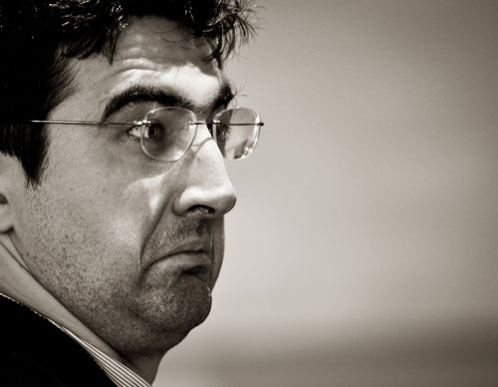
Diagram 379

The 20th (and unfortunately the last) annual Amber Blindfold
& Rapid-Play Tournament played in Nice concluded last month
with victory going to the Armenian GM Levon Aronian with
15.5/22, losing only one Rapid game. Second was Magnus Carlsen
(Norway) on 14.5 who scored a record 9.5/11 in Rapid, and third
world champion Viswanathan Anand (India) with 13. Other scores:
Vassily Ivanchuk (Ukraine) and Alexander Grischuk (Russia) 11, A far from happy Vladimir Kramnik
Hikaru Nakamura (USA), Boris Gelfand (Israel), Veselin Topalov

(Bulgaria) & Vugar Gashimov (Azerbijan) 10.5, Sergey Karjakin
(Russia) 10, former world champion Vladimir Kramnik (Russia) 8,
16 year old Anish Giri (Netherlands) 7. Time limits were 25 mins
+10 sec Rapid & 25 mins + 20 sec Blindfold. In the Blindfold each
player faced a computer screen showing an empty chess board and
printed out his moves which were shown instantly to the spectators
and watchers on web sites throughout the world. Here is a game
from the tournament:

Magnus Carlsen - Vassily Ivanchuk
French Winawer Aronian Blinfold
20th Amber 2011, Rapid Rd 5
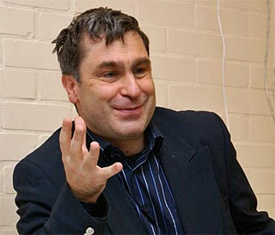
1.e4 e6 2.d4 d5
3.Nc3 Bb4 4.e5 c5
5.Qg4(a) Ne7 6.Qxg7 Rg8
7.Qxh7 Qa5(b) 8.Bd2 cxd4
9.Nb1 Nbc6 10.Nf3 Bd7
11.a3 0-0-0 12.c3(c) dxc3
13.Nxc3 d4 14.Nb5 Bxd2+
15.Nxd2 Nf5 16.Rc1 Kb8
17.b4 Qa6 18.Qh3 Nxe5
19.Nxd4 Qd6 20.N4b3 Bc6(d)
21.Rg1 Bd5 22.Qc3 Bxb3
23.Nxb3 Nh4 24.Be2(e) Nxg2+
25.Kf1 Nf4 26.Qe3(f) Rxg1+ Vassily Ivanchuk
27.Kxg1 Qd5 28.Bg4(g) Qg2#
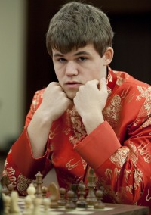
a) The main line is 5.a3 Bxc3+ 6.bxc3 Ne7 7.Qg4 Qc7
8.Qxg7 Rg8 9.Qxh7 with Black having attacking chances
for the pawn similar to the game.
b) This appears to be new: 7…cxd is usual.
c) 12.Bxb4 Nxb4 13.c3 dxc3 14.Nxc3 d4 15.Nxd4 Qxe5+
16.Qe4 maintains equality.
d) The pressure on g2 prevents White from castling and
completing development.
e) Black threatened 24…N(either)f3+!
f) 26.Rxg8 Rxg8 27.Nd4 would prolong the game.
g) Shortens the agony. Ivanchuk has the distinction of
having played in every Amber tournament. Magnus Carlsen


I wonder how many readers last week linked the article on the
proposal to ban the teaching of chess in Swiss schools with the
date, April 1st, and said, ‘Pull the other one.’ Yes, the story was
a complete hoax. By coincidence I read this week of a recent
meeting of European Chess Union President Silvio Danailov and
former world champion Gary Kasparov with the European
Commissioner of Education, Culture, Multiculturism and Youth,
Androlla Vassilou, to discuss a joint project from the European
Chess Union and the Kasparov Chess Foundation, Chess in School,
which aims to have chess included in the European education systems.
Mrs Vassilou gave her full support and Danailov and Kasparov will
present their project to the European Parliament in September. Danailov & Kasparov with
Commissioner Vassilou

SOLUTION: 1.Nf4+! resigns (1…Nxf4 2.Bf7+ Ng6 3.Bxg6#).

