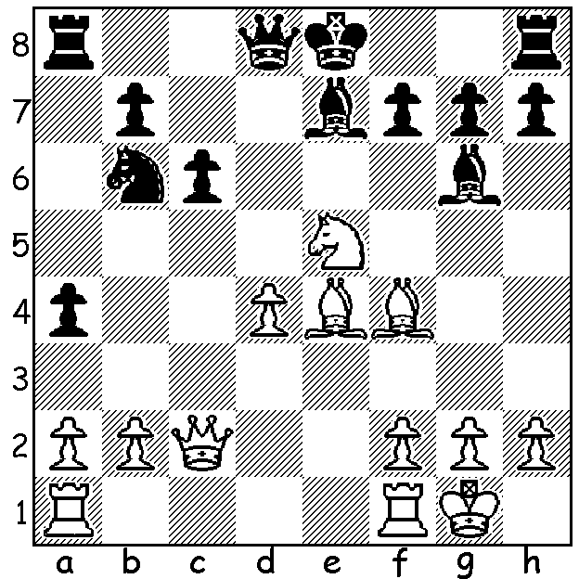
For the next few weeks I intend publishing outstanding
games and wining combinations from a number of
recent international events. We start with a position
from the Aeroflot Masters played in February which
was won for the second year running by 19 year old
Liem Le Quang (Vietnam), a former world Under
14 champion. Here is a position from his game
against former world championship contender Gita
Kamsky (USA) with White to play and win (beware
380 of the obvious but inadequate 3rd move!):

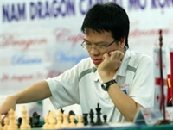
Here is an amazing miniature from the same
event in which the winner, Vasilios Kotronias
from Cyprus, offers three pawns, two pieces
and a rook and in the variation given on move
16 White discards his remaining two minor
pieces to force a brilliant mate.

Vasilios Kotronias - Xiu Deshun
2011 Aeroflot Open, Rd 6
Sicilian Najdorf
1.e4 c5 2.Nf3 d6
3.d4 cxd4 4.Nxd4 Nf6 Liem Le Quang
5.Nc3 a6 6.Bg5 Nbd7
7.f4 e5 8.Nf5 Qb6
9.Qf3 Qxb2 10.Rb1 Qxc2
11.Bc4 Nxe4!? 12.0-0! Qxc3(a)
13.Qxe4 Nc5 14.Bxf7+! Kxf7
15.Qd5+ Be6(b) 16.Rxb7+!! Kg8(c)
17.Rxg7+! Bxg7 18.Ne7+ Kf7
19.fxe5+ Bf6 20.Rxf6+ Kxe7(d)
21.Qxd6+ resigns (e)

a) If 12...Nxc3 the game might continue 13.Nxg7+! Bxg7 14.Bxf7+! Kxf7 15.fxe5+ Nf6 16.Bxf6 Nxb1(to stop 17.Rxb7+) 17.e6+! Kg8 18.Bxg7 Bxe6 19.Bh6 threatening 20.Qf8+! & if 20…Qc8 21.Qf6 Qd7 22.Qg5+.
b) If 15...Kg6 16.Nh4+ Kh5 17.Qf7+ g6 18.f5!! Kxg5 19.Nxg6! winning. Best seems 15...Ke8 16.fxe5 Ne6 (16…Be6 17.Nxg7+! Bxg7 18.Qxd6 Bf8 19.Rxf8+! wins) 17.Be3 Qxe5 18.Qf3! with threat of 19.Nh6! gxh6 20.Qf7+ Kd8 21.Bb6#.
c) If 16...Nxb7 17.Nh6+! gxh6 18.fxe5+ Kg6 19.Qxe6+ Kxg5 20.Qf5+ Kh4 21.Rf4#.
d) If 20...Kg7 21.Bh6#.
e) 21...Ke8 22.Rf8+! Rxf8 23.Qe7#.

Auction house Weiss Auctions has recently sold the chess set used in Game 3 of the World Chess
Championship Match of 1972 between Bobby Fischer and Boris Spassky for $67,500. The game
was the first ever win by Fischer over Spassky and followed a Game 2 default by Fischer. There were two chess sets used at the 1972 World Chess Championship, this set for the 3rd game only, and
another for all the other games which is now in possession of The Chess Memorial Museum in
Reykjavik. The board was signed by both players in 1972 but wasn't used in the match. In a different sale some very personal Fischer letters sold for almost $10,000.

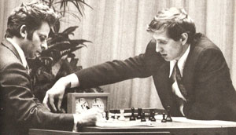
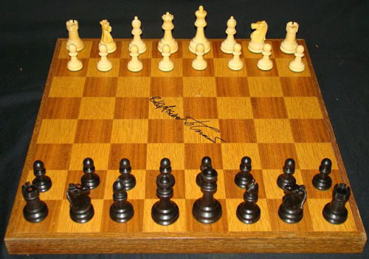

SOLUTION: 1.Bxc6+! (White catches the Black king in the centre) 1…bxc6 2.Qxc6+ Nd7 3.Nxg6! (clearing the open e file: not 3.Nxd7 Rc8!) 3…hxg6 4.Rfe1 (threatening both 5.Bd6 and 5.Rxe7+) 4…0-0 (if 4…Kf8 5.Rxe7! or 4…Rc8 5.Rxe7+!) 5.Bc7 (regaining the piece) 5…Nb8 (5…Qe8 6.Bd6) 6.Bxd8 Nxc6 7.Bxe7 Nxe7 8.Rxe7 and 2 pawns up White had no difficulty winning the ending. Black was no better after 3…fxg6 4.Rfe1 Kf7 5.Qd5+ Kf8 6.Rxe7! Kxe7 7.Re1+ Kf8 8.Bd6+.

