English international Gawain Jones finds a fine move to gain a winning position against world number 22 David Navara (Czech Rep) in the 2011 European Championship (4 moves):

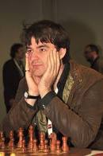
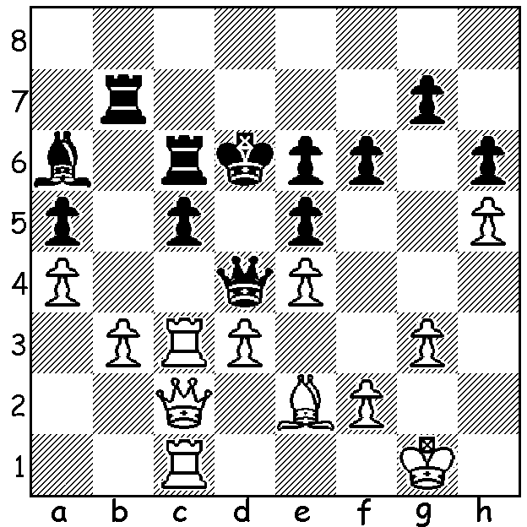
Gawain Jones

The 12th European Championship (22 March – 2 April, 409 players) was won on tie break by Vladimir Potkin (Russia) with 8.5/11, the same score as Radoslav Wotjtaszek (Poland) and Judit Polgar (Hungary), with a further 11 players a half point behind on 8. The event was a qualifier for the FIDE World Cup with 23 places available. Here are two miniatures from the event including a fine win by Potkin:

B Jobava - V Potkin
2011 European Championship, Rd 10

Slav Defence
1.c4 c6 2.d4 d5
3.Nf3 Nf6 4.Qb3 e6
5.Bg5 h6 6.Bh4 dxc4
7.Qxc4 b5 8.Qc2 Bb7
9.Nc3 Nbd7 10.e4 Qb6
11.Be2 Nh5 12.d5 Nf4
13.dxe6 Nxe6 14.0-0-0 Bb4
15.Kb1 Ndc5 16.Rd6 0-0
17.Nd5 cxd5! 18.Rxb6 axb6
19.a3 dxe4! 20.axb4 exf3
21.bxc5 fxe2 22.c6 Nd4!
23.Qd3(a) Nxc6 24.f3(b) Ra4
25.Qd7 Rxh4 26.Qxb7 Rd4
White resigns Vladimir Potkin

a) If 23.cxb7 Ra1+! 24.Kxa1 Nxc2+ 25.Kb1 e1=Q+ 26.Rxe1 Nxe1 27.Bg3 Nxg2 with a winning endgame
b) If 24.Qxe2 Ra4! 25.Bg3 Rfa8 wins.

S Fedorchuk - S Martinovic
2011 European Championship, Rd 10
French Tarrasch
1.e4 e6 2.d4 d5
3.Nd2 c5 4.Ngf3 cxd4
5.Nxd4 Nf6 6.exd5 Nxd5
7.N2f3 Bb4+! 8.Bd2(a) 0-0
9.Bc4 e5! 10.Nb5 e4
11.Bxd5? exf3 12.Bxb4 Qe8+!
13.Kd2 Qxb5 14.Kc3 Be6!
15.Bxe6 Nc6! 16.Bxf8 Qe5+!
17.Kb3 Nd4+! 18.Kb4 Qb5+
19.Kc3 Ne2+ 20.Kd2 Rd8+
21.Ke3 Qe5+ 22.Kxf3 Nd4+
White resigns(b)

a) If 8.c3 Nxc3!
b) 23.Kg4 Qxe6+ 24.Kg3 Nf5+ wins.

THE GUFELD CUP (Grand Prix event) tomorrow (start 12.30) & Sunday (start 10.30) at Moresby Centre, Kensington: enter today for $10 discount to Haydn Barber (hadix@vianet.net.au / 9398 4242).

SOLUTION: 1.Rc4! Bxc4 2.dxc4 & Black’s queen is trapped: 2…Rcb6 3.Rd1 Rxb3 4.Rxd4+ exd4 5.e5! (preventing Black from blocking the position with …e5) 5…Kxe5 6.Bf3 and White won.

