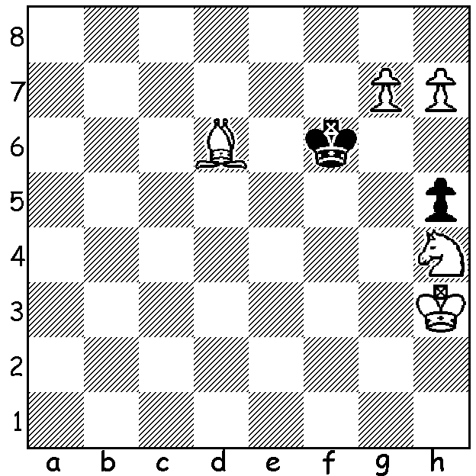
For a night flight back from Hong Kong I purchased
the Financial Times, not to check the markets but to
have some puzzles to while away the time. While the
Sudoku and the Cryptic Crossword were challenging
the chess problem was much less so. A pretty problem
by Pal Benko, White to play and mate in 3, was much
easier than most 2 move mates:

Diagram 383

ELEMENTARY, MY DEAR WATSON!

Fourteen years ago today Gary Kasparov was playing his third game against Deep Blue in a six
game match he was to lose 2.5 – 3.5. Since then the main improvement for the chess-playing computer has been in downsizing, from the giant 32 linked computers standing 2 metres high to a microchip which was capable of defeating Kasparov’s successor as world champion, Vladimir Kramnik. However IBM retired Deep Blue after the match despite Kasparov’s desire for a return match and extended their research into other fields of artificial intelligence. If I mention the name Watson you might immediately think of Australian cricketer Shane Watson, the top all-rounder in the world, or maybe Jessica Watson, the teenage round the world sailor, or even Sherlock Holmes’ assistant. No, I’m talking about just Watson, the IBM computer named after IBM’s founder Thomas J Watson, which can be described as a successor to Deep Blue after taking on the US Quiz show Jeopardy’s two most successful champions, Ken Jennings and Brad Rutter, (Feb 14-16) and defeating them. Watson was capable of hearing and verbally answering questions and won $1 million which IBM donated to World Vision and World Community Aid.

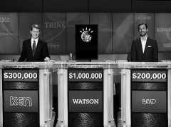

Watson competing in Jeopardy against
Ken Jennings and Brad Rutter

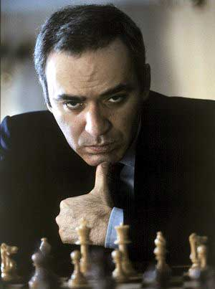
Gary Kasparov - Deep Blue
Game 5, 10 March 1997
Reti Opening
1.Nf3 d5 2.g3 Bg4
3.Bg2(a) Nd7 4.h3 Bxf3
5.Bxf3 c6 6.d3 e6
7.e4 Ne5! 8.Bg2 dxe
9.Bxe4 Nf6 10.Bg2 Bb4+
11.Nd2 h5 12.Qe2 Qc7
13.c3 Be7 14.d4 Ng6
15.h4 e5 16.Nf3 exd
17.Nxd4 0-0-0 18.Bg5 Ng4
19.0-0-0 Rhe8 20.Qc2 Kb8 Gary Kasparov
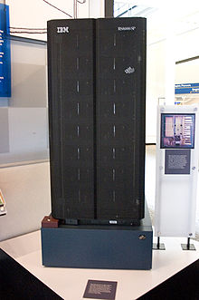
21.Kb1 Bxg5 22.hxg5 N6e5
23.Rhe1(b) c5 24.Nf3 Rxd1+
25.Rxd1 Nc4! 26.Qa4 Rd8!
27.Re1 Nb6 28.Qc2 Qd6
29.c4 Qg6 30.Qxg6 fxg6
31.b3 Nxf2 32.Re6 Kc7
33.Rxg6 Rd7 34.Nh4 Nc8!(c)
35.Bd5 Nd6 36.Re6 Nb5!
37.cxb5 Rxd5 38.Rg6 Rd7
39.Nf5 Ne4 40.Nxg7 Rd1+(d)
41.Kc2 Rd2+ 42.Kc1 Rxa2
43.Nxh5 Nd2 44.Nf4 Nxb3+
45.Kb1(e) Rd2 46.Re6 c4
47.Re3 Kb6!!(f) 48.g6 Kxb5
49.g7 Kb4 Draw (g) Deep Blue

a) In most games of the match Kasparov tried to steer clear of regular openings to make Deep Blue rely on its own judgement from as early as possible. In Game 1 which Kasparov won he played 4.b3.
b) 23.Rxh5 was bad – 23…c5 24.Nb5 Qb6.
c) If now 35.Nf5 Ne7! 36.Nxe7 Rxe7 leaving the White rook trapped on g6.
d) If 40…Nxg3 41.Ne6+ wins.
e) If 45.Kd1 45…Rd2+ gives Black ample counterplay.
f) The king joins the attack to force a draw.
g) If 50.g8=Q 51.Rd1+ would draw by repetition – 51.Kc2 Rd2 52.Kb1 Rd1+ - as White could not risk 50.Re2 Rd1+ 51.Kb2 (51.Kc2? Rc8+ 52.Kb2 c3+ 53.Ka2 Ra1#) 51…Kb2 c3+ 52.Kc2 Rc1+ 54.Ke4 .

SOLUTION: 1.g8=B! (avoiding stalemate by 1.g8=Q? but preventing a King escape via c7): if 1…Kg7 2.Be7 Kh8 (2…Kh6 3.h8=Q#) 3.Bf6#: if 1…Kg5 2.h8=B! Kh6 3.Bf4#.

