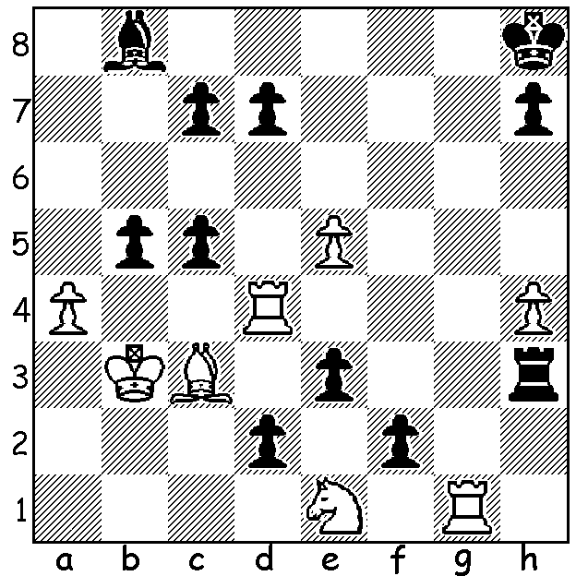

White to play and mate in 2
(C J Morse 1968): a simple
problem notable for the number
of variations in which Black
tries to avoid mate – can you
work out how many?

Diagram 384

The Gufeld Cup (WA Grand Prix event), a trophy presented to CAWA by the late Russian
Grandmaster Eduard Gufeld in 1986, attracted a strong field headed by WA Number 2 Yita Choong and WA champion Tim Hare. Although Yita tied with Tim for first place he was not his usual assured self, being outplayed in a 5th round endgame with Dave Dempster and surviving the following game in Rd 3:

David Ellis - Yita Choong
2011 Gufeld Cup, Rd 3
Closed Sicilian
1.f4 g6 2.g3 Bg7
3.Bg2 c5 4.e4 d6
5.d3 Nc6 6.Nf3 Nf6
7.0-0 0-0 8.Nc3(a) Rb8
9.h3 b5 10.a3 a5
11.Be3 b4 12.axb axb
13.Ne2 Bb7 14.Rb1(b) Ra8
15.b3 Ra2 16.g4 Qc7
17.Ng3 Rfa8 18.g5 Nd7
19.h4 Nd4 20.Bxd4 cxd4
21.Ne1 R8a5 22.Qg4 Bc8
23.Qf3 Ra1 24.Rxa1 Rxa1
25.Bh3 e6(c) 26.Qe2 Ra5
27.h5 f5?(d) 28.hxg hxg
29.exf exf 30.Qe6+ Kh7
31.Bxf5! gxf5 32.Rf2 Nf6!(e)
33.Rh2+ Kg6 34.Rh6+! Bxh6
35.Qxf6+ Kh7 36.Qxh6+ Kg8
37.Nh5 Rc5!(f) 38.Nf6+ Kf7
39.Qh7+(g) Ke6 40.Nf3?(h) Qxh7
41.Nxd4+ Kf7 42.Nxh7 Be6
43.Kf2 Rc8 44.Nf6 Rh8
White loses on time (i)
a) Both sides could be happy with the transposition from the Birds (Dutch Leningrad Reversed) to the Closed Sicilian as Black is a habitual player of the Sicilian when faced with 1.e4 and for years the Closed Variation was a favourite with White. I did consider 8.c4 transposing into a Closed English and 8.c3 (Korchnoi-Karpov, Wld Ch 1978). How the game might develop had Black played an early …d5 can be seen in Ellis-Viswanath (Metro Ch 2011): 1.f4 c5 2.Nf3 Nc6 3.Bg2 d5 4.Bg2 g6 5.0-0 Bg7 6.d3 Nf6 7.Nc3 d4 8.Na4 Qd6 9.c4 0-0 10.a3 b6 11.Ne5 Bb7 12.b4! cxb 13.axb Nd7 14.c5! bxc (14…Qd7 15.Nxd7 Qxd7 16.b5 N moves 17.c6 wins) 15.Nxd7 Qxd7 16.Nxc5 Qc7 17.Nxb7 Qxb7 18.Qa4 resigns (18…Rac8 19.b5 wins a piece)
b) I thought I was following an idea of Spassky but the correct moves were 14.b3 Ra8 15.Rc1 freeing the queen from defence of the c pawn (Spassky-Geller 1968).
c) Stopping White’s plan of 28.Bxd7 Bxd7 29.f5 when Black has no knight to occupy e5.
d) A recklessly loosening move.
e) Giving the king an escape square.
f) Providing necessary protection for the queen and bishop.
g) Forgetting that passed pawns lust for promotion – 39.g6+! Ke7 (39…Kxf6 40.g7+) 40.g7 Be6 41.g8=Q or N+ Bxg8 42.Nxg8+: 39.Nf3! would also be good. The move played brings to mind the words of Bobby Fischer: “Patzer see check, patzer make check.”
h) 40.Qh6 would maintain the winning attack.
i) It would be difficult for either side to make progress.

GUFELD CUP PRIZES: =1st Yita Choong & Tim Hare (5/6), 3rd David Ellis (4): Under 1900 - Aston Taminsjah (3.5), Under 1700 - Behrouz Ghobanian (3), Under 1400 - Joseph Cheong (2.5), Junior - Thomas Pinnock (3.5), an excellent result which included wins against Taminsjah and Dempster. I believe this was Thomas’ first tournament for a year or two.

METROPOLITAN CHESS CLUB OPEN will be played on successive Thursdays, May 26 to July 7 (7.45 start) at Drabble House, Stirling Hwy., Nedlands (behind library). Entry on cawa.org.au or contact Kelvin Taylor 9381 7854 (h).

WA ALLEGRO CHAMPIONSHIP Sunday 22 May at Moresby St Hall, Kensington, (11 – 5). Please enter by 10.45am. Details at cawa.org.au or contact Haydn Barber 9398 4242. Members are asked to attend the annual AGM following at approx. 5.30.

SOLUTION: With Black king trapped at h8 the solution must mean a mate by a discovered check from the bishop, thus 1.e6! Obviously if 1.cxd4 2.Bxd4# but virtually every other move by Black is an attempt to avoid mate, each foiled by the positioning of the White rook in discovering check: 1…c4+ 2.Rxc4#, 1…b4 2.Rxb4#, 1…bxa4+ 2.Rxa4, 1…d5 2.Rxd5#, 1…c6 2.Rd6#, 1…e2 Rd3#, 1…fxg1=Q 2.Rg4#, 1…f1=Q 2.Rf4, 1…dxe1=Q, 2.Rd2#, 1…d1=Q+ 2.Rxd1, 1…d1=N 2.Rxd1#, 1…Rxh4 2.Rxh4# (or 2.Rdg4), 1...Rg3 Rg4#, 1…h6/5 2.Rxd7#. Apart from the first mate after the rook capture there are a record 13 rook moves to administer mate.

