METROPOLITAN CHESS CLUB OPEN will be played on successive Thursdays, May 26 to July 7 (7.45 start) at Drabble House, Stirling Hwy., Nedlands (behind library). Entry on cawa.org.au or contact Kelvin Taylor 9381 7854 (h).

WA ALLEGRO CHAMPIONSHIP Sunday 22 May at Moresby St Hall, Kensington, (11 – 5). Please enter by 10.45am. Details at cawa.org.au or contact Haydn Barber 9398 4242. Members are asked to attend the annual AGM following at approx. 5.30.

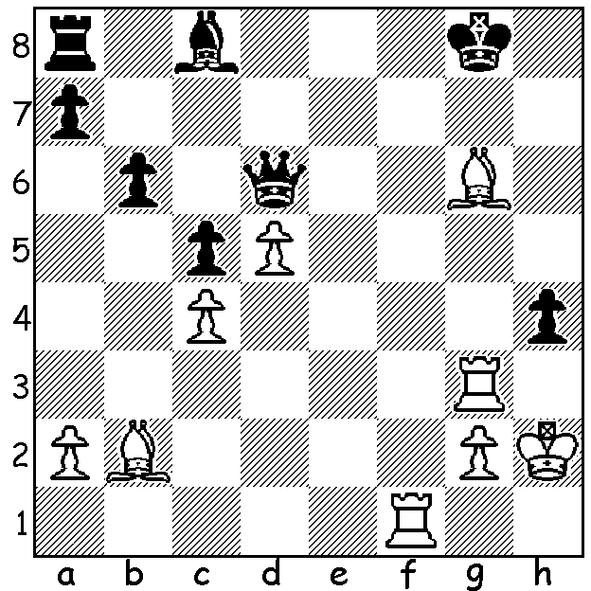

Gelfand-Ftacnik 1989,
White mates in 5:

Diagram 385

World Championship Candidates Matches

The 2011 Candidates Matches began this month in Kazan, Russia. The event is an 8 player knock-out, with the first two rounds being 4 game matches (plus play-offs if necessary), and the final round being a 6 game match (plus play-offs if necessary). The time control is 40 moves in two hours, followed by 20 moves in an hour, and then 15 minutes plus a 30 second increment for the remainder of the game. If matches finish all-square there will be tie-breaks of four games at a rate of 25 minutes plus 10 second increments. If scores are still level there will be pairs of blitz games at a rate of 5 minutes plus 3 seconds increments. If the scores are still level after 5 pairs of blitz games, then there will be a sudden-death game (5 mins v 4 mins, with 3 second increments after move 60, with White needing to win). The winner of the Candidates Series will play Viswanathan Anand (India) in next years World Championship Match, at a venue yet to be determined.

Quarterfinal pairings were:-

Topalov (Bulgaria) v Kamsky (USA)
Kramnik (Russia) v Radjabov (Azerbaijan)
Aronian (Armenia) v Grischuk (Russia)
Gelfand (Israel) v Mamedyarov (Azerbaijan)

The biggest name missing is Magnus Carlsen (Norway), a former World Number 1, who withdrew last year with Grischuk taking his place.

Top of Form
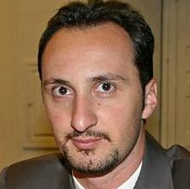 | 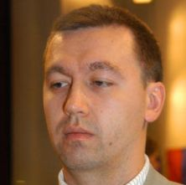
Veselin Topalov | Gata Kamsky
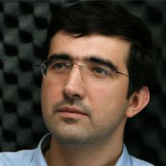 | 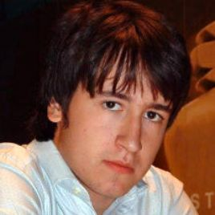
Vladimir Kramnik | Teimour Radjabov
 | 
Levon Aronian | Alexander Grischuk
 | 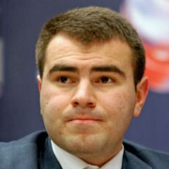
Boris Gelfand Shakhriya Mamedyarov

Here is one of the few games from the first round that did not finish in a draw with the oldest player defeating the youngest with delightful play:

Shakhriyar Mamedyarov - Boris Gelfand
Candidates 2011 (Quarter Finals Game 3)
Sicilian Najdorf

1.e4 c5 2.Nf3 d6
3.d4 cxd4 4.Nxd4 Nf6
5.Nc3 a6 6.Bc4 e6
7.Bb3 b5 8.0-0 Be7
9.Qf3 Qc7 10.Qg3 0-0
11.Bh6 Ne8 12.Rad1 Bd7
13.f4 Nc6 14.f5 Nxd4
15.Rxd4 Kh8 16.Be3(a) Nf6
17.Qh3 d5! 18.e5(b) Qxe5
19.Rh4 Rfc8(c) 20.Kh1 Rxc3!(d)
21.bxc3 Qxc3 22.Rd4 a5!
23.Rd3(e) Qc6 24.c3 a4
25.Bc2 e5 26.Bg5 b4
27.Qh4 bxc3 28.Rh3 Kg8!
29.Re1(f) e4 30.g4 Kf8
31.Be3 Qc4 32.g5 Bxf5!!
33.gxf6 Bxf6 34.Qh5 Bg6
35.Qg4 Qxa2 36.Bb1 Qc4
37.Qg2 a3 38.Ba2 Qc6
39.Rg3 Rb8 White resigns(g)

a) If 16.f6!? Bxf6 17.Rxf6 gxh6 or 17...Qc5.
b) If 18.exd5 exf5 is good.
c) To meet the threat of 20.Bd4 with 20…Bc5.
d) A thematic exchange sacrifice to gain central dominance.
e) No better is 23.a4 bxa4 24.Bxa4 Bxa4 25.Rxa4 Bb4.
f) After 29.Bxf6 Bxf6 30.Qxh7+ Kf8 Black’s king is in no danger.
g) If 40.Bc1 Rb2! 41.Bxb2 axb2 42.Bb1 Be5 43.Rge3 f5! and the pawn avalanche just keeps advancing.

SOLUTION: 1.Bh7+! (1.Be8+ also wins) 1…Kxh7 2.Rf7+ Kh6 3.Bc1+ Kh5 4.Rh7+ Qh6 5.Rxh6#

ADDITIONAL INFORMATION ON CANDIDATES

QUALIFICATION
- Veselin Topalov (lost to Anand in the last World Championship match)
- Gata Kamsky (runner up to Topalov in the last qualifying cycle)
- Boris Gelfand (winner of the 2009 World Cup)
- Lev Aronian (winner of the Grand Prix Series)
- Teimour Radjabov (runner-up of the Grand Prix Series)
- Alexander Grischuk (third in the Grand Prix Series)
- Vladimir Kramnik (next highest rated not otherwise qualified)
- Shakhriyar Mamedyarov (wildcard)
THE PRIZE FUND
- Quarter-final losers get €30,000
- Semi-final losers get €60,000
- Finalists get €90,000 each
THE SCHEDULE
05-May | Q-Finals Game 1
06-May | Q-Finals Game 2
07-May | Q-Finals Game 3
08-May | Q-Finals Game 4
09-May | Tie-breaks
10-May | Rest Day
11-May | Rest Day
12-May | S-Finals, Game 1
13-May | S-Finals, Game 2
14-May | S-Finals, Game 3
15-May | S-Finals, Game 4
16-May | Tie-breaks
17-May | Rest Day
18-May | Rest Day
19-May | Final, Game 1
20-May | Final, Game 2
21-May | Final, Game 3
22-May | Rest Day
23-May | Final, Game 4
24-May | Final, Game 5
25-May | Final, Game 6
26-May | Tie-breaks

