World Championship Candidates Matches
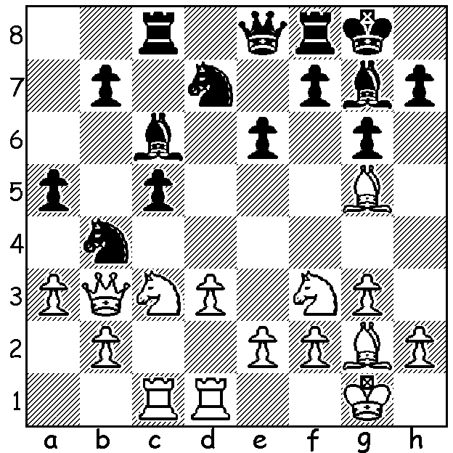
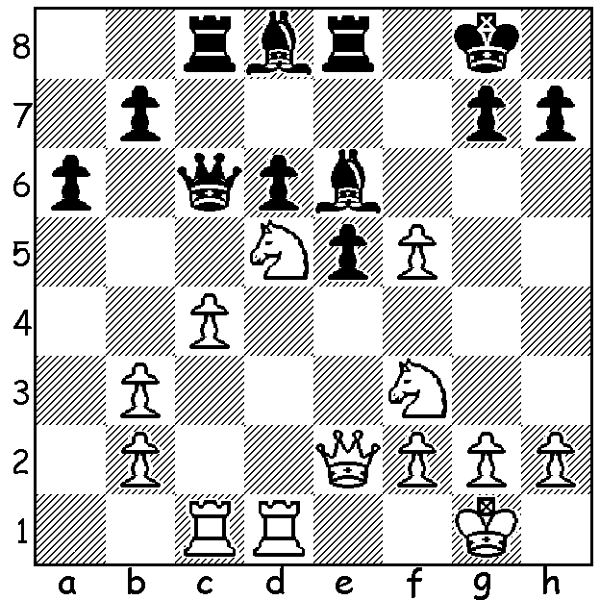 386 387

386) Kamsky-Gelfand, Semi Final Rapidplay Game 2: White plays 1.exf5: what should Black now play?
387) Gelfand-Kamsky, Rapidplay Game 3: how does Black win?

The quarter finals had two matches decided in normal play with the other two requiring further games to decide the winner after all four normal games were drawn. Boris Gelfand defeated Shakhriyar Mamedyarov +1 =3 while Gata Kamsky defeated Veselin Topalov by the same score. Alexander Grischuk defeated the favourite Levon Aronian 2.5 – 1.5 in the rapidplay and ex-world championa Vladimir Kramnik needed to come from behind to beat Teimour Radjabov 2.5-1.5 in four blitz games after the score remained equal after the four rapidplay games.
In the semi-final both matches produced all draws in normal play. Grischuk appeared to make little effort to beat Kramnik with White in normal or the ensuing four rapidplay games but went through to the final with a win and draw in the blitz games. Gelfand came from a game down to tie the error strewn rapidplay to win both blitz games

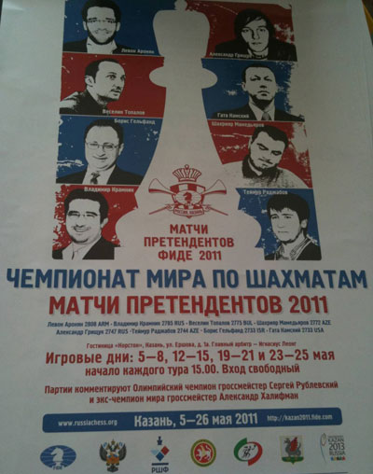
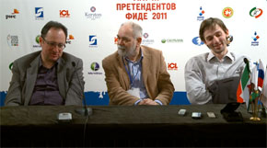

Above: Boris Gelfand (left) & Alexander Grischuk (right)
after their semi final wins.
Right: Official Poster showing the eight players.
Below: The venue for the Candidates in Kazan, Russia.
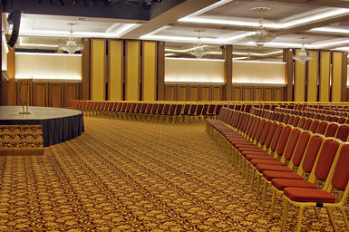
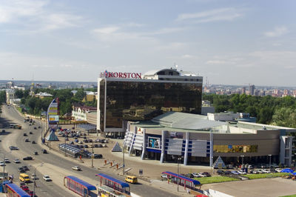

In the best of their four rapidplay games Kamsky used his queenside majority to create a dangerous passed pawn, putting Gelfand on the defensive. With White achieving a queenside blockade Black attempted a kingside diversion which gave Gelfand an opportunity to force a brilliant draw.

Boris Gelfand - Gata Kamsky
2011 Candidates Semi Final, Game 1 Rapidplay
English Opening
1.c4 g6 2.Nf3 Nf6
3.Nc3 d5 4.Qa4+ Bd7
5.Qb3 dxc 6.Qxc4 a6
7.g3 b5 8.Qb3 c5
9.Bg2 c4 10.Qd1 Nc6
11.b3 cxb 12.axb Bg7
13.d4 0-0 14.0-0 Rc8
15.Bb2 Qb6 16.Ne5 Rfd8
17.Nxd7 Rxd7 18.e3 e6
19.Rc1 Rdc7 20.Ne4 Nxe4
21.Bxe4 a5 22.Qd2 a4
23.bxa bxa 24.Ba3 Na5
25.Bc5 Qb5 26.Rb1 Nb3
27.Qa2 Bf8 28.Bc2 Rb8
29.Bxf8 Kxf8 30.Rb2 Rc3
31.Ra1 Qc4 32.Bd1 Rb4
33.Rab1 Kg7 34.Rc2 Qd3
35.Rxc3 Qxc3 36.Bc2 f6
37.h4 h6 38.Kh2! g5
39.Bxb3! Rxb3 40.Qxa4! Rxb1
41.Qd7+ Kg6 42.g4! gxh
Draw (White has perpetual check)

SOLUTION: 386) After 1.exf? Black missed 1…Bxd5! 2.Rxd5 (2.cxd5 Qxc1 transposes) 2…Qxd5! 3.cxd5 Rxc1+ 4.Ne1 Ba5 wins. `
387) 1…c4! (a clearance & obstruction sacrifice) 2.Qxc4 (2.dxc4 Nc5 traps the queen) 2…Bxf3 3.Bxf3 Rxc4 wins.

