Readers will have wondered why no chess column appeared last week. Well, mea culpa entirely. The column was written but I forgot to email it to the West and to Mike. My apologies. Here then is the article:

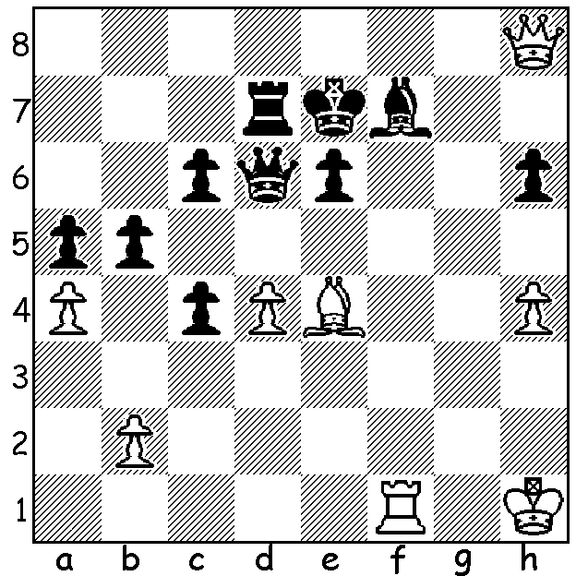
Diagram 388

Gelfand-Lobron 1991:
White has a quick win.

Diagram 388

World Championship Candidates Final
The 6th and final game with classic time controls was won by Boris Gelfand after 5 draws with Alexander Grischuk and gives the Israeli GM the right to play World Champion Viswanathan Anand next year in a title match. Gelfand is ranked 16th in the world and at 42 is a year older than the champion.

Boris Gelfand – Alexander Grischuk
Game 6 Candidates Final Kazan, Russia
Queens Pawn, Semi-Grunfeld Defence
1.d4(a) Nf6 2.c4 g6
3.Nf3 Bg7 4.g3 d5
5.cxd5 Nxd5 6.Bg2 Nb6
7.Nc3 Nc6 8.e3 0-0
9.0-0 Re8 10.Re1 a5
11.Qe2 Bg4(b) 12.h3 Be6
13.b3!(c) a4 14.Rb1 axb3
15.axb3 Qc8 16.Kh2 Ra5
17.Rd1 Rh5 18.Nh4 Bf6
19.f4! Rd8 20.Qf2 Bxh4
21.gxh4 Nd5 22.Nxd5 Rhxd5
23.Bb2!(d) Rb5?(e) 24.Qe2 Rh5
25.e4! Bxb3 26.Rdc1 Na5
27.d5 b6 28.Be5 c5(f)
29.dxc6 f6(g) 30.Ba1 Rc5(h)
31.Rxc5 bxc5 32.Qb5 Qc7?(i)
33.Rxb3 Nxc6(j) 34.e5 Nd4
35.Qc4+ resigns

a) A switch from the English (1.c4) which failed to give him any advantage in Games 2 & 4.
b) 11...e5 is an excellent alternative - 12.dxe5 Nxe5 13.Nxe5 Bxe5 14.f4 (14.e4 Be6 15.f4 Bd4+ 16.Be3 Nc4 17.Bf2 c6 18.Red1 Bxf2+ 19.Qxf2 Qb6=) 14...Bxc3! 15.bxc3 Bf5! Ljubojevic-Grischuk 2009.
c) A new move which prevents `Black’s plan of …a4, …Bc4 and …e5.
d) If 23.Bxd5 Bxd5 followed by …Qf5 gives Black good chances through his control of the white squares.
e) The attack on White’s isolated b pawn proves disastrous: better 23…f5 although White has prospects of an attack after 24.h5.
f) Black’s position is almost certainly already lost.
g) If 29...Rxe5 30.fxe5 Qe6 31.c7 Qxe5+ 32.Kh1 Rc8 33.Qd3 wins.
h) If 30...Bf7 31.e5 Qc7 32.Qb5 Rd2 33.Kg1 winning (not 33.Qxb6? Bd5!! drawing).
i) Time trouble miscalculation: better but still losing was 32...Ba2 33.Rb2 Qc7 34.e5 (34.Rxa2?? would lose 34...Qxf4+ 35.Kg1 Rd1+) 34…Be6 35.Qb6 Qxb6 36.Rxb6.
j) Now if 33...Qxf4+ 34.Rg3.

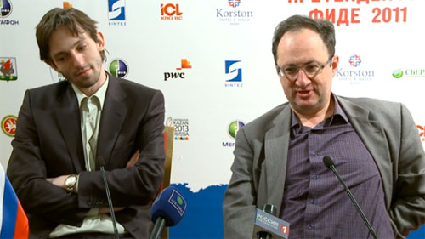

At post game interviews Grischuk (left) revealed commendable sportsmanship when he said, “White played an absolutely great game. It started with a novelty b3 which made my position cramped and I had to find this manoeuvre with …Ra5-h5 to find any counter-play. But then Boris found an amazing concept with his f4, just giving up the pawn - it didn't even cross my mind, this idea.”
(more on Candidates on page 3)

SOLUTION: 1.Bg6! wins outright: if 1…Bxg6 2.Qf8# while 1…Qd5+ 2.Kh2 Qd6 3.Kh3 merely delays the end.

Speaking on the lack of media interest in the event and the proliferation of draws Malcolm Pein in The Week in Chess writes:

“I believe … the chaotic leadership of FIDE, and its dubious leading personalities are responsible for the decline in media interest in the game, but that's been true for a long time and Ilyumzhinov's hold on the Federation is as strong as ever. Holding most of their major events in oil-fields rather than major world cities hardly helps either. If any blame is to be attached as to the lack of decisive results I think it is as to the format. … With the matches being so short, and the penalty for losing even a single game so comparatively great, of course caution was going to come to the fore.

“One universally praised element of the matches was the official coverage. Kazan had high quality video streaming from three cameramen and a producer. It was like you were actually there, in fact it was better than being there, in the early rounds the close ups of the players were almost intrusive. Also the streaming did not fail at peak viewing times, and you could go forward and backwards, just amazing!

“… I'm sure those who did watch came away with a favourable impression of Kazan as a modern city, which was the aim of their sponsorship. They had some pretty slick advertising showcasing of their city throughout the play and from what I saw it looked like a place I might want to visit. They even made the effort to get some comments in English from the players, and largely did.

“So now we know where Kazan is! (It) hosts the Universiade 2013 (World University
Games) and some matches for Russia's 2018 World (Soccer) Cup.”

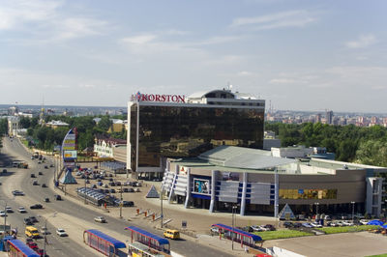

Venue for Candidates at Kazan, Russia

