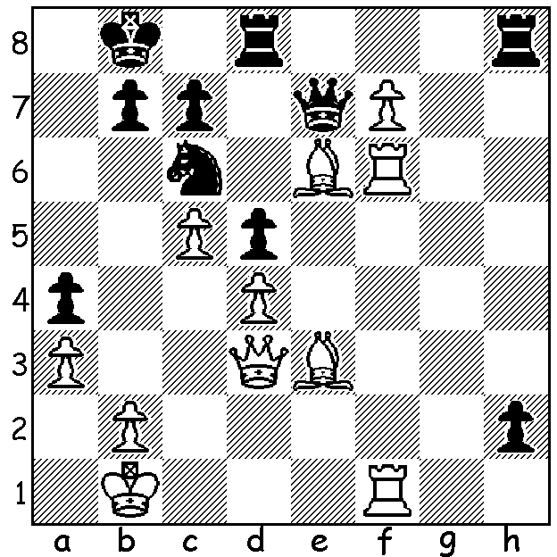
The Reykjavik Open (Iceland), March 9-16, attracted
381 166 players from 30 countries, including 27 GMs. One
of the six players tied on 7/9 is currently the world’s
youngest GM, 14 year old Illya Nyzhnyk from Ukraine.
Winner on countback (a complicated process to decide
which of tied players faced the toughest field) was fellow Ukranian Yuriy Kuzubov. Here is a position from the event in which Englishman Gawain Jones
(White) is a piece up. However his opponent Vladimir
Sveshnikov is threatening to win material by promoting. Find the move which results in Black’s immediate
resignation.

And now a game from Reyjkavik in which another English GM, the ultra aggressive Simon Williams, gains a win by most imaginative sacrifices (the game really explodes into action on move 40!):

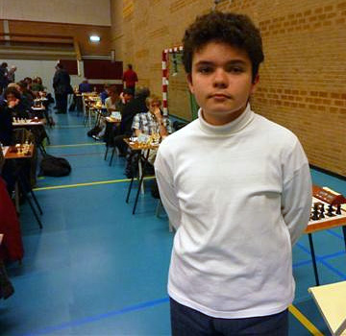
Vilka Sipila - Simon Williams
2011 Reykjavik Open
Larsens Opening
1.b3 e5 2.Bb2 Nc6
3.e3 d6 4.Bb5 Bd7
5.Nf3 a6 6.Be2 g6
7.d4 Bg7 8.d5 Nce7
9.c4 f5 10.Nc3 Nf6
11.Ng5 0-0 12.h4 Qc8
13.c5 h6 14.Nf3 Ne8
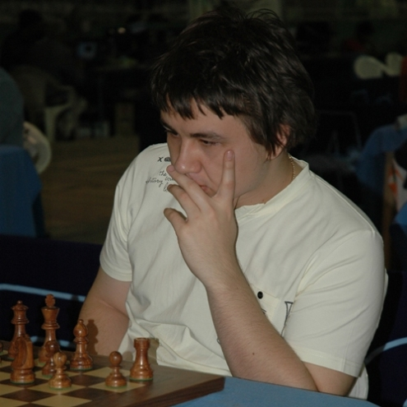
15.Ba3 dxc5 16.Bxc5 Nd6
17.Rc1 Qe8 18.Na4 Qd8
19.Nb6 Rb8 20.h5 g5
21.Nc4 e4 22.Nd4 Rf6
23.Nc2 Nb5 24.Qd2 Rf7
25.Nb4 b6 26.Bxe7 Qxe7
27.a4 Nd6 28.Nxa6 Rb7
29.Nb4 f4 30.Nc6 Qe8
31.Nxd6 cxd6 32.Nd4 f3
33.gxf3 exf3 34.Ba6 Ra7

35.Bc4 Qe4 36.Nc6 Ra8
37.Bd3 Qg4 38.Bf1 Re8
39.Rc4 Re4 40.Qb4 Rxe3+!?
41.Kd1!(a) Qg2!!?(b) 42.Bxg2 fxg2
43.Rg1 Rxf2 44.Rc1?(c) Bb2!(d)
45.Rc2 Rd3+ 46.Rd2 Bc3!
47.Rxd3(e) Bxb4 48.Rxg2 Rxg2
49.Nxb4 Bg4+ 50.Ke1?(f) Re2+
51.Kf1 Re4 and Black wins(g)

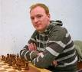
a) Not 41.fxe3 f2+ 42.Kd1 Qg1!!
b) 41...Qf5 was the safe alternative - 42.fxe3 f2 43.Rh2
Qxd5+ 44.Nd4 Be5 45.Rg2 Bh3 Black regains material
while retaining the attack.
c) White should play 44.Qxb6 Rf1+ 45.Kd2 Rxg1
46.Qxe3 Rf1 47.Rc1 winning.
d) Another startling move. He could also play 44...Rxb3!
when 45.Qxb3 Bg4+ 46.Ke1 Re2+ 47.Kd1 Rb2+ is good
for Black and 45.Qe4 Rbb2 46.Ke1 Bh3 allows White a
perpetual check with 47.Ne7+.
e) If 47.Qxc3 Rf1+ 48.Ke2 Rxc3 49.Rxf1 Bg4+ 50.Kf2 Pictured (top to bottom)
gxf1Q+ 51.Kxf1 Rxb3 winning. Illya Nyzhynk
f) 50.Kc1 Bxh5 51.Rh3 keeps White alive. Yuriy Kuzubov
g) Threatening both 52…Be2+ & …Rxb4 giving Black Gawain Jones
an easy win. Simon Williams

I played a similar opening in the following game:

David Ellis - Paul Foster
1979 WA Championship Rd 5
Larsens Opening
1.b3 e5 2.Bb2 Nc6 3.e3 Nf6
4.Bb5 d6 5.d4 exd 6.Qxd4 Bd7
7.Qf4 Be7 8.Nc3 Ne5 9.Be2 Bc6
10.Nf3 Ng6 11.Qd4 Qd7 12.0-0-0 Qg4
13.Nb5 0-0 14.Nxc7 Rac8 15.Nb5 Qxg2
16.Nc3 Qxf2 17.Rdf1 Qg2 18.h3 Ne5
19.Nxe5 dxe5 20.Qxe5 Rfe8 21.Rhg1 Qxh3
22.Rg3 Qh6 23.Rfg1 g6 24.Bc4 Nd7
25.Qf5 Bf6 26.Rxg6+! resigns

The Perth Open (Grand Prix event) will be played tomorrow and Sunday at N. Woodvale Primary (10 am start both days). Details on www.cawa.org.au or contact Norbert Muller 9409 9579.

SOLUTION: 1.Bxd5! Black resigns. If 1…h1=Q (1…Rxd5 2.f8=Q+) 2.Bxh1 Rxh1 3.f8=Q Rxf1+ 4.Qxf1 and White is a rook up.

