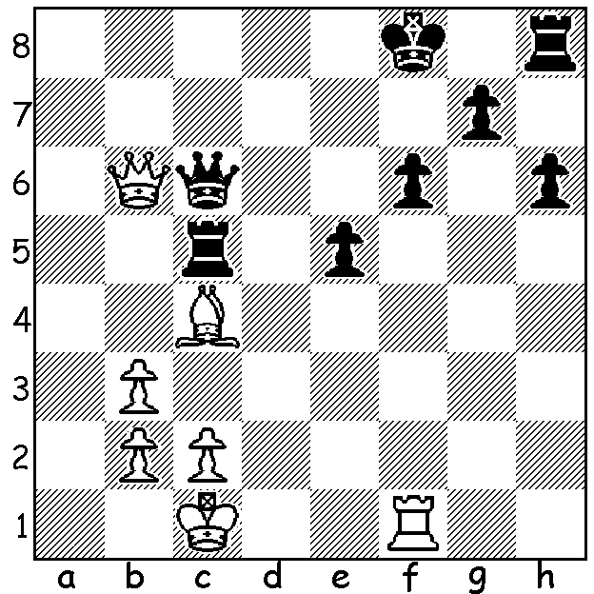

Robson-Shankland 2007:
White mates in 4:

Diagram 389

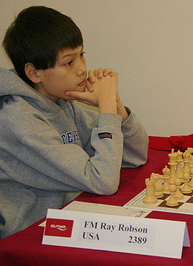
Last week mention was made of the current youngest
GM, 14 year old Illya Nyzhnyk from Ukraine, who
was one of the seven players tied for first place in the
Reykjavik Open. Today we learn of another chess
prodigy, American Ray Robson, who became a
Grandmaster at fourteen, earlier than any other
American including Bobby Fischer. He was born
in Guam in 1994 to an Asian mother, Yee-chen, and
an American father, Gary Robson, who was a one
time Peace Corps education worker and drifter before
returning to the USA and settling in Florida. Ray
Robson recently was in action at an event organised
by the St Louis Chess Centre at which US number
one Hikaru Nakamura took on former FIDE KO
champion Ruslan Ponomariov of Ukraine in a short
match incorporating both Classic and Rapidplay chess
while Ray Robson was a late substitute for Viktor
Korchnoi against St Louis GM in Residence Ben
Finegold. Robson won the Classic match 4-2 although
the match might have ended level had Finegold not
missed a win in Game 6:

Ray Robson - Ben Finegold
Sicilian Dragon, Yugoslav Attack
Match Saint Louis, May 2011, Game 6
1.e4 c5 2.Nf3 Nc6
3.Nc3 g6 4.d4 cxd4
5.Nxd4 Bg7 6.Be3 Nf6
7.Bc4 0-0 8.Bb3 d6
9.f3 Bd7 10.h4 Nxd4
11.Bxd4 b5 12.h5 a5
13.hxg6 hxg6 14.Nd5 Be6(a)
15.Nxf6+ exf6 16.Qd3 d5
17.Qxb5 dxe4 18.0-0-0 Bxb3
19.Qxb3 a4 20.Qe3 a3
21.b3 exf3 22.Qxf3 Re8
23.g4 Rc8 24.Kb1 Qe7
25.Qh3 Qe4 26.g5 Qxc2+
27.Ka1 Re2(b) 28.Qh7+ Kf8
29.Qxg7+!! resigns (c)

a) If 14...Nxd5 White could draw with 15.Bxd5 Rc8 16.Qd2 e6 17.Bxg7 Kxg7 18.Qh6+ Kf6 19.Qh4+, a result unacceptable to Black.
b) This seems decisive but it enables White to bring off a brilliant finish. Black could win by the clever 27...Re5! masking the attack on f6.
c) 29...Kxg7 30.Bxf6+ Kg8/f8 Rh8 mate.

JUNIOR CHESS in WA: Over the past few weeks there have been two well patronised junior events, the Independent Schools Primary Teams Competition held at St Stephens, Carromar, and the Perth Modern Novice Tournament which attracted 65 entries divided into three sections. Seventy-two players from twelve schools competed in the former with first place going to Wesley College with 8/8 followed by Trinity College (7) and Christ Church Grammar (5).

SOLUTION: 1.Qd8+ Qe8 2.Rxf6+! gxf6 3.Qxf6+ Qf7 4.Qxf7#.

