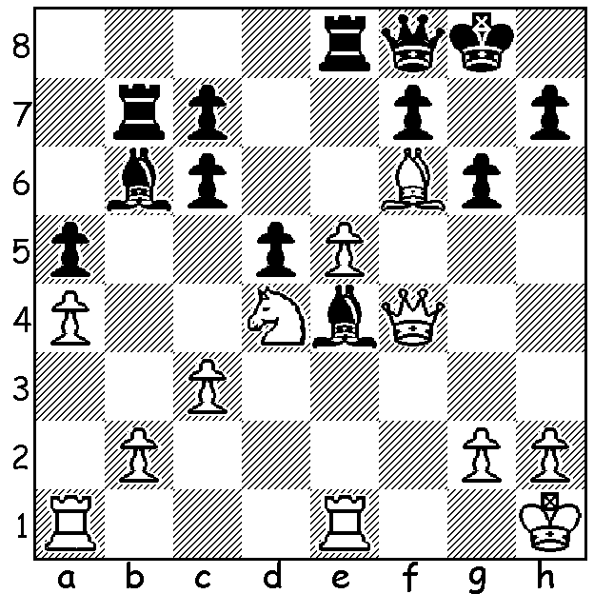
The recently completed Commonwealth and South
African Open was won by British GM Gawain Jones
who edged out Nigel Short on tie-break after both
finished on 9.5/11. In Jones’ game against Indian
GM Abhijeet Gupta White cleverly exploits the black
square weaknesses around Black’s king:

Diagram 391




Gawain Jones Nigel Short



Australia’s one representative,
GM David Smerdon, came third
(+9 -2), winning more games than
anyone else. See below how he
outplays his Round 3 opponent
from a los tposition:

Tapera Uzenit – David Smerdon
2011 Commonwealth & South Africa Open, Rd 3
Sicilian Irregular (90 min then 30 mins + 30 sec/move)
1.e4 c5 2.Nf3 g6 3.e5 Bg7
4.c3 d6 5.d4 cxd4(a) 6.cxd4 Nc6
7.Bb5 a6(b) 8.Bxc6+ bxc6 9.O-O h5(c)
10.Bf4 Nh6 11.exd6 exd6 12.Re1+ Be6(d)
13.Ng5 Qf6 14.Nxe6 fxe6 15.Bxd6 Ng4
16.Qe2 Rd8 17.Bc5 Bf8 18.Nc3 Bxc5
19.dxc5 O-O 20.Qxe6+ Qxe6 21.Rxe6 Rd2?
22.f3 Nf6? 23.b4?(e) Rc2 24.Nd1 Nd5
25.a3 Nf4(f) 26.Ne3 Rxg2+! 27.Nxg2 Nxe6
28.f4(g) Rd8! 29.Re1 Kf7 30.Re2 Rd3
31.Re3 Rd2(h) 32.Kf1 Nd4 33.h3 Kf6
34.Ne1 Nf5 35.Rd3 Ra2 36.Nf3 Ng3+
37.Ke1 Ne4 38.Ne5 g5 39.Nxc6(i) gxf4
40.Nd4 Ra1+ 41.Ke2 Ra2+ 42.Kf3 Nf2
43.Rc3 Ke5 44.c6(j) Nxh3 45.Nc2(k) Ng5+
46.Kg2 f3+ 47.Kf2 Kf4 48.c7 Ne4+
49.Kg1 Nxc3 50.c8=Q Rxc2 51.Qc4+ Ke3
52.Qc5+ Kd2 53.Qf2+ Ne2+ 54.Kh1 Rc3
55.a4 Rb3 56.Qc5?(l) Ke1 57.Qe5 Rc3!
58.Qh2 f2 59.Qh4 Rc4! White resigns

a) 5…dxe 6.Nxe5 Bxe5 7.dxe5 Qxd1+ is slightly better for Black.
b) This leads to difficulties: 7…Bd7 or 7…dxe are better.
c) Black really hasn’t time for this non-developing move.
d) The unattractive 12…Kf8 avoids material loss.
e) 23.Rxf6! wins – 23…Rxf6 24.Ne4.
f) Or 25…Rxg2+! immediately – 26.Kxg2 Nf4+.
g) Better 28.Kf2 Rd8 29.Ke3
h) 31…Nxf4! regains the pawn.
i) Best although 29.Nd7 / 30.fxg is safer.
j) The pawn cannot be stopped from queening.
k) Not 45.c7?? Rf2#.
l) A fatal error allowing the advance of the f pawn.

I was saddened to hear of the death of Stuart Dibden whose funeral will take place next Tuesday 12 July at Fremantle Cemetry (meet main entrance Carrington St. 3.30pm). Stuart was a strong player in the 70s/80s before enthusiasm for golf took over. He tied for first place in the 1984 WA Championship before finishing fourth in the play-off.

SOLUTION: 1.Rxe4! dxe4 2.Nf5! h5 (2…gxf5 3.Qg5+) 3.Bg7 & wins (if 3…Qc5 4.Qh6 f6 5.Qxg6 / 6.Nh6#). Play continued 3…Qxg7 4.Nxg7 Kxg7 5.Qf6+ & White went on to win.

