
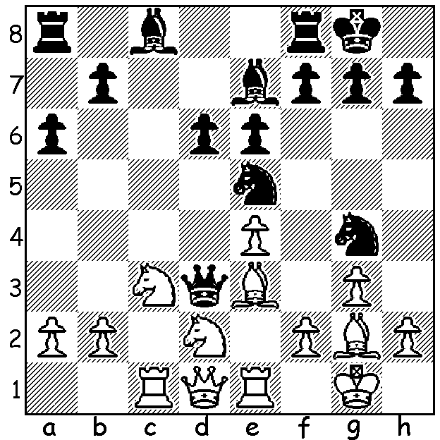

Loek Van Wely
Diagram 392
Michael Mulyar – Loek van Wely (World Open Round 3):
White on successive moves attempts to gain a winning material
advantage but finishes in a lost position (4 moves):


While Gawain Jones and Nigel Short were taking
out the top two places in the South African and
Commonwealth Open their compatriot UK number
1 Michael Adams was competing in the grandly
named World Open Championship in Philadelphia.
Adams (7/9) finished with a better tiebreak score than
American Gata Kamsky but this did not guarantee
him top place but merely the choice of colours in an
‘Armageddon’ play-off. Adams chose Black with
three minutes against Kamsky’s five minutes but
needed only to draw. However Kamsky was able to
win a pawn in a well played positional game leaving

Adams with a lost endgame. This was Kamsky’s Michael Adams
third World Open win and he and Adams each
earned over $14,000. Almost a thousand players
competed in five sections (177 in the main event).
Two 20 year old Australians, Junta Ikeda and
Moulthun Ly, scored 5 and 4.5 repectively.

Loek Van Wely (Netherlands), who was the only player
to defeat Kamsky, led for most of the tournament
before losses in Rounds 7 and 8 meant he finished
in only 3rd=. Here is one of his losses in which he finds
it difficult to develop his queen’s knight and unwisely
grabs a loose pawn rather than swop queens:

Gata Kamsky

Timur Gareev - Loek Van Wely
2011 World Open, Rd 8: Queens Gambit: Semi-Slav Defence
1.d4 Nf6 2.c4 e6 3.Nf3 d5
4.Nc3 c6 5.Qd3 dxc 6.Qxc4 b5
7.Qd3 b4 8.Ne4 Ba6 9.Qc2 Nxe4
10.Qxe4 Be7 11.g3 0-0 12.Bg2 Qd5
13.Qc2 Qb5 14.Ne5 Bf6 15.Bf4 Rc8
16.Rd1 Bxe5 17.dxe5 Qc4 18.Rd2 Qxa2 ?
19.Be4 h6 20.0-0 Bc4 21.Rd4 Bd5
22.Bxd5 exd5 23.Bxh6! gxh6 24.Rg4+ Kf1
25.Qc5 resigns

American child prodigy Ray Robson (born 1994) was among those sharing 3rd place with Van Wely. Here he conducts a fine attack against his opponent’s uncastled king despite the early exchange of queens:

Victor Mikhalevski - Ray Robson
2011 World Open Rd 8: Catalan Opening
1.d4 d5 2.c4 e6 3.Nf3 Nf6
4.g3 dxc 5.Bg2 Bb4+ 6.Bd2 c5
7.Bxb4 cxb4 8.Ne5 0-0 9.Nxc4 Nc6
10.e3 e5! 11.dxe Qxd1+ 12.Kxd1 Ng4
13.Ke2 Ngxe5 14.Nbd2 Bg4+ 15.f3 Bf5
16.e4 Bd7 17.Rac1 Rad8 18.Rhd1 f5!
19.f4 Nd4+ 20.Ke3 Ng4+!! 21.Kxd4 Ba4+
22.Kc5 Nf2 and the threat of 23.Nd3# wins a rook and the game (White resigned after 53 moves).

I have been asked to pass on the following request: ‘Reward (negotiable) to whoever puts me
in direct contact with the owner of a 100 year old complete chess set, Staunton pattern, exceptionally large…. The owner purchased it privately in NW London about 2007 and subsequently emigrated to Australia ….. Contact John Roycroft, roycroft@btinternet.com
or google Roycroft Chess.’

SOLUTION: Black’s queen has no escape square so 1.Bf1. After 1..Nxe3 attacking White’s queen White plays 2.fxe3 again depriving the queen of an escape. Unfortunately for White Black has 2.Qxd2! meeting 3.Qxd2 with 3…Nf3+ forking king and queen.

