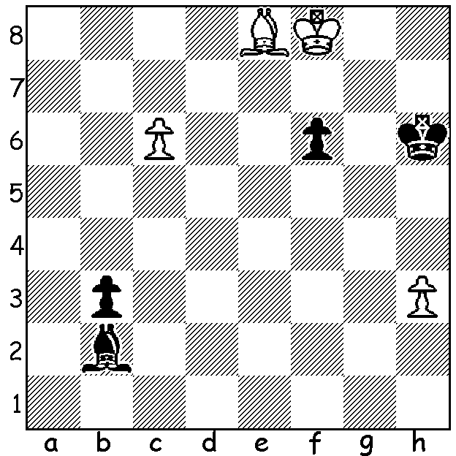

In endgame studies, with White to play and win,
decisive material advantage rather than mate is
usually the aim. Obviously unexpected sacrifices
abound. The example below is by J van den Ende
(one variation, 8 moves). Clearly both sides will promote so how does White take advantage of promoting half a move earlier than Black?

Diagram 393
Diagram 393

Last week I reported the death of Stuart Dibden, a prominent WA player in the 1970s & 1980s. An electrical engineer by profession, Stuart suffered from ill health in his latter years and died aged 62. Originally from the UK Stuart came to Perth from Adelaide and in his first WA championship in 1974 was in the lead going into the final round. However he lost a short but intense struggle to defending champion Richard Lilly who went on to secure his second title. Stuart was again in contention in 1985 when he finished equal first and took an early lead in a four man, six game play-off after winning his first two games. Again he faltered finishing fourth with 2/6. Stuart’s enthusiasm for the game waned due to a new interest, golf, although he did play the occasional club and weekend tournament. I am indebted to Richard Lilly for passing on the following game:

Stuart Dibden - Richard Lilly
1974 WA Championship, Rd 9
Sicilian Najdorf
1.e4 c5 2.Nf3 d6
3.d4 cxd 4.Nxd4 Nf6
5.Nc3 a6 6.Bg5 e6
7.f4 Be7 8.Qf3 h6(a)
9.Bh4 Nbd7 10.0-0-0 Qc7
11.Bd3 b5(b) 12.e5 Bb7
13.exf6!?(c) Bxf3 14.Nxe6 fxe6(d)
15.Bg6+ Kd8! 16.fxe7+ Kc8
17.gxf3 b4(e) 18.Rhe1(f) bxc3
19.Rxe6 d5 20.e8=Q+ Rxe8
21.Rxe8+ Kb7 22.Re7(g) Qxf4+
23.Kb1 Qb4! 24.Rxd7+ Kc6
White resigns (h)

a) This weakens g6.
b) 11…g5 would justify 8…h6: 12.fxg Ne5 13.Qe2 Nfg4 14.Nf3 Nxf3 15.gxf3 hxg5 (Westerin –Browne, Hastings 1972/3).
c) An amazing queen sacrifice! White tries to improve on Gligoric-Bobotsov, Hastings 1959/60. However Gligoric’s 13.Nxe6 fxe6 14.Bg6+ was preferable and White would only sacrifice his queen after 14…Kf8, meeting 14…Kd8 with 15.Qh3.
d) Black must accept the knight sacrifice for if queen moves White has an overwhelming attack.
e) If 17…Kb7, to provide extra protection of e8, 18.Be4+! d5 19.Nxd5! exd5 20.Rxd5 with a strong attacking position.
f) It was unnecessary to give up the knight: both 18.Ne2 Kb7 19.Nd4 Nc5 20.Rhe1 d5 and 18.Na4 (18…Qc6 19.e8=Q+! Rxe8 20.Bxe8 Kc7 – 20…Qxa4? 21.Rxd6 and the knight is lost - 21.Bxd7 Kxd7) are possible.
g) White now appears lost but 22.Rd4 cxb+ 23.Kb1 would enable him to struggle on.
h) Mate on b2 is unavoidable.
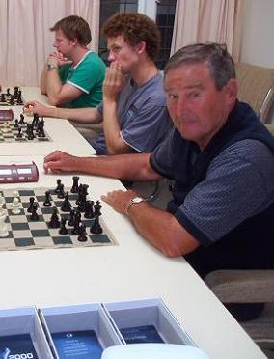

Richard Lilly turned back the clock with
equal first place (5.5/7) in the recently
completed Metropolitan Open, defeating
the other joint winner Luciano Pavez (Chile)
in the final round. Other prize winners: =3rd
David Ellis, John Fedec, Robert Baumgartner
(5): Under 1750 – Wally Lubtchenko, Robin
Shaw (4.5): Under 1500 – John McArthur,
Alex de Heer, Evan Yeung (4): Under 1200 –
Adam Kelly, Gary Taylor, Ron Bailye (3.5).

Richard Lilly at Metro
(with Mark Vliestra and Leon Taylor)

SOLUTION:
1.c7 Ba3+ 2.Kg8 b2 3.Bg6!! (a delightful deflection sacrifice preparing a skewer of king & queen) 3…Kxg6 4.c8=Q b1=Q 5.Qg4+ Kh6 6.Qh4+ Kg6 7.Qh7+Kg5 8.Qxb1.

