Our alphabet series brings us to Y and the English master Frederick Dewhurst YATES (1884-1932). Yates played at the highest level in international chess and although his results were not outstanding he was capable of defeating the strongest opposition and his victims included Alekhine, Reti, Bogoljubov, Tartakower, Rubinstein, Euwe, Nimzovitsch and Vidmar. He was a regular at the annual Hastings Christmas tournament, winning once and coming third four times. He was British champion six times and can be considered among the best half dozen British players ever. Yates came into serious competitive chess at a relatively late age after abandoning his career as an accountant in 1909. He died from accidental asphyxiation caused by a faulty gas connection in his rooms at the age of 48. Yates was one of the pioneers of the Kings Indian Defence and, although considered a rather dogged player, was capable of adventurous and brilliant play.

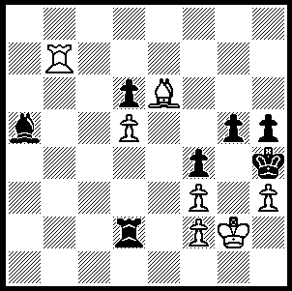
Diagram 394

Yates (White v Rubinstein) is is clearly being pressed but turns the tables cleverly (find Black’s ingenious reply and White’s subsequent winning line to reach a won king and pawn ending):

Frederick Yates – Richard Reti
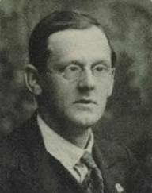
New York,1924
Caro-Kann Defence, Classical Variation
1.e4 c6 2.d4 d5
3.Nc3 dxe4 4.Nxe4 Bf5
5.Ng3 Bg6 6.Nf3 Nd7
7.c3 Ngf6 8.Bc4 e6
9.Qe2 Be7 10.0-0 0-0
11.Re1 Nd5(a) 12.Bb3 a5
13.a3(b) Qc7 14.c4 Nf4
15.Bxf4 Qxf4 16.Rad1 Bf6
17.Bc2 Rfd8(c) 18.Bxg6 hxg6
19.Ne4 Nb6?! 20.b3 Be7(d)
21.Rd3! Bxa3(e) 22.Ne5 Qh4(f)
23.Rh3 Qe7 24.Ng5!!(g) resigns

a) If 11...c5 12.dxc5 (not 12.Bxe6 fxe6 13.Qxe6+ Rf7 14.Ng5 Qc7! 15.Nf5 Re8 16.Nxf7 Bf8!) 12...Nxc5 (or 12...Bxc5 13.Nh4) 13.Ne5 and White is a little better.
b) 13.c4 Nb4 14.a3 Nd3 15.Rd1 Nxc1 16.Raxc1 Bd6 (an alternative is 16...a4 17.Bc2 Bxc2 18.Qxc2 Bd6 19.Ne4 Bf4) 17.Ne5 would also give White a small advantage.
c) 17...Bxc2 might lead to 18.Qxc2 Rfd8 19.Re4 Qh6 20.Qb3.
d) 20...a4 21.b4 Be7 22.Ne5 is in White’s favour.
e) If 21...Qc7 22.Nfg5 a4 23.Qg4 Bxg5 24.Nxg5 & White’s attack is very strong.
f) The exchange sacrifice 22...Rxd4 would not help Black - 23.Rxd4 Qxe5 24.Qd2
g) A stunning finish 24...Qxg5 25.Rh8+! Kxh8 26.Nxf7+.

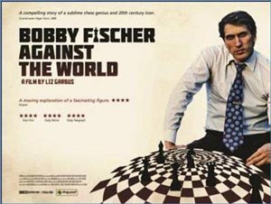

The premier of the documentary film
‘Bobby Fischer Against the World’
was screened in London on July 5 and
included a 20 board simul by Nigel Short
(there had been an earlier preview attended
by Magnus Carlsen). The film, tracing
Fischer’s trouble life from childhood to
child prodigy to world champion and
finally to recluse and fugitive from the
law, focuses mainly on his world
championship match with Boris Spassky
in Iceland.

SOLUTION: 1.Bg4!! Bb6!! (1…hxg4?? Rh7#) 2.Rxb6 (not 2.Rh7? Rxf2+ with perpetual) 2…hxg4 3.hxg4 Rb2! 4.Rc6 (4.Rxb2? stalemate) 4…Rb1 (4…Rb6/c2 5.Kf1) 5.Rc4 (5.Rxd6? Rb6! 6.Rd8 Rb8! or 6.Rc6 Rxc6 draw) 5…Re1 6.Re4! Rxe4 (otherwise 7.Re6 / 8.Rh6#) 7.fxe4 Kxg4 8.e5! f3+ 9.Kg1 Kf5 10.e6 resigns.

