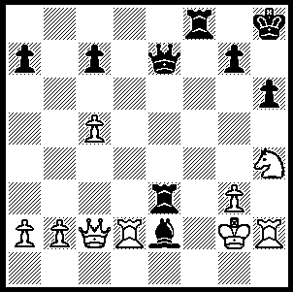
Last week featured one of the strongest English
players Frederick Dewhust YATES (1884-1932)
who died tragically from asphixiation caused by
a faulty gas connection in his rooms at the age of
48. Today we see some more of his brilliance. In
Winter – Yates Black is threatened by the family
fork Ng6+ but unleaches an attack leading to mate
in 7 moves:

Diagram 395

Georg SCHORIES - Frederick YATES
Blackpool 1910
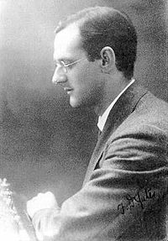
Ruy Lopez, Open (Tarrasch) Defence
1.e4 e5 2.Nf3 Nc6
3.Bb5 a6 4.Ba4 Nf6
5.0-0 Nxe4 6.d4 b5
7.Bb3 d5 8.a4 Nxd4
9.Nxd4 exd4 10.axb Bc5
11.c3 Bb7 12.cxd Bd6
13.Qe2 0-0 14.f3 Ng3!
15.hxg3 Bxg3 16.Be3 Qh4
17.Rd1 Rfe8 18.Qd2 Re6
19.bxa Rexa6 20.Na3 Rxa3!
21.Rxa3 Rxa3 22.Bc4(a) Qh2+
23.Kf1 Qh1+ 24.Bg1 Rxf3+!
25.gxf3 Qxf3+ 26.Bf2 dxc4
White resigns(b)

a) If 23.bxa3 Qh2+ 24.Kf1 Ba6+ wins. b) If 28.d5 Bxd5!

F. YATES - S. TAKACS
Kecskemet 1927
Sicilian, Scheveningen Variation
1.e4 c5 2.Nf3 Nc6 3.d4 cxd 4.Nxd4 Nf6 5.Nc3 d6 6.Be2 e6
7.0-0 Be7 8.Kh1 a6 9.Be3 Qc7 10.f4 Bd7 11.Qe1 b5 12.a3 0-0
13.Rd1 Na5 14.Qg3 Nc4 15.Bc1 Rfc8 16.b3!? Nxa3 17.e5 Ne8 18.Ne4 d5
19.Nf6+! Kh8 20 Qh4! Nxf6(a) 21.Bd3 g6 22.exf6 Bf8 23.Nf3 Kg8 24.Ng5 h6
25.Bxa3 hxg5 26.fxg5 Bxa3 27.Bxg6! fxg6 28.Rd3 Rf8 29.b4! Bxb4 30.Rh3 resigns(b)

a) If 20…gxf6 21.Bd3 f5 22.Qxe7 wins. b) 30…Kf7 31.Qxb4 wins.

SOUTH AFRICAN & COMMONWEALTH CHAMPIONSHIP: I reported that GM David Smerdon (3rd with 9/11) was Australia’s only representative. In fact four other Australians also preformed well with Thomas Feng & Tristan Stevens scoring 7/11 in the main event and Rowan & Kevin Willathgamura scoring 8/11 and 7.5 respectively in the B Section.

SOLUTION: 1...Rxg3+! 2.Kxg3 Qe3+ 3.Kg2 Rf2+ 4.Kh1(4.Kg1 Rf1+ 5.Kg2 Qg1+ 6.Kh3 Q/Bg4#) 4...Bf3+ 5.Nxf3 + (5.Kg1 Rg7+ 6.Kf1/h1 Qg8#) 5...Qxf3+ 6.Kg1 Qg3+ 7.Kh1 Qxh2# or 7.Rg2 Qxg2#.

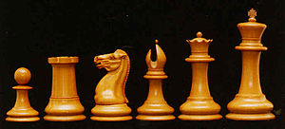

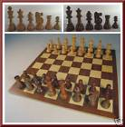

I am repeating a request to pass on the following:
‘Reward (negotiable) to whoever puts me in direct
contact with the owner of a 100 year old complete
chess set, Staunton pattern, exceptionally large….
The owner purchased it privately in NW London
about 2007 and subsequently emigrated to Australia
….. Contact John Roycroft, roycroft@btinternet.com
or google Roycroft Chess.’

