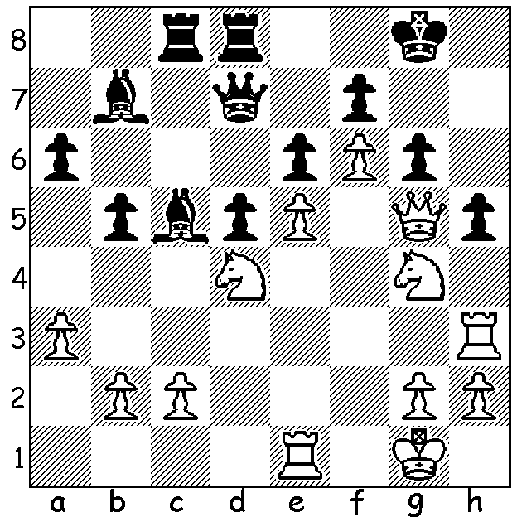

Yates – Steiner 1926:
White to play and win:

Diagram 396

This week concludes our study of Frederick Dewhust YATES (1884-1932) one of the strongest ever English players who died tragically from asphixiation caused by a faulty gas connection in his rooms at the age of 48. Throughout his career his results suffered from lack of consistency which has been attributed to poor health and loss of stamina. He suffered a constant hacking cough which went unchecked through insufficient funds to follow medical advice to take holidays in warmer climes. He was also subject to journalistic pressures during tournaments, a necessity to supplement his meagre earnings from play. Nevertheless he was able to defeat most of the leading players of his day, was British champion six times and achieved plus scores in the three Olympiads he competed in. As a journalist he was the chess columnist of the Manchester Guardian and, with William Winter, the co-author of Modern Master Play. He wrote accounts of two world championship encounters, those between Alekhine and Capablanca, and Alekhine and Bogoljubow. Here is perhaps his most famous win in which he concludes with an 18 move combination to defeat the future world champion Alexander Alekhine and win the tournament Brilliancy Prize:

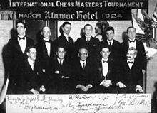

Alekhine (standing 4th from left) & Yates (sitting 1st on left) at New York 1924.
The tournament was won by Lasker (sitting extreme right) with Capablanca
(seated 2nd left) runner-up and Alekhine third.

Alexander Alekhine – Frederick Yates
Karlsbad 1923
Kings Indian Defence
1. d4 Nf6 2. c4 g6 3. g3 Bg7
4. Bg2 O-O 5. Nc3 d6 6. Nf3 Nc6
7. d5 Nb8(a) 8. e4 Nbd7 9. O-O a5
10. Be3 Ng4 11. Bd4 Nge5 12. Nxe5 Nxe5
13. c5(b) dxc5 14. Bxc5 b6 15. Bd4 Ba6
16. Re1 Qd6 17. Bf1 Bxf1 18. Rxf1 c5
19. Bxe5 Qxe5 20. Qb3 Rab8 21. Qb5(c) f5(d)
22. Rae1 f4 23. Qd7 Rbd8 24. gxf4(e) Qxf4
25. Qe6+(f) Kh8 26. f3(g) Qg5+ 27. Kh1 Rd6
28. Qh3(h) Be5 29. Re2 Rdf6 30. Nd1 Rf4
31. Ne3 Rh4 32. Qe6?(i) Qh5 33. Ng4 Rxg4!
34. fxg4 Rxf1+ 35. Kg2 Qxh2+ 36. Kxf1 Qh1+
37. Kf2 Bd4+ 38. Kg3 Qg1+ 39. Kh3 Qf1+
40. Rg2 Qh1+ 41. Kg3 Qe1+ 42. Kh3 g5!
43. Rc2 Qf1+ 44. Kh2 Qg1+ 45. Kh3 Qh1+
46. Kg3 Qd1 47. Rc3 Qg1+ 48. Kh3 Qf1+
49. Kg3(j) Bf2+ 50. Kf3 Bg1+ White resigns(k)

a) Yates was one of the pioneers of the Kings Indian and habitually employed this retreat to reposition the knight on c5 (eg after 7.0-0 e5 8.d5 Nb8). In the 1950s 7…Na5 followed by …c5 or …c6 (the Panno Variation) became quite popular.
b) If 13.b3 c5.
c) If 21.Rad1 b5!
d) The start of a kingside attack.
e) If 24.Qg4 Rd6 followed by …Rdf6.
f) Not 25.Qxe7? Rfe8! and White will not be able to defend his king.
g) If 26.Re3 Be5 27.Rg3 Qf6 28.Qxf6 Rxf6 with advantage.
h) Better 28.Qg4 although after 28…Qf4 29.Qxf4 Rxf4 White remains under pressure.
i) The losing move: essential was 32.Qd7 with the threat of Qe8+ if Black’s back rank becomes unprotected.
j) 49.Kh2 Bg1+ 50.Kh1 Bf2+ 51.Kh2 Qg1+ 52.Kh3 Qh1#
k) 51.Kg3 Qf2+ 52.Kh3 Qh2#.

SOLUTION: 1.Rxh6! Bxd4+ 2.Kh1 with 3.Rh8+! Kxh8 4.Qh6+ Kg8 5.Qg7#: if 1…Bf8 2.Nh6+ quickly mates.

