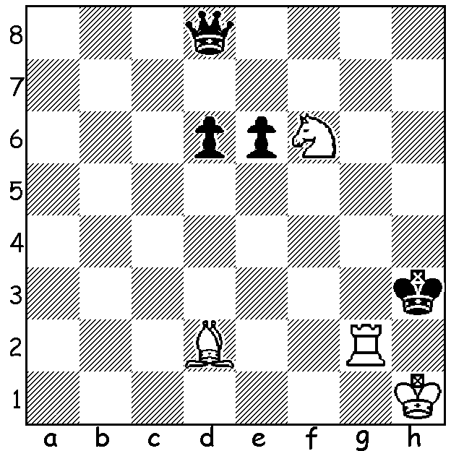

An endgame study by F. Amelung (1907):
White to play and win. In 5 moves
White wins decisive material:

Diagram 397

After my last foray out of the state to compete in a tournament nine years ago I had decided that I would henceforth confine myself to purely WA events. However with
Frequent Flyer points about to run out after a cancelled holiday I was attracted to
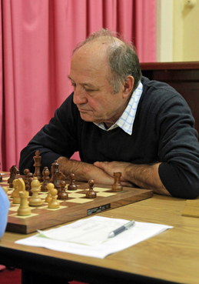
the Oceana Seniors (over 60 years) to be held at the
Box Hill Club in Melbourne. The event attracted 31
players, mainly from Australia but including two New
Zealanders, a player from PNG and one other unspecified
overseas player. The top prize included an expenses
paid entry to the next Seniors World Championship
where one might rub shoulders with famous grandmasters
of the past. The winner at Box Hill was International
Master Mirko Rujevic (Vic) with 6/7 (+5 =2). My own
score was 4/7 (+3, =2, -2) leaving me =9th. I was hoping
to be able to show the exciting game in which runner up
Bill Kerr (SA) obtained a perpetual a queen down against
Rujevic. Unfortunately the later round games have not
Winner Mirko Rujevic who been published so here is my most interesting game
defeated me in Rd 3. against the winner of the 70+ prize:

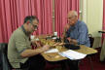
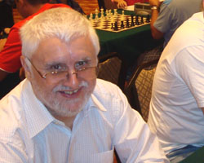

Runner up Bill Kerr (rt)
Organiser and 3rd placed Brian Jones
(NSW) with whom I drew in Rd 5.

Richard Voon - David Ellis
2011 Oceana Seniors, Rd 2
Two Knights Tango
1.d4 Nf6 2.c4 Nc6 3.Nf3 e6
4.a3 d6 5.g3 g6(a) 6.Nc3 Bg7
7.Bg2 0-0 8.0-0 e5 9.d5 Ne7
10.b4 Ne8 11.Bb2 h6 12.c5 f5
13.Nd2 g5 14.Nc4 f4 15.Rc1 Bf5
16.e4 Bg6 17.Bh3 h5 18.f3 fxg
19.hxg Bh6 20.Rc2 Kh7 21.Bc1 Ng8
22.Be3 Nef6 23.Bg2(b) Qe7 24.cxd cxd
25.Nb5 Ne8(c) 26.Bxa7(d) Qd7 27.a4 Rxa7
28.Nxa7 Qxa4 29.Nc8 Qxb4 30.N8b6 Nef6
31.Kh1 g4 32.Qd3?(e) gxf 33.Bxf3 Nxe4!
34.Bxe4 Rxf1+ 35.Kg2 Rf6?(f) 36.Rb2?(g) Qe1
37.Bxg6+ Rxg6 38.Nxd6 h4(h) 39.Ne4 Bf4
40.Nc4 h3+ 41.Kh2 Kh8 42.d6?(i) Nf6!
43.Nxf6?(j) Bxg3+ White resigns.

a) After White declines to play the main line 3.d5 and then with 4.a3 avoids the Nimzo-Indian, Black decides to play the Kings Indian with White having an extra tempo with a3.
b) 23.Be6 is more aggressive.
c) 25...a6 26.Nbxd6 b5 27.Bc5 bxc4 28.Nxc4 would be winning for White.
d) 26.Ncxd6?! Nxd6 27.Rc7 Nxb5 28.Rxe7+ Nxe7 leaves a very unbalanced position.
e) 32.Rb2 Qc5 33.fxg is better - 33...Nxg4 34.Rxf8+ Bxf8 35.Qg1 or 33..Nxe4 34.Rxf8+ Bxf8 35.Qe1 Nef3 36.g5 Ng5 37.Nd7 Qxc4 38.Nxf8+ Kg7 39.Nxg6 Kxg6.
f) With both sides in time trouble mistakes keep coming. Black should follow the maxim, ‘Always look at checks’. 35...Rg1+! should be played: 36.Kh2 (not 36.Kxg1? Qe1+ wins) 36...Qe1 37.Bxg6+ Kh8 and if 38.Nxd6 Rxg3! 39.Qxg3 Bf4.
g) White returns the favour – 36.Nd7 would be winning - 36...Bxe4+ 37.Qxe4+ Rg3 (37...Kg7 is better ) 38.Rf2 Bg7 (38...Kg7 39.Rf7+! Kxf7 40.Ncxe4+ wins the queen) 38.Rf2 Kh6 39.Qe3+ Rg5 40.Rxg7).
h) 38...Be3! was strong – 39.Nbc4 Qxg3+ 40.Kf1 b6 41.Qxe3 Qxe3 42.Nxe3 Rxd6.
i) 42.Rb1 should be played when Black would need to find 42....Bxg3+ 43.Kxh3 Rh6+ 44.Kg2 Rh2+ 45.Kf3 Rh6!! 46.Kg2 Rh2+ drawing or 46.Rxe1 Bxe1+ 47.Ke2 Rxd3 48.Kxd3 again drawing.
j) 43.Qf3 would leave Black problems in gaining the win: 43...Qxe4 44.Qxe4 Bxg3+ 45.Kxh3 Nxe4 46.d7.

SOLUTION: 1.Nd5! (not 1.Be1?? Qa8) 1...exd5 (1...Qa8 2.Nf4+ Kh4 3.Be1# or 1...Kh4 2.Nf4 / 3.Be1#) 2.Be1 and now Black’s queen is lost, eg 2...Qe7 3.Rg3+ Kh4 4.Re3

