2011 Russian Championship

Earlier this month cricket loving Peter Svidler became Russian champion for the sixth time, winning the 8 player Russian Super Final with 5/7, losing only his last game when already assured of victory. Second was Alexander Morozevich with 4.5 followed by Sergey Karjakin, Alexander Grischuk and former world champion Vladimir Kramnik with 4 points.
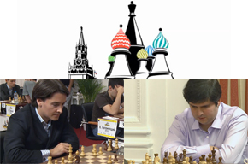

Runner up Alexander Morozevich (left) and winner Peter Svidler

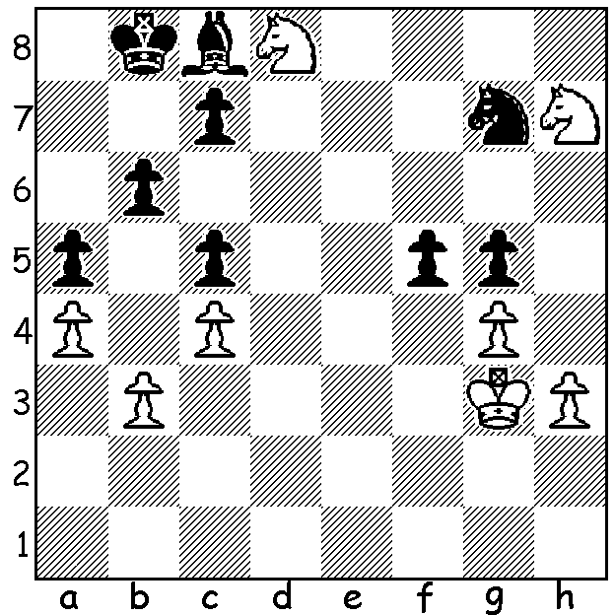
In Karjakin – Kramnik (Rd 3) Kramnik employed
the Berlin Defence (now commonly referred to as
the Berlin Wall) against the Ruy Lopez (1.e4 e5
2.Nf3 Nc6 3.Bb5 Nf6 4.0-0 Nxe4 5.d4 Nd6 6.Bxc6
dxc6 7.dxe5 Nf5 8.Qxd8+ Kxd8), a defence Kramnik
revived to good effect during his succesful world
championship challenge to Gary Kasparov.
Appropriately this time Kramnik’s Berlin Wall
fell (this month marked the 50th anniversary of the
building of the actual Berlin Wall). In the position
below Kramnik (Black to move) appears certain to
lose his g pawn. However there is a study like
drawing line which Kramnik failed to see. Can you
find the draw (4 moves)?
Diagram 398

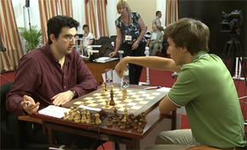

Karjakin (rt) about
to defeat Kramnik

Here is a fine win by Morozevich in which he sacrifices queenside pawns for an attack and concludes with a sensational sacrifice:
Alexander Morozevich - Alexander Grischuk
2011 Russian Chanpionship, Rd 2
Queens Gambit Declined
1.d4 d5 2.c4 e6 3.Nc3 Be7(a)
4.cxd exd 5.Bf4 c6 6.e3 Bf5
7.h3 Nd7 8.Nf3 Qb6 9.Qe2 Ngf6
10.g4 Bg6 11.Nh4 Qa5 12.Bg2 Ne4
13.Nxg6 Nxc3 14.Qd2 hxg6(b) 15.bxc3 Nb6
16.0-0 Nc4 17.Qe2 0-0 18.e4 Bd6
19.e5 Ba3 20.Rab1 Qxc3 21.Rfd1 b5
22.Rb3 Qa5 23.g5 Rfe8 24.h4 Bf8
25.h5(c) gxh5 26.Qxh5 g6 27.Qh4 Qxa2
28.Rh3 Bg7 29.Qh7+ Kf8 30.Rf3 Qe2
31.Rdd3 Re6 32.Bg3 a5?(d) 33.Bf1!(e) Qe4
34.Rf4 Qxf4 35.Bxf4 a4 36.Rd1 a3
37.Bxc4 dxc4 38.Bd2 Ra4 39.Be3 Re7
40.d5 a2 41.d6 Rd7 42.Bd5 b4
43.Qxg7+!!(f) Black resigns

a) This move rather than 3...Nf6, brought to prominence by Petrosian in the 1963 World Championship match against Botvinnik, avoids the pin 4.Bg5.
b) Possible was 14...Bb4!? 15.a3 hxg6 16.0-0 Ne4 17.Qxb4 Qxb4 18.axb4 Nb6.
c) Even stronger was 25.Rh3.
d) Best was 32...Nd2 - 33.Rfe3 Qd1+ 34.Kh2 a5 35.Bh3 Rae8 36.Bxe6 Rxe6 37.f4 Qc2! Kh3 Ne4.
e) Black had expected 33.Rxf7+ Kxf7 34.Rf3+ Qxf3 35.Bxf3 Rh8. Now if 33...Qc2 33.Rxf7+ wins.
f) Just when Black seemed to be developing serious threats of promoting comes this bombshell. After 43...Kxg7 44.e6+ Kh7 45.exd7 Ra8 46.Kg2 threatening 47.Rh1+ / 48.Rh8#.

SOLUTION: 1...fxg 2.hxg Nf5! 3.gxf5 Bxf5 4.Nxg5 Bc2 and White loses his queenside pawns.

