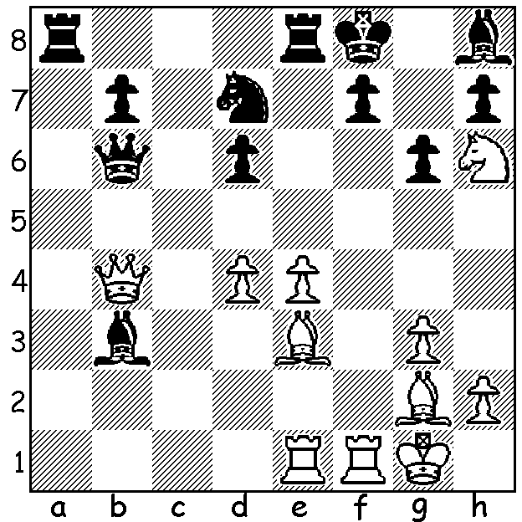

Robson – Udishi
(World Junior Ch. 2011):
Black resigns after White’s next move:

Diagram 399

The World Junior Championships were played 1-16th August in Chennai, India. Poland's Grandmaster Swiercz Dariusz caught leader Robert Hovhannisyan (Armenia) in the final round to take the junior title on superior tie-break, both scoring 10.5/13. Sahaj Grover (9.5) from New Delhi, who defeated two successive GMs in the final two rounds, emerged a clear third and gained a Grandmaster norm. Australia had two representatives, Junta Ikeda and Moulthun Ly who scored 7 and 6.5 respectively. Both are former Australian Junior Champions and Moulthun came =1st in this year’s Australian Open.

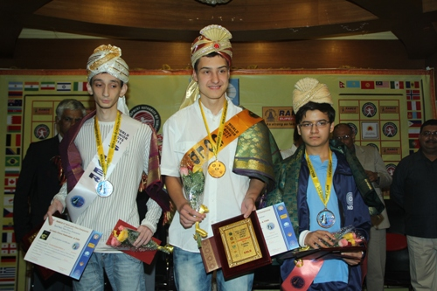

The top three prizewinners, (L to R) Runner-up Robert Hovhannisyan (Armenia),
Champion Swiercz Dariusz (Poland), Third Sahaj Grover (India)

Here is a sparkling game culminating in a queen sacrifice from American Ray Robson who came =4th with 9:

K Priyadharshan - R Robson
2011 World Junior Championship
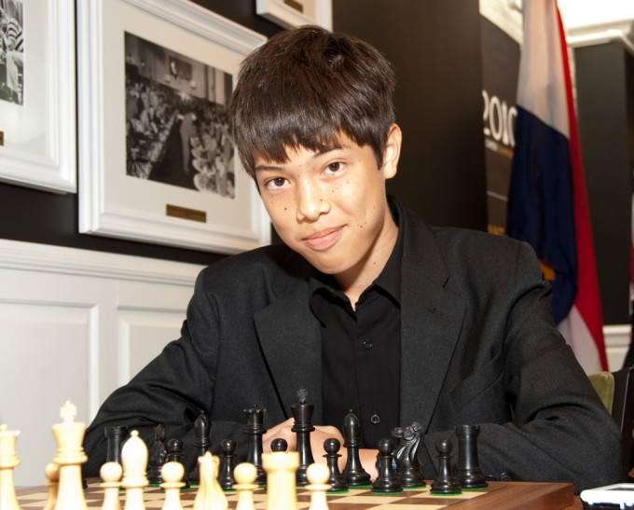
Sicilian Dragon
1.e4 c5 2.Nf3 d6
3.d4 cxd 4.Nxd4 Nf6
5.Nc3 g6 6.Be3 Bg7
7.f3 Nc6 8.Qd2 0-0
9.0-0-0 d5 10.exd Nxd5
11.Nxc6 bxc6 12.Bd4 e5(a)
13.Bc5 Rb8?!(b) 14.Nxd5 cxd5
15.Qxd5 Qf6 16.Qd2(c) Be6(d)
17.Bxf8 Bxf8 18.Kb1 e4
19.Qd4 Qe7 20.b3 Qa3
21.fxe(e) Bg7 22.e5 Qa5
23.Be2 Bxe5 24.Qe3 Rb4
25.Rd8+ Kg7! 26.Rhd1(f) Qxa2!! Ray Robson (USA)
White resigns(g)

a) 12…Bxd4 13.Qxd4 Qc7 gives even chances but Black wants to preserve his king’s bishop for attack..
b) 13…Be6 is reasonable alternative.
c) 15. The immediate 16.Bxf8 is better: 16…Bxf8 17.Qd8 Qf4+ 18.Rd2 Qa4 19.a3.
d) 16…Re8 is safe giving equal chances.
e) Better is 21.Qf6 – 26…exf 27.gxf Qa5 and White remains better.
f) This loses immediately. Also inadequate is 26.a4 Rxa4 & wins. The only move is 26.c4! where best play leads to an ending a pawn up for Black – 26…Bf5+ 27.Kc1 Ra4!! 28.Rd2 (28.axb4 Bf4!! 29.Qxf4 Qc3+ 30.Kd1 Bc2+ 31.Kc1 Bb3+ 32.Kb1+ Qc2+ 33.Ka1 Qxa2#) 27…Bf4!! 28.Qd4+ (28.Qxf4 Qc3+ 29.Kd1 Qa1#) 28…f6 29.Kd1 Bxd2 30.Qxd2 Qxd2+ 31.Kxd2 Rxa2+ 32.Ke3 Rb2.
g) 27.Kxa2 Ra4+ 28.Kb1 Ra1#.

THE 2011 WEST AUSTRALIAN CHAMPIONSHIP is about two thirds completed. Of the favourites in the 10 player field teenager Yita Choong leads with 5.5/7. 2010 champion Tim Hare has 4.5/6, many times champion Haydn Barber 3.5/6 and top rated Stephanus Kurniawan 2.5/5. Akef Saleh has made a surprisingly competitive score of 4/7, defeating Choong and Barber and drawing with Kurniawan.

SOLUTION: 1.d5!! with the dual threats of 2.Bxb6 & 2.Rxf7#.

