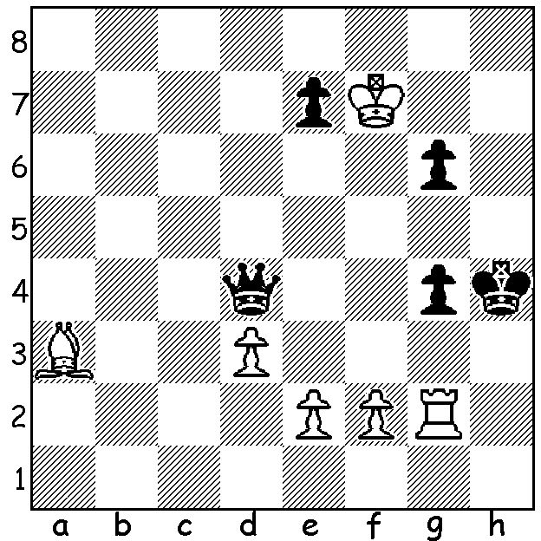

A pretty study by the great French study
composer Henri Rinck (1928): White to
play and win. In 7 moves White gains a
decisive material advantage (move 4 is
the difficult one):

Diagram 400

The column last week concentrated on the The World Junior Championships, played 1-16 August in Chennai, India and won by Poland's Grandmaster Swiercz Dariusz. This week a game from the event from one of our two Australian representatives, Junta Ikeda, a former Australian Junior Champion in which he shows tremendous attacking skill against Black’s castled king:

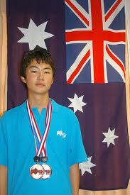
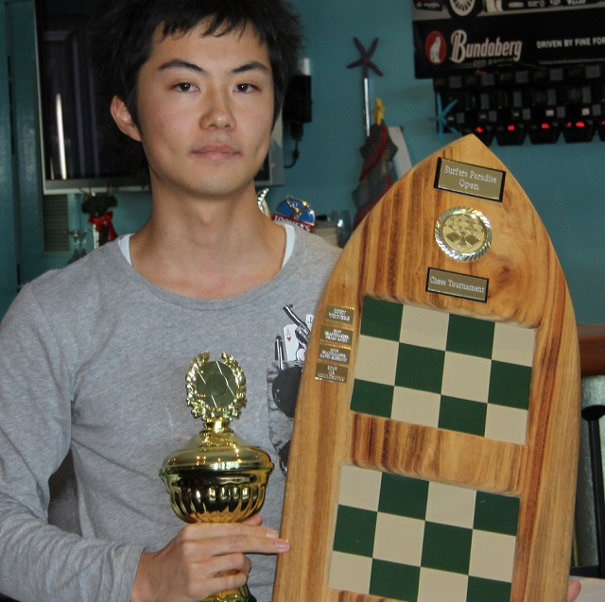

Junta Ikeda, after winning the
2010 Queensland International

JUNTA IKEDA - JORGE CORI
2011 World Junior Championship
French Defence: Tchigorin Attack
1.e4 e6 2.Qe2(a) c5
3.Nf3 Nc6 4.g3 d6
5.Bg2 g6 6.d3 Bg7
7.0-0 Nge 7 8.c3 0-0
9.Na3 Rb8 10.d4 cxd
11.cxd b5 12.Nc2 b4
13.Rd1 Qa5 14.Ne3 Ba6
15.Qd2 Rfd8 16.d5 exd
17.exd Ne5 18.Nxe5 dxe5
19.b3 Nc6(b) 20.Bb2 Nd4
21.Re1(c) Rbc8 22.Kh1 h5(d)
23.f4 exf 24.gxf Ne6
25.f5 Bc3(e) 26.Qf2 Nc5(f)
27.fxg fxg 28.Bxc3 bxc3
29.Qg3 Qc7(g) 30.Qxg6+ Qg7
31.Qxh5 Nd3 32.Rf1 c2
33.Nf5(h) Nf4(i) 34.Rxf4! Qxa1+(j)
35.Bf1! Kf8 36.Nd4+ Ke7
37.Qf7+(k) resigns

a) The unusual Tchigorin Attack (2.Qe2) deters the thematic French move 2…d5 and here leads to a Kings Indian Attack position against the Sicilian.
b) An alternative was 19…e4 20.Bb2 Bc3 21.Bxc3 bxc3 22.Qd4=.
c) Interesting was 21.Nc4 Qc5 22.Nxe5!? (22.Rac1 Rbc8! 23.Nxe5? Ne2+!) 22…Ne2+ 23.Kh1 Nc3.
d) This proves a disastrous weakening move.
e) If 25.Bxb2 26.Qxb2 Nf4 27.fxg fxg 28.Qd4 with some advantage.
f) 26….Ng7 is necessary to give some cover to the king.
g) If 29...Qb6 30.Nc4 Qf6 31.Rac1 maintains White’s advantage.
h) 33.Bh3 was a surer way to victory.
i) Black had to play 33…Nf2+! 34.Kg1 Qf6. Now White breaks through.
j) No better is 34.c1=Q 35.Rxc1 Rxc1+ 36.Bf1 winning.
k) 37.Qe5+ Kd7 38.Rf7# finishes quickly but now after 37...Kd6 White mops up – eg 38.Rf6+ Kc5 39.Qxa7+ Kb4 40.Nxc2+ Rxc2 41.Qe7+ etc.

SOLUTION: 1. Rh2+ Kg5 2. Bc1+ Kf5 3. e4+ Ke5 4. Bb2!! (clever deflection sacrifice followed by a discovered attack) 4…Qxb2 5. f4+ gxf3 6 Rxb2 and White wins (6…g5 7.Rb5+ Kf4 8.Rf5+ ….).

