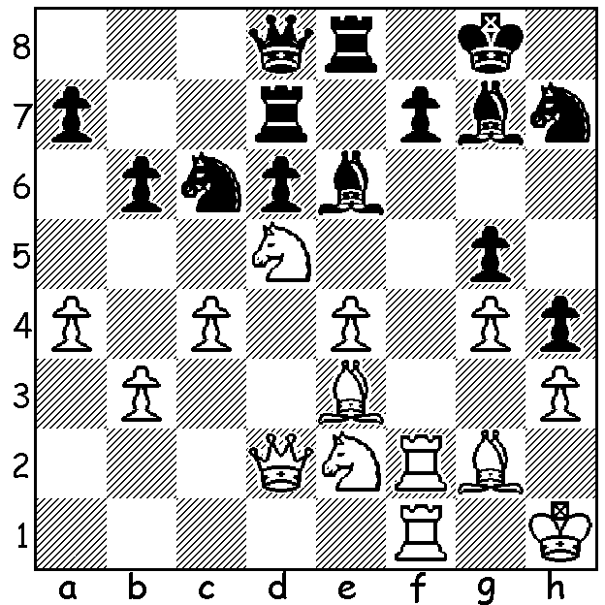

Ivanchuk-Radjabov (2011 World Cup): Black has just played 1…g5? How does White take advantage of this error?

Diagram 401

The 2011 Chess World Cup is being played at Khanty-Mansiyak, Siberia, venue of the 2010 Chess Olympiad. One hundred and twenty eight of the world’s best players began the knock out event on 26 August and the final will be completed on September 21. Players play a two game Classic time control match (90 mins followed by 30 mins + 30 sec increments). If scores are level at 1-1 two Rapid-Play games are played (25 mins + 30 sec), then if needed two more games at 10 mins + 10 secs, and again if needed two games at 5 mins + 3 sec. If scores are still level an ‘Armageddon’ decider is played with White needing to win. With a win in the first game a player might be expected to play a quiet and safe opening in game 2. This was certainly not the thinking of Emil Sutovsky who employs one of the sharpest of attacks against Vassily Ivanchuk’s Pirc Defence involving a piece sacrifice on move 9:

Emil Sutovsky - Vassily Ivanchuk
2011 World Cup, Rd 3, Game 2
Pirc Defence
1.e4 g6 2.d4 Bg7
3.Nc3 d6 4.f4 Nf6

5.Nf3 0-0 6.e5 Nfd7
7.h4 c5 8.h5 cxd4
9.hxg6 dxc3 10.gxf7+ Rxf7
11.Bc4 e6 12.Ng5 cxb2
13.Bxb2 Qa5+(a) 14.Ke2 Nf8
15.Nxf7 Kxf7 16.f5?!(b) Bxe5!(c)
17.Rh5 Ke8! 18.fxe6 Bxe6(d)
19.Bxe6 Qb5+ 20.Qd3 Qxb2
21.Qf5 Qb5+ 22.c4 Qb2+
23.Kf3 Nc6 24.Qf7+ Kd8
25.Qxf8+ Kc7 26.Rxh7+ Kb6
27.Qxa8 Nd4+(e) 28.Kg4 Qxg2+
29.Kh5 Qh2+ 30.Kg6 Qc2+!
31.Kh6 Bf4+ 32.Kg7 Nxe6+ A happy looking
33.Kf6 Qxh7 34.Kxe6 Qg6+ Vassily Ivanchuk
35.Ke7 Bg5+ 36.Kf8 Qf6+
White resigns(f)

a) If 13...Nxe5 14.Qh5!
b) 16.Qxd6 seems better.
c) Fearless play by Ivanchuk.
d) 18...Qb4 forking the bishops leaves Black badly undeveloped against White’s attack.
e) Black now wins by a series of forcing moves
f) Drained by this loss Sutovsky lost the tie break 0-2.

The WA LIGHTNING CHAMPIONSHIP (5 mins per player) will be held on Sunday 25 Sept at Moresby St. Centre, Kensington between 11 am & 2.45 pm. Entries accepted up to 10.45. Further information on cawa.org.au or contact Haydn Barber 9398 4242.

SOLUTION: 2.Nf6+! wins: if 2…Bxf6 3.Rxf6! Nxf6 4.Bg5 winning the knight followed by a queen invasion to mate. Black played 2…Nxf6 but after 3.Bxg5 Nxg4 4.Bxd8 Nxf2+ 5.Rxf2 Rdxd8 6.Qg5 soon lost.

