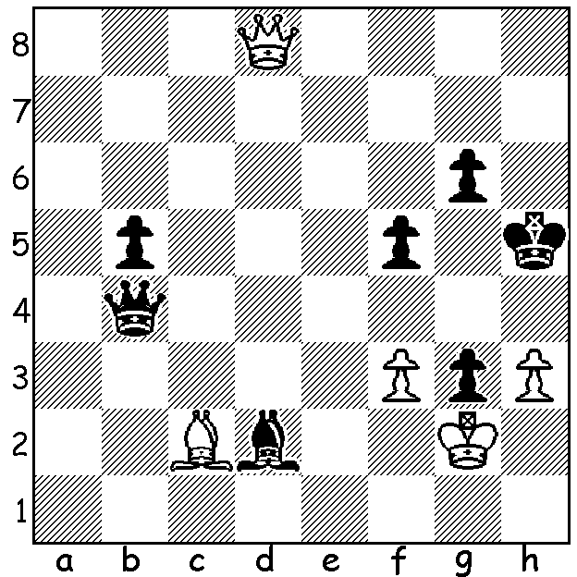

Bu Xiangzhi – Gupta
(2011 World Cup):
White brings off an unlikely
win (6 moves):

Diagram 402

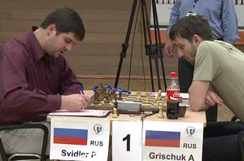
Last week we reported on the early stages of the 132-player FIDE World Cup (Knock-Out) in Khanty Mansiysk, Siberia. The two players who won through to the 4-game final were Peter Svidler and Alexander Grischuk who defeated Ruslan Ponomariov and Vassily Ivanchuk respectively in the semi-finals. Cricket loving Svidler is current and six-times Russian champion while Grischuk was recent runner-up to Boris Gelfand in the 2011 Candidates tournament (to decide the
challenger to world champion Vishy Anand).
Throughout the tournament Svidler seemed
to make a habit of winning with the Black
pieces and in the final against Grischuk
Svidler he started off with a win with Black.
The final three games were drawn giving
Svidler victory and the $96,000 first prize.
Here is an outstanding win by Svidler from
the event, again with Black:

Gata Kamsky - Peter Svidler
FIDE World Cup 2011, Rd4 Game 2
Ruy Lopez: Moeller Defence
1.e4 e5 2.Nf3 Nc6
3.Bb5 a6 4.Ba4 Nf6
5.0-0 b5 6.Bb3 Bc5
7.a4(a) Rb8 8.axb5 axb5
9.c3 d6 10.d4 Bb6
11.Be3 0-0 12.Nbd2 h6
13.h3 Re8 14.Qc2 exd4
15.cxd4 Na5(b) 16.Ba2 Bb7
17.e5 Nd5 18.Bb1(c) g6
19.Bxh6 Nc6 20.exd6(d) Qxd6
21.Ne4 Qb4 22.Ba2 Nxd4
23.Nf6+!(e) Kh8(f) 24.Nxd4 Nxf6
25.Nc6 Qh4!!(g) 26.Nxb8(h) Re2!!(i)
27.Qc3 Rxf2 28.Nc6 Rxf1+
White resigns

a) 7.Nxe5 Nxe5 8.d4 Bxd4 9.Qxd4 is often played.
b) The immediate 15...Bb7 is better.
c) Surprisingly missed by Svidler in his calculations.
d) This move loses White the advantage. Better 20.Qe4 dxe5 21.dxe5 then if 21…Nf6?! 22.Qh4 Nxe5 23.Bg5 Nxf3+ 24.Nxf3 and Black is virtually lost (24…Kg7? 25.Qh6+ Kg8 26.Bxg6 winning). 21...f5 or even 21...Nxe5?! seem better alternatives.
e) If 23.Nxd4 Qxd4 24.Nc3 Kh7 (not 24…Nxc3?? 25.Qxg6+) 25.Rad1 Nb4 and Black is better.
f) 23…Nxf6?? 24.Qxg6+)
g) If 25...Bxc6 26.Qxc6 Qh4 27.Be3 Black is in serious trouble.
h) Loses but if 26.Be3 Rxe3! 27.fxe3 Re8 with a strong attack.
i) This move deflects the white queen, stopping Nc6 or just adds a rook to the attack. If 27.Qxe2 Qg3! mating. “It's something you see in Anderssen games,” remarked Svidler who was delighted with his play. It might remind readers of Pillsbury – Lasker (St Petersburg 1895/6) where Lasker sacrificed both rooks (shown in the West July 2002).

The WA LIGHTNING CHAMPIONSHIP (5 mins per player) will be held this Sunday 25 Sept at Moresby St. Centre, Kensington, between 11 am & 2.45 pm. Entries accepted up to 10.45. Further information on cawa.org.au or contact Haydn Barber 9398 4242.

SOLUTION: 1.f4!! If 1…Qxf4 (1…Bxf4 2.Bd1+ Kh6 3.Qh8+ Kg5 4.h4#) 2.Bd1+ Kh6 3.Qh8+ Kg5 4.h4+! Qxh4 5.Qd8+ Kf4 6.Qxh4

