Congratulations to Yita Choong on winning his first WA Championship. Yita went into the last round with a mere half point lead over 2010 champion Tim Hare. He duly won his final game while Tim lost to Gordon Dunlop. Leading scores in the 10 player event were: 1st Yita Choong 7/9, =2nd Stephanus Kurniawan, Tim Hare and Akef Saleh 5.5, 5th Haydn Barber 5. Below is a position with Yita White against 15 times champion Haydn Barber. The position provides White with an opportunity to make a deep simplifying combination which puts the result beyond doubt (5 moves):
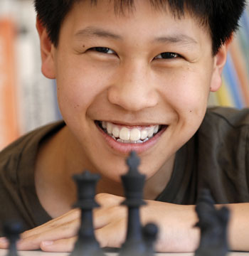
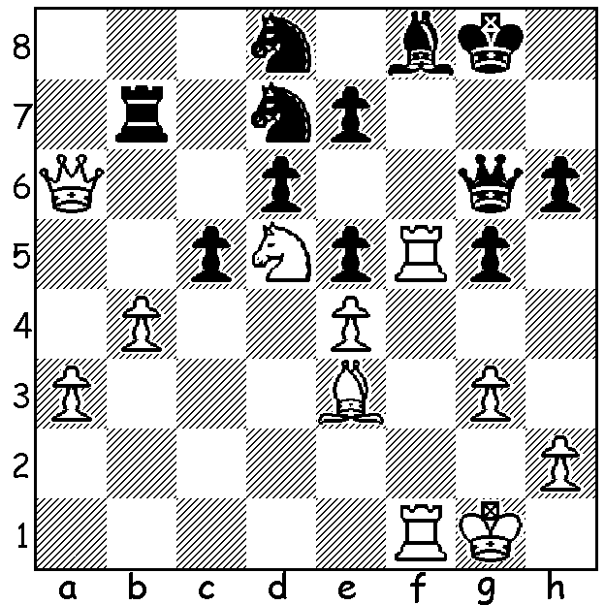 Diagram 402
Yita Choong (2007)

The surprise of the tournament was the excellent performance of Akef Saleh who came equal third and defeated both Choong and Barber. Here he inflicts the only defeat on the new champion:

AKEF SALEH - YITA CHOONG
2011 WA Championship, Rd 5
Sicilian Najdorf
1.e4 c5 2.Nf3 d6
3.d4 cxd 4.Nxd4 Nf6
5.Nc3 a6 6.Bg5 e6
7.f4 Qc7 8.Bd3 Nbd7
9.Qf3 b5 10.0-0-0 b4
11.Ne2 Bb7 12.Kb1 Be7
13.Rhe1 Nc5 14.Ng3 Rc8
15.Nb3 h6 16.Bxf6 Bxf6
17.Nh5 Qe7 18.Nxf6 Qxf6
19.Nxc5 Rxc5 20.Qe3 Qe7
21.g4 a5 22.e5 dxe
23.fxe Bd5 24.h4 a5
25.Be4 Bxe4 26.Qxe4 Rc8(a)
27.g5 Qc5(b) 28.Qd3 hxg?(c)
29.Qd7+ Kf8 30.Rf1! f5
31.exf6 Qxc2+ 32.Ka1 Rh7
33.fxg+ Kg8 34.Qf7#

a) Black might have tried 26…0-0 with attacking chances for both sides.
b) If 27…a3 28.Qd3 Qc7 29.gxh Rxh6 30.Re4 maintains White’s advantage.
c) Losing - Black needed to play 28…Qd5 (29.Qe2 Qb7)

Whilst the two junior competitors, WA Junior Champion Thomas Pinnock and joint WA Rapid-Play champion 13 year old Aston Taminsjay, finished equal ninth they nevertheless provided stiff opposition throughout the event. Here is their entertaining Round 2 clash:

THOMAS PINNOCK - ASTON TAMINSJAY
2011 WA Championship, Rd 2
Three Knights
1.e4 e5 2.Nf3 Nc6
3.Nc3 Bc5 4.Nxe5! Nxe5
5.d4 Bxd4 6.Qxd4 Qf6
7.Be3 Ne7 8.0-0-0 0-0
9.Be2 N7c6 10.Qd2 d6
11.Bg5!? Qxf2 12.Nd5 Qxg2
13.Rhg1 Qxe5?(a) 14.Nf6+! gxf6
15.Bxf6+ Ng6 16.Qh6 resigns

a) Allowing a sacrificial fork to expose Black’s king.

The penultimate Grand Prix event of 2011, the WILLETTON OPEN, will be held at the Moresby St. Centre on October 8/9. Details at cawa.org.au or contact Haydn Barber 9398 4242.

SOLUTION: 1.Qxb7!! (the tactical theme ‘Removing the Guard’, the rook’s potential protection of e7) 1…Nxb7 2.Rxf8+! (now removing the remaining protection of e2) 2…Kg7! (2…Nxf8 3.Nxe7+ winning) 3.Rg8+! (now a deflection sacrifice) 3.Kxg8 4.Nxe7+ Kg7 5.Nxg6: play continued 5…Kxg6 6.bxc Ndxc5 7.Bxc5 Nxc5 8.Ra1 resigns (the knight is helpless to prevent the advance of the a pawn). Less spectacular but simpler would have been the transposition 1.Rxf8+! Nxf8 2.Qxb7.

