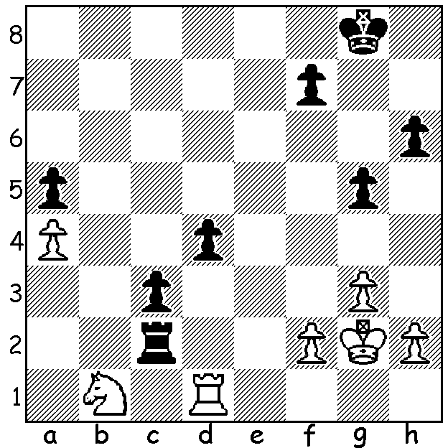
The Botvinnik Rapid-Play Memorial to
commemorate the birth of the great
Russian world champion Mikhail
Botvinnik in August 1911 was won by
world champion Vishwanathan Anand
ahead of ex-world champion Vladimir
Kramnik, Levon Aronian and Magnus
Carlsen. In Carlsen – Anand Black finds
a draw in a desperate looking position (in
fact White then has to play accurately to
draw – 5 moves):

Diagram 405

An Australian Chess Federation newsletter from last month reported the death on August 27th of Sydney player John Purdy (1935 – 2011), son of the Australian chess legend Cecil Purdy, a many times Australian champion and the inaugural World Correspondence champion. John, a former judge, was himself Australian champion in 1953 and 1963. Here is an exciting game against his illustrious father:

Cecil Purdy - John Purdy
1960 Australian Championship
Kings Indian Defence: Averbakh Variation

1.d4 Nf6 2.c4 g6
3.Nc3 Bg7 4.e4 d6
5.Bg5 h6 6.Bh4 0-0
7.Be2 c5 8.d5 Qa5
9.f3 e6 10.a4 Na6
11.g4 Re8(a) 12.Kf1 exd
13.cxd Nb4 14.Bg3 Rd8
15.h4 Ne8(b) 16.Nh3 a6
17.Qc1(c) Bd7 18.Bf4 Kh7
19.h5 g5 20.Bxg5! hxg5
21.Nxg5+ Kg8 22.h6 Bh8
23.Qf4 f6 24.h7+ Kf8
25.Ne6+ Bxe6 26.Qh6+(d) Ke7
27.dxe6 Kxe6 28.Bc4+ Kd7
29.Rd1 Kc7 30.Qf8 Ng7
31.Qxf6 Rd7 32.e5 Re8
33.exd+ Kb8 34.Qg6(e) Nc6
35.Bd5 Ne5 36.Qh6 Qb4
37.Be4?(f) Qxb2 38.Nd5?(g) Nxg4!
39.Qf4? Qf2#

a) 11…exd 12.cxd h5 13.h3 would better protect the king from attack.
b) Again 15…h5 16.g5 Ne8 maintains the pawn shield around the king.
c) Preparing to break open the kingside by a sacrifice.
d) White allows the loss of his advanced pawn to activate his bishop although the immediate 26.dxe6 may have been better.
e) Better 34.Rh2 Nc6 35.Re2.
f) Again 37.Rh2 (37…Nc4 38.Bxc4 Qxc4+ 39.Kg1=).
g) White had to play 38.Qd2 but the game is slipping away. White’s latter stage errors are almost certainly the result of a time scramble.

Dave Dempster has followed up his =1st in the WA Qualifying Championship by winning the WILLETTON OPEN (22 players) with 6/6. Eddy Seah, Akef Saleh and young junior George Carolin-Unkovich were =2nd with 4.5. This was an outstanding result for George who is reaping the benefits of regular participation in the weekenders against W A’s senior players.

SOLUTION: 1…d3!! and now if 2.Rxd3? Rxf2+!! ( a brilliant clearance sacrifice) 3.Kxf2 c2 and queens. Play continued 2.Kf3 d2 3.Ke4 Rc1 4.Nxc3! draw (4…Rxc3 5.Rxd2).

