Ex-world champion Gary Kasparov and England’s Nigel Short resumed their match rivalry earlier this month in Belgium. It was in 1993 that Short challenged Kasparov for
the world title in London. The match was most entertaining with some wonderful chess
but finished with a comfortable 12.5 – 7.5 victory to Kasparov. That match led to the
fracture of the chess world with FIDE refusing to
sanction the London venue and declaring Kasparov Kasparov – Korchnoi 2001:
no longer world champion. Kasparov and Short created White to play and win (6 moves)
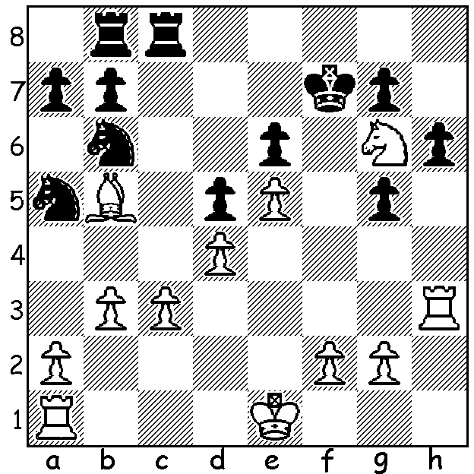
the Professional Chessplayers Association in opposition
to FIDE with the schism only resolved when Anand
became undisputed world champion in 2007. The latest
Kasparov – Short match was a much less serious affair
than the first, 9 Blitz games (5 mins + 2 sec increments),
but produced a much closer score. After three draws
Kasparov won the next two games only for Short to
draw level with two wins. However a determined
Kasparov was able to clinch victory with a final round
win. Short was his usual enterprising self, ready to play
offbeat openings which included the Evans Gambit, the
Kings Gambit and St Georges Defence (1. Nf3 b5 2.e4 a6 Diagram 406
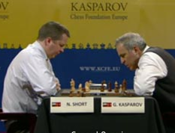
3.d4 e6) in a game he won. The match was to publicise
the 5th year of the ‘Your Next Move’ organisation which
seeks to promote chess as a sport and popularise the game
in schools.

Nigel Short - Gary Kasparov
2011 Blitz Match, Game 6
Kings Bishops Gambit Accepted
1.e4 e5 2.f4 exf
3.Bc4 Nf6 4.Nc3 c6
5.Bb3 d5 6.exd cxd
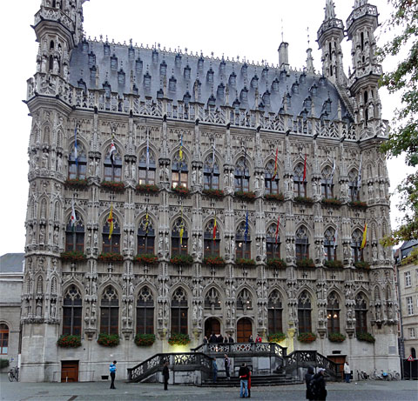
7.d4 Bd6 8.Nge2 Nc6
9.Bxf4 0-0 10.0-0(a) Be6
11.Qd2 Be7 12.Rae1 Re8
13.Kh1 a6 14.Ng3 b5
15.Nd1 Na5 16.c3 Nxb3
17.axb3 Ne4 18.Nxe4 dxe4
19.Qc2 Rc8 20.Ne3(b) Bh4
21.Rd1 f5 22.d5 Bd7
23.c4 Qb6 24.d6 bxc
25.bxc Qc6(c) 26.b3 g5!?
27.Bg3(d) Bxg3 28.hxg3(e) Qc5
29.Qf2 Rf8(f) 30.Rd5 Qb6
31.Nxf5 Qxf2 32.Rxf2 e3 The 15th century Town Hall in
33.Ne7+ Kg7 34.Rxg5+ Kh6 Leuven, venue for the match
35.Rxf8 resigns (g)

a) 10.Bxd5 Bxd4 11.Nxf4 Re8+ 12.Kf2 g5 13.Bxc6 bxc6 with Black having the better chances
b) 20.Rxe4 loses the exchange to 20…Bf5.
c) 25…g5 is met by 26.Nd5.
d) 27.Nxf5! gxf4 28.Nxh4 e3 looks dangerous.
e) Black has left White with doubled isolated g pawns and has seemingly mobilised his pawn majority. However his f pawn proves weak.
f) Better the counter attack 29…Rb8 (29.Rd5 Qa7).
g) 35…Rxf8 36.Re5 or 35…Kxg5 36.Rxc8 e2 37.Rc5+ Kf6 (37…Kg4/h6 38.Re5) 38.Nd5+ with an easy win.

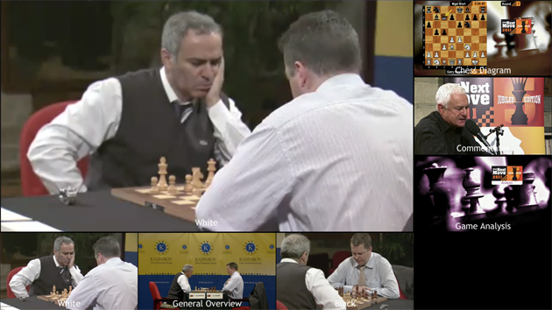

Second down right: GM Genna Sosonko who provided a running commentary on the games.

SOLUTION: 1.Rf3+! wins: if 1…Kxg6 (1…Kg8 loses the exchange to 2.Ne7+) 2.Bd3+ Kh5 3.Rh3+ Kg4 4.Ke2 with 5.f3+ & 6.g3#.

