Kramnik – Vachier-Lagrave ( 2011): Black threatens the knight as well as a mate on h1. Can you save the game for White (3 moves)?

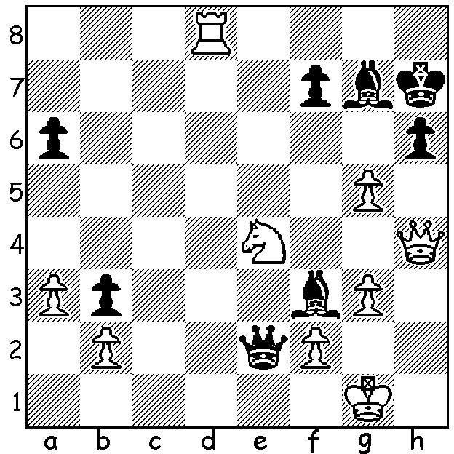

Diagram 407 (L to R) Kramnik, Vachier-Lagrave,
Giri, Polgar
The 15th Crown Group Unive Tournaments, played in Hoogeveen, Netherlands, finished earlier this week. Besides an 88 player Open there was also a four player GM Invitation event with the older generation represented by fourteenth world champion Vladimir Kramnik and the world's greatest ever female player Judit Polgar and the younger generation by the Dutch prodigy Anish Giri and French number one Maxime Vachier-Lagrave. The tournament was won convincingly by Kramnik with 4.5/6, winning all three games with White and drawing his three with Black, while the other three players could only muster one win between them (Giri against Polgar). Almost all great players have been innovators, prepared to challenge accepted theory and Kramnik is no exception. In his successful challenge against world champion Gary Kasparov in 2000 he employed the unfashionable and virtually forgotten Berlin Defence to the Ruy Lopez four times for four draws (1.e4 e5 2.Nf3 Nc6 3.Bb5 Nf6 4.0-0 Nxe4 5.d4 Nd6 6.Bxc6 dxc6 7.dxe Nf5 8.Qxd8+ Kxd8) and here he employs a very original idea against Giri on move 14:

Vladimir Kramnik - Anish Giri
2011 Crown Unive Invitation, Rd 1
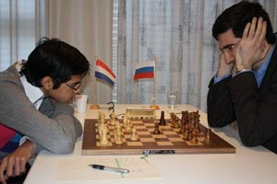
King's Indian Defence, Main Line
1.Nf3 Nf6 2.c4 g6
3.Nc3 Bg7 4.e4 d6
5.d4 0-0 6.Be2 e5
7.0-0 Nc6 8.d5 Ne7
9.b4 Nh5 10.g3 f5
11.Ng5 Nf6 12.Bf3 c6
13.Ba3 cxd5 14.exd5(a) e4
15.Be2 Ne8 16.Rc1 h6
17.Ne6 Bxe6 18.dxe6 Nc7
19.b5 Be5 20.Qb3 Kg7(b)
21.Rfd1 Nxe6 22.c5! Nd4 .
23.Rxd4! Bxd4 24.cxd6 Ng8 Giri came close to winning his
25.Nd5 Kh8 26.Rc7 Be5 second game with Kramnik
27.Bb2(c) Qxd6 28.Rxb7 g5(d)
29.b6 a5 30.Bh5 Rab8
31.Ra7 Bxb2 32.Qxb2+ Nf6
33.Bf7 Kg7 34.Rd7!(e) Qc6
35.Be6+ resigns(f)

a) 14.cxd is invariably played: Kramnik’s choice seems to give Black an overwhelming mobile kingside pawn majority.
b) Taking the d pawn is fatal in view of the subsequent pin on the knight on e6 - 20...Nxe6 21.c5 d5 22.Rfd1 Nd4 23.Rxd4! Bxd4 24.Nxd5!! Nxd5 25.Rd1!
c) 27.Re7! is also good (if 27…Bxd6 28.Bb2+ wins).
d) Trying to mobilise his pawn majority but creating a weakness which enables the second bishop to join the attack.
e) A clever deflection sacrifice: if 34...Qxd7 35.Qxf6+ Kh7 36.Qg6+ Kh8 37.Qxh6#.
f) 35…Kg6 36.Ne7+ or 35...Kh8 36.Nxf6 Qxe6 37.Rh7#.

SOLUTION: 1.Nd2 meets the two threats. Now if 1…Qd1+ 2.Nf1 Qxd8? 3.g6+ wins the queen and if 1…Qe1+ 2.Nf1 Be2? 3.Qe4+ mates. Black played 1…Bc6 and although Kramnik was forced to give up his rook for the bishop he was able to win a queen ending.

