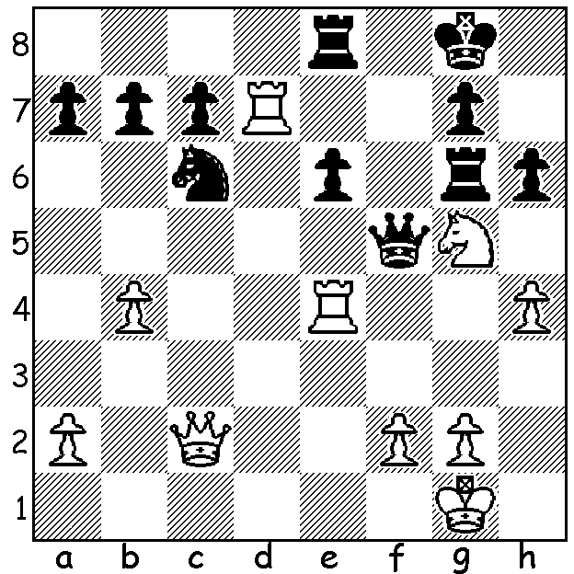

Aronian – Anand (Bilboa 2011):
White to play and win (2 moves):

Diagram 408

GRANDMASTER ROBBED AT GUNPOINT


One of the top tournaments of the year, the Grand Slam Chess Finals (also called the Bilboa Masters Finals), was played half in Sao Paulo, Brazil, (Sept 25 – Oct 1) and half in Bilboa, Spain, (Oct 5 – 11). For much of the event it looked like a one horse race (I’m writing this on Melbourne Cup Day) with Vassily Ivanchuk (replacing ex-world champion Vladimir Kramnik who declined to play) taking a commanding lead. However he was caught near the line by Magnus Carlsen who then won the play-off 1.5-0.5. In all Carlsen defeated Ivanchuk 3 times in the 4 games they played. Scores: 1st Carlsen (+3 =6 -1) & Ivanchuk (+4, =3, -3) 17/30: =3rd US champion Hikaru Nakamura, world champion Viswanathan Anand & Levon Aronian 12/30, 6th Francisco Vallejo-Pons (who replaced Sergey Karjakin) 10/30. Three points were awarded for a win and one for a draw. Ivanchuk contemplated withdrawing after being robbed of his luggage at gunpoint outside his hotel in Sao Paulo as he was about to taxi to the airport. It says much for his character that he was able to complete the tournament and tie for 1st place. Here is Carlsen’s Rd 9 win against Ivanchuk:

Magnus Carlsen - Vassily Ivanchuk
2011 Grand Slam Finals, Rd 9
Nimzo Indian Defence
1.d4 Nf6 2.c4 e6
3.Nc3 Bb4 4.Nf3 b6
5.Qc2 Bb7 6.a3 Bxc3
7.Qxc3 Ne4 8.Qc2 f5(a)
9.g3 Nf6 10.Bh3(b) 0-0
11.0-0 a5(c) 12.Rd1 Qe8

13.Bf4 Na6 14.d5 exd
15.Bxf5(d) dxc 16.Ng5 Qh5
17.Rxd7! Kh8(e) 18.Re7(f) Nd5
19.Bg4! Qg6(g) 20.Nf7+ Kg8(h)
21.Bf5 Qxf5!(i) 22.Qxf5 Nxe7
23.Nh6+! gxh6 24.Qg4+ Ng6
25.Bxh6 Rf7 26.Rd1 Re8
27.h4 Nc5 28.h5 Bc8
29.Qxc5 Ne5 30.Qh4 Nc6(j)
31.Rd5 Ne6 32.Qc4 Ncd8?(k)
33.Qg4+ Ng7(l) 34.Qxc8 resigns Ivanchuk (top) & Carlsen

a) This position could also arise from the Dutch Defence (1d4 f5). Black would usually try to attack on the kingside after castling by positioning his queen and/or rook on the h file and/or advancing his g pawn, all backed by the fianchettoed bishop on b7.
b) A novelty and at first glance a beginner’s move placing the bishop where it is unprotected and liable to attack from Black’s queen. However it attacks the f pawn which could lose its protection from the e pawn after d5.
c) If 11…Qe8 12.Bf4 (12…d6 13.c5).
d) Now it’s White with the kingside attack.
e) 17…Nxd7 loses the queen to 18.Bxh7+ Kh8 19.Bg6 Qg4 20.f3 or 19…Qh6 Nf7+.
f) Also good is 18.Rd4 with the latent threat of Rh4 winning the queen.
g) 19…Qxg4?? 20.Qxh7#.
h) If 20…Rxf7 21.Qxg6 hxg6 22.Rxf7.
i) If 21…Qh5 22.g4 Qh4 23.Bg3! Qh3 (23…Qxe7 24.Bxh7+ Kxf7 25.Qg6#) 24.Be6 winning. Now Black has a material advantage but White’s next move fatally exposes Black’s king leaving him in great danger of queen & bishop mating batteries.
j) 31…Ne6 which also guards against 32.Rd8 seems better.
k) Losing quickly – 32…Ne2 would offer continued chances.
l) If 33.Kh8 34.Bd2 wins.

SOLUTION: 1.Rxe6! resigns (1…Qxc2 2.Rxe8# or 1…Rgxe6 2.Qxf5 or 1…Qxe6 Nxd6 winning).

