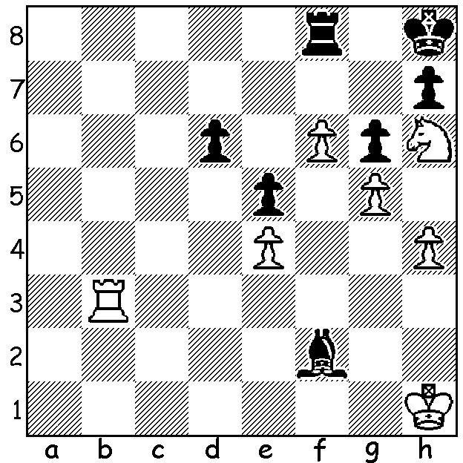

Johannes Zukertort
(White v Von Schute)
ignores the threat to his pawn
chain and mates in four:

Diagram 409

JOHANNES ZUKERTORT (1842 – 1888)

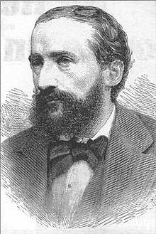
It is now nearly 13 years since the start of my chess
alphabet series which began with an article on
Alexander Alekhine on February 6, 1999. I now
arrive at the last letter with Johannes Zukertort. By
coincidence I came across the news that the grave
of Zukertort, who was buried in Brompton Cemetery,
London, is in need of restoration and a public appeal
has been made for donations, with the Polish Embassy
promising £2000. Much of the information on
Zukertort’s life comes from the flamboyant Zukertort
himself and needs to be taken with a pinch of salt. He
claims to have been born to a baroness in Lublin,
Poland, that he obtained a doctorate in medicine at
Breslau University, that he spoke nine languages, that
he was an accomplished swordsman, that he had
fought for Prussia in three wars and had once been
left for dead on the battlefield, that he had been a
music critic and editor of a political paper, that (like
Fischer) he was gifted with so colossal memory that
he never forgot a game he had played. His greatest
chess success was gained at the London Tournament
of 1883, one of the most important tournaments of
the nineteenth century with an unparalleled prizefund of £1,100 which helped to insure the participation of the leading world players and in which double headed chess clocks were used for the first time. Zukertort scored 22/26 despite losing his last three games. He was followed by Wilhelm Steinitz, the future first world champion, on 19, England’s Joseph Blackburne, ‘the Black Death’, on 16.5, Russia’s Mikhail Tchigorin 16, et alia. Here is Zukertort’s most famous game, a win against Blackburne in London, most notable for amazing successive deflection
sacrifice offers of queen and rook:

Johannes Zukertort - Joseph Blackburne
London 1883:
English / Queens Indian / Queens Gambit Declined?
1.c4 e6 2.e3 Nf6
3.Nf3 b6 4.Be2 Bb7
5.O-O d5 6.d4 Bd6
7.Nc3 O-O 8.b3 Nbd7
9.Bb2 Qe7 10.Nb5 Ne4
11.Nxd6 cxd6 12.Nd2 Ndf6
13.f3 Nxd2 14.Qxd2 dxc4
15.Bxc4 d5 16.Bd3 Rfc8
17.Rae1(a) Rc7 18.e4 Rac8
19.e5 Ne8 20.f4 g6
21.Re3 f5(b) 22.exf6 Nxf6
23.f5! Ne4 24.Bxe4 dxe4
25.fxg6! Rc2(c) 26.gxh7+ Kh8
27.d5+ e5 28.Qb4!! R8c5(d)
29.Rf8+! Kxh7(e) 30.Qxe4+ Kg7
31.Bxe5+ Kxf8 32.Bg7+ Kg8(f)
33.Qxe7 resigns

a) Ignoring the open c file to prepare a central advance and kingside attack.
b) Otherwise he will be swamped by g4, f5.
c) Black’s domination of the open file appears to win a piece. If instead 25... hxg6 26. Rg3 wins (26…Qg7 27. d5 e5 28.Qg5 Re8 29. Rf6).
d) If 28…Qxb4 29.Bxe5+ Kxh7 30.Rh3+ Kg6 31.Rg3+ Kh6 32.Rf6+ Kh5 33.Rf5+ Kh6 34.Bf4+ Kh7 Rh5#.
e) If 29…Qxf8+ 30. Bxe5+ Kxh7 31.Qxe4+ Kh6 32.Rh3+ and mates.
f) 32…Qxg7 33.Qe8#.

SOLUTION: 1.Rb7! Bxh4 2.Rg7 Bxg5 3.Rg8+!! Rxg8 4.Nf7#.

